POSTDOCTORAL OPPORTUNITIES
Postdoctoral Recruitment in Professor Xu Yanming’s Research Group
Institute of Stereo Cell Biomedicine, Shantou University (STU-ISCB)

About STU-ISCB
The Institute of Stereo Cell Biomedicine at Shantou University (STU-ISCB) is a high-level interdisciplinary research platform established as a strategic priority of the University. Based within Shantou University Medical College, the Institute advances the frontiers of life and health sciences by integrating clinical medicine, biology, mathematics, and artificial intelligence.
Focusing on spatial and temporal single-cell biomedicine, STU-ISCB is building an integrated research ecosystem spanning technology development, data infrastructure, and clinical application. Key areas include AI and virtual cells, stereo-cell biomedical informatics and big data, clinical AI, and cell-based translation. The Institute addresses major health challenges—including cancer, immune regulation, chronic diseases, and ageing—through mechanistic research, precision diagnostics, targeted therapies, and AI-enabled medical systems.
Our research community brings together academicians, senior professors, and emerging research leaders from clinical medicine, mathematics, AI, and bioinformatics. Collaborations with the European Stereo Cell Research Center, BGI, leading tertiary hospitals, and prominent research institutes provide strong research infrastructure, project resources, and pathways for translation.

Open Positions and Compensation
Standard Track：RMB 360,000, five positions;
Faculty Track (Clinical / Basic Sciences)：RMB 480,000, five positions;
Innovation Track：RMB 600,000, five positions;

Research Areas
Applications are invited in the following areas. Candidates with interdisciplinary backgrounds are particularly encouraged to apply:
- Stereo-cell technologies; single-cell and spatial multi-omics; cell biology; molecular biology
- Computer science; mathematics and scientific computing; artificial intelligence; large-model development
- Cancer biology; targeted cancer therapy; tumor immunology; pathophysiology
- Bioinformatics; medical big data; mathematical modeling of disease; multi-omics data analysis
- Artificial intelligence in medicine; medical image analysis; intelligent diagnostic and treatment systems
- Mechanisms and precision diagnosis and treatment of major diseases

Eligibility
- A strong commitment to academic integrity, professional ethics, teamwork, research excellence, and continued scholarly development.
- Normally 35 years of age or younger. The age requirement may be relaxed for candidates with exceptional achievements.
- A doctoral degree normally awarded within the past three years, or current status as a graduating PhD candidate able to provide official confirmation that the doctoral degree will be awarded.
- Good physical and mental health, with the ability to undertake full-time postdoctoral research.

Benefits and Career Development
- Faculty appointment pathway: Outstanding Faculty-Track and Innovation-Track postdoctoral fellows who meet the relevant performance requirements during their appointment may sign an early faculty appointment letter of intent with the University and the Institute.
- Competitive compensation: Starting annual salaries of RMB 360,000 for the Standard Track, RMB 480,000 for the Faculty Track, and RMB 600,000 for the Innovation Track.
- Additional research incentives: Research output exceeding agreed targets is eligible for additional rewards in accordance with applicable policies, with no preset ceiling.
- Professional advancement: Access to a dedicated pathway for professional-title evaluation.
- Clinical training: Postdoctoral fellows conducting clinical research at affiliated hospitals may concurrently undertake standardized residency or specialist training during their appointment.
- Progression during appointment: Postdoctoral fellows may advance to a higher postdoctoral tier based on performance and receive the corresponding benefits.
- Housing support: Eligibility to apply for on-campus accommodation or receive a housing allowance during the appointment.
- Talent services: Access, subject to applicable requirements, to services available to high-level talent in Shantou.
Note: Compensation, benefits, and eligibility requirements are subject to the latest policies of Shantou University, STU-ISCB, and the relevant local authorities.

How to Apply
Please email the following application materials to STU_ISBM@163.com;
- Curriculum vitae
- Doctoral degree certificate (or official confirmation of expected degree conferral for graduating PhD candidates)
- List of research outputs
- Representative publications or other research achievements

汕头大学logo：
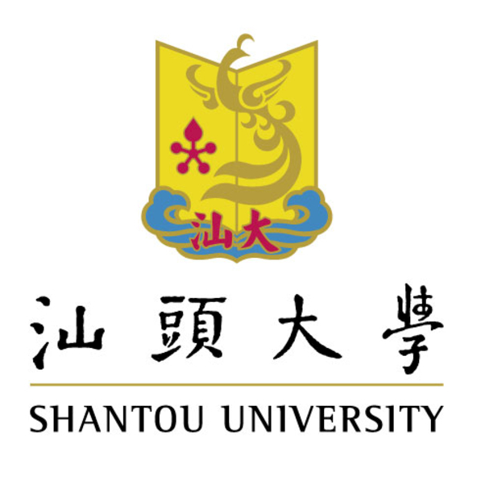
学校图片
