
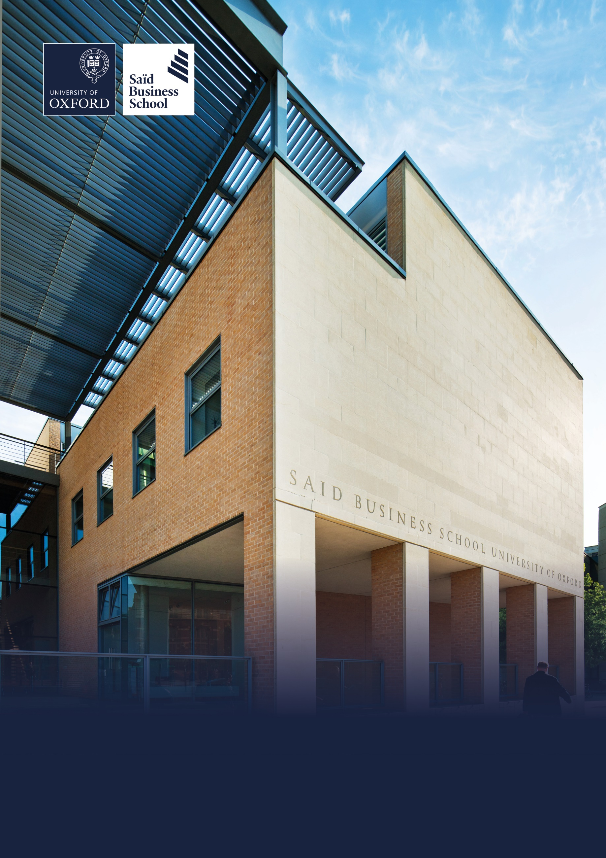

Hybrid (two days per week onsite), Park End Street, Oxford
Grade 8: £49,119 - £58,265 per annum including the Oxford University weighting of £1,730 per annum
Fixed Term Contract or Secondment: until 31 July 2027, full time (37.5 hours per week)
Saïd Business School, Social Sciences Division, University of Oxford
Senior Manager for Impact Education


The role

The Skoll Centre’s mission is to equip entrepreneurial leaders to catalyse social impact within and beyond business. We see a world where social change is driven by people who embrace paradox – bridging theory and practice, profit and purpose, local communities, and global businesses – to find solutions and transform broken systems. Driven by this vision, we bring together academic researchers, students, and practitioners to share expertise and generate insights on how to lead, organise, finance, measure, and scale impact. Leveraging these insights, our educational programmes cultivate impactful leaders at Oxford and worldwide.

The Skoll Centre’s impact education portfolio blends insights from research and practice to equip learners at Oxford and worldwide with the knowledge, skills, and mindsets needed to create positive social impact within and beyond business.

As a member of the Centre’s senior leadership team, the Senior Manager for Impact Education will play a key role in setting strategic direction for the impact education portfolio, leading impact education programmes that align with and contribute to the Centre’s overall mission and strategy and which build relationships with internal and external partners for programme design and delivery. Additionally, the Senior Manager will be responsible for identifying and developing opportunities to expand the reach and impact of the Centre’s education portfolio.

Responsibilities

Centre leadership and strategic direction
As a member of the Centre’s senior leadership team, work with the Academic Director and Deputy Director to develop and implement the Centre’s impact education strategy and ensure the Centre’s educational programmes advance the Centre’s overall mission and strategy.
• Represent the Centre and our educational programmes within the School, across the University, and with external stakeholders and partners.
• Ensure the integration and alignment of Skoll Centre educational activities with relevant curricular, co-curricular and careers programming in the School and across the University.
• Develop and manage the impact education portfolio’s priorities and success measures, including a framework to monitor the impact of the Centre’s educational programmes and an annual workplan and budget.
• Recruit and manage staff within the impact education portfolio, including Programme Coordinators and external consultants as needed.
• Support the Academic Director and Deputy Director in identifying and securing new sources of funding, from both University and external sources, to bring the Centre’s impact education strategy to fruition.
Impact education programming
• Working closely with the Deputy Director, Senior Manager for Strategic Partnerships and Communications, and relevant teams across the School, contribute to developing and ensuring execution of marketing, recruitment, and outreach strategies for the Skoll Scholarship and Impact Lab programmes.
• Design and ensure delivery of the Centre’s existing impact education programmes, including the Skoll Scholarship, Impact Lab, Map the System, and AfOx Mastercard leadership development programme.
• Identify and bring to fruition new impact education opportunities that advance the Centre’s overall mission and strategy.
Impact education partnerships and community
• Develop and nurture relationships with academic faculty and other instructors across the School and the University, and with the global network of external partners involved in designing, delivering, or otherwise supporting the Centre’s educational programmes.
• Act as the key link between this network of impact education partners and the Skoll Centre staff, ensuring that relevant ideas and approaches are incorporated into other areas of Skoll Centre programming.
Learner engagement at Oxford and globally
• Develop and nurture relationships with current Skoll Scholars during their time at Oxford, and ensure a seamless relationship transition to the Senior Manager for Strategic Partnerships and Communications upon students’ graduation.
• Ensure the Centre guides Oxford MBAs to appropriate impact education programmes, resources, networks, and mentoring opportunities.
• Engage learners beyond the Oxford MBA cohort, including other Oxford students as well as adult learners globally, in relevant Centre programmes and opportunities, in line with the Centre’s overall impact education strategy. Any other duties appropriate to the level and purpose of the post.

Selection criteria

Essential selection criteria
• Bachelor’s degree or equivalent experience.

• Demonstrated knowledge of and experience with educational approaches for teaching social entrepreneurship, social innovation, and systems change.

• Experience developing and delivering interactive educational content and skills training, ideally in a co-curricular and/or elective context for postgraduate students.

• Excellent public speaking, presentation, and group facilitation skills.

• Demonstrable commitment to user-centred programme design, and an interest and desire to engage with and support students in their own aspirations and learning journeys.
• Excellent interpersonal skills, with the ability to manage and develop relationships and communicate effectively with a wide range of stakeholders including faculty, support staff, students, and external collaborators.

• Experience managing projects and budgets, with the ability to design and deliver programmes to a high standard.

• Excellent IT skills, including MS Office applications.

• Relentless attention to detail, outstanding organisational skills, and sound judgment

• The ability to handle and prioritise a complex portfolio of responsibilities in a complex institutional environment.

• Proven ability to work with minimal supervision in designing, implementing, and evaluating projects and initiatives.

• Demonstrated alignment with the Skoll Centre values, including:
➢ Integrity and accountability
➢ Openness, flexibility, and a commitment to learning and growth
➢ Diversity, inclusion, and respect for others’ voices, perspectives, and experiences
➢ A collaborative approach that encourages involvement of multiple stakeholders

Desirable selection criteria

- Experience starting or working in a social enterprise, non-profit, or other relevant social purpose organisation.

- Experience leading a team and line managing staff.

- Experience working in a higher education institution and familiarity with the academic environment.

- Master’s degree in a related subject.

Pre-employment screening

Standard checks
If you are offered the post, the offer will be subject to standard pre-employment checks. You will be asked to provide: proof of your right-to-work in the UK; proof of your identity; and (if we haven’t done so already) we will contact the referees you have nominated. If you have previously worked for the University we will also verify key information such as your dates of employment and reason for leaving your previous role with the department/unit where you worked. You will also be asked to complete a health declaration so that you can tell us about any health conditions or disabilities for which you may need us to make appropriate adjustments.

Please read the candidate notes on the University’s pre-employment screening procedures at Pre-employment checks (https://www.ox.ac.uk/about/jobs/explore-our-careers/applications-process/pre-employment-screening).



About the University of Oxford
Welcome to the University of Oxford. We aim to lead the world in research and education for the benefit of society both in the UK and globally. Oxford’s researchers engage with academic, commercial and cultural partners across the world to stimulate high-quality research and enable innovation through a broad range of social, policy and economic impacts.

We believe our strengths lie both in empowering individuals and teams to address fundamental questions of global significance, while providing all our staff with a welcoming and inclusive workplace that enables everyone to develop and do their best work. Recognising that diversity is our strength, vital for innovation and creativity, we aspire to build a truly diverse community which values and respects every individual’s unique contribution.

While we have long traditions of scholarship, we are also forward-looking, creative and cutting-edge. Oxford is one of Europe’s most entrepreneurial universities and we rank first in the UK for university spin-outs, and in recent years we have spun out 15-20 new companies every year. We are also recognised as leaders in support for social enterprise.

Join us and you will find a unique, democratic and international community, a great range of staff benefits and access to a vibrant array of cultural activities in the beautiful city of Oxford. For more information, please visit About the University of Oxford (https://www.ox.ac.uk/about).

Saïd Business School
Saïd Business School blends the best of new and old. We are a vibrant and innovative business school, but yet deeply embedded in an 800 year old world-class university. We create programmes and ideas that have global impact. We educate people for successful business careers, and as a community seek to tackle world-scale problems.

We deliver cutting-edge programmes, including the highly regarded MBA, Executive MBA, a number of specialist MScs, a portfolio of custom and open programmes and accredited diplomas for executives, and we undertake ground-breaking research that transform individuals, organisations, business practice and society. We are an international and outward looking School with our programme participants coming from more than 50 countries.

We seek to be a world-class business school community, embedded in a world-class University, tackling world-scale problems.

Sustainability
Saïd Business School is committed to the highest standards of environmental sustainability, preserving the planet for future generations and acting in a socially sustainable manner. As an employee you are expected to uphold these commitments in accordance with our Environmental Policy. You can learn more about our organisation’s sustainability efforts at Sustainability | Saïd Business School (https://www.sbs.oxford.edu/about-us/school/sustainability).

Diversity and Inclusion
Oxford Saïd is committed to fostering an inclusive culture which promotes equality, values diversity and maintains a working, learning and social environment in which the rights and dignity of all its staff and students are respected. We recognise that the broad range of experiences that a diverse staff and student body brings strengthens our research and enhances our teaching, and that in order for Oxford to remain a world-leading institution we must continue to provide a diverse, inclusive, fair and open environment that allows everyone to grow and flourish.

Oxford Saïd holds a bronze Athena Swan award to recognise advancement of gender equality: representation, progression and success for all.

Our Values
To better understand our Values, what behaviours demonstrate them and how they are involved in your everyday work we have created the below descriptors.

Transformational
We challenge constructively, provoke thought, and influence and inspire others to develop.

Respectful
We are caring, supportive, appreciative, embrace difference and value each other's opinions.

Entrepreneurial
We embrace and encourage change and innovation. We are creative, flexible and brave.

Collaborative
We are stronger together. We are inclusive, approachable, listen to others and value good communication.

Purposeful

We are a community who believe in sustainable growth, and are responsible, principled and transparent.

Excellence
We are professional, focused and aligned, and have a responsibility to do the very best we can.

Wellbeing
Saïd Business School acknowledge the importance of wellbeing, in enabling people to thrive at work and ensure a work-life balance. It provides a number of initiatives to help support wellbeing and would encourage you to participate. At an individual level, wellbeing means recognising what helps us remain resilient and taking appropriate steps. If we experience difficulties, doing our best to rectify them and making our line manager aware of aspects that they could support us with.

Further information about Saïd Business School is available at Saïd Business School (www.sbs.oxford.edu).

Social Sciences
Oxford Saïd is a department within the Social Sciences Division, one of four academic Divisions in the University, each with considerable devolved budgetary and financial authority; and responsibility for providing a broad strategic focus across its constituent disciplines.

The Social Sciences Division represents the largest grouping of social sciences in the UK: home to a number of outstanding departments and to the internationally ranked Law Faculty; all are committed to research to develop a greater understanding of all aspects of society, from the impact of political, legal and economic systems on social and economic welfare to human rights and security. That research is disseminated through innovative graduate programmes and enhances undergraduate courses. For more information please visit Social Sciences Division (https://www.socsci.ox.ac.uk).


How to apply
Applications are made through our online recruitment portal. Information about how to apply is available on our Jobs website at How to apply (https://www.ox.ac.uk/about/jobs/explore-our-careers/applications-process/how-to-apply).

Your application will be judged solely on the basis of how you demonstrate that you meet the selection criteria stated in the job description.

As part of your application you will be asked to provide details of two referees and indicate whether we can contact them now.

You will be asked to upload a CV and a supporting statement. The supporting statement must explain how you meet each of the selection criteria for the post using examples of your skills and experience. This may include experience gained in employment, education or during career breaks (such as time out to care for dependants).

Please upload all documents as PDF files with your name and the document type in the filename.

All applications must be received by midday UK time on the closing date stated in the online advertisement.

Information for internal candidates
If you currently work for the University please note that:

- As part of the referencing process, we will contact your current department to confirm basic employment details including reason for leaving.

- Although employees may hold multiple part-time posts, they may not hold more than the equivalent of a full time post. If you are offered this post, and accepting it would take you over the equivalent of full-time hours, you will be expected to resign from, or reduce hours in, your other post(s) before starting work in the new post.

- Before applying for this post, you are advised to read the Internal Mobility Principles (https://unioxfordnexus.sharepoint.com/sites/OXINTRANET-working-here/SitePages/internal-mobility-principles.aspx). The principles promote good practice for moving into professional services roles and are designed to provide clarity on expectations for managers and individuals.

Information for priority candidates
A priority candidate is a University employee who is seeking redeployment because they have been advised that they are at risk of redundancy, or on grounds of ill-health/disability. Priority candidates are issued with a redeployment letter by their employing department(s).

If you are a priority candidate, please ensure that you attach your redeployment letter to your application (or email it to the contact address on the advert if the application form used for the vacancy does not allow attachments).

If you need help
Application FAQs, including technical troubleshooting advice is available at Support with online applications (https://www.ox.ac.uk/about/jobs/explore-our-careers/applications-process/support-with-online-applications).

Non-technical questions about this job should be addressed to HR.Recruitment@sbs.ox.ac.uk.

To return to the online application at any stage, please go to How to apply (https://www.ox.ac.uk/about/jobs/explore-our-careers/applications-process/how-to-apply).

Please note that you will receive an automated email from our online recruitment portal to confirm receipt of your application. Please check your spam/junk mail if you do not receive this email.


Important information for candidates

Data Privacy
Please note that any personal data submitted to the University as part of the job application process will be processed in accordance with the GDPR and related UK data protection legislation. For further information, please see the University’s Privacy Notice for Job Applicants at Job applicant privacy policy (https://compliance.admin.ox.ac.uk/job-applicant-privacy-policy).

The University’s Policy on Data Protection is available at Data protection policy (https://compliance.admin.ox.ac.uk/data-protection-policy).

The University’s policy on retirement
The University operates an Employer Justified Retirement Age (EJRA) for very senior research posts at grade RSIV/D35 and clinical equivalents E62 and E82 of 30 September before the 70th birthday.

For existing employees, any employment beyond the retirement age is subject to approval through the procedures. Please see The EJRA (https://unioxfordnexus.sharepoint.com/sites/OXINTRANET-working-here/SitePages/the-ejra.aspx).

There is no normal or fixed age at which staff in posts at other grades have to retire. Staff at these grades may elect to retire in accordance with the rules of the applicable pension scheme, as may be amended from time to time.

Equality of opportunity
The University of Oxford is committed to equal opportunity and to being a place where everyone belongs and is supported to succeed. We recognise how the diversity of our community enriches our ability to deliver on our academic mission.

We welcome applications from individuals from all backgrounds, including those underrepresented within higher education. No applicant or member of staff shall be unlawfully discriminated against on the basis of age, disability, gender reassignment, marriage or civil partnership, pregnancy or maternity, race, religion or belief, sex or sexual orientation.

Employment with the University and progression within employment will be determined according to personal merit and the application of criteria related to the duties and conditions of the post. In all cases, the primary consideration will be the ability to perform the job.

As stated in the University’s Equality Policy and Equality, Diversity and Inclusion Strategic Plan, our commitment to equality and diversity goes hand in hand with our commitment to academic freedom and free speech.


Oxford Saïd Exclusive Benefits

Wellbeing initiatives
Oxford Saïd runs a fortnightly Wellbeing Wednesday when staff are encouraged to take time (one hour for full-time staff and half an hour for part-time staff) during the working day to focus on their wellbeing in addition to their lunch break. We also have excellent catering facilities that provide a high standard of food, including healthy eating and vegetarian options at a subsidised cost.

Staff Summer and Christmas parties
Oxford Saïd like to reward all of their staff for their great work and their Christmas and Summer parties are our way of saying thank you. The Christmas party is for all staff and the summer party is for staff and their immediate family members, because we know how important family is to all of us.

Employee Assistance provider
Spectrum.Life is an employee assistance and wellbeing consultancy that works in partnership with the Business School to provide staff and their immediate family with a free 24-hour per day helpline providing confidential information and counselling services on personal issues.

University of Oxford Benefits

Annual leave
38 days (inc. public holidays). Long service additional annual leave – up to 5 days per annum, pro rata for part time employees. Previous service within higher education sector can be recognised. An additional scheme enables staff to request to purchase up to 10 additional days in each holiday year.

Salary and salary sacrifice schemes
The University salary and grading structure allows for annual incremental progression until a scale-bar point is reached. This incremental progression is automatic. Additionally, there are salary sacrifice schemes for bicycles and electric cars. See Working here (https://www.ox.ac.uk/about/jobs/working-here).

Pension
If you are on an academic or academic related pay scale (grade 6 or above), you are automatically a member of USS. Employer contribution is 14.5% and Employee contribution is 6.1%.

If you are on a pay scale other than academic or academic related (grade 1-5) you are automatically a member of OSPS. Employee contribution can be between 4%- 8% and Employer contribution 10%-14%.

University discounts
All University staff can purchase a TOTUM discount card for £14.99 for 12 months (£24.99 for 2 years, £34.99 for 3 years) which gives access to numerous exclusive offers and discounts from many popular retailers. There are a wide range of other discounts from external companies available using a university card.

University Club
Membership of the University Club is free for all University staff. The University Club offers social, sporting and hospitality facilities. Staff can also use the University Sports Centre on Iffley Road at discounted rates, including a fitness centre, powerlifting room and swimming pool. See The University Club (www.club.ox.ac.uk) and Oxford University Sport (https://www.sport.ox.ac.uk).

Access to Oxford buildings
Free access to a number of Oxford colleges, Botanic Gardens, Harcourt Arboretum, Wytham Woods and discount at numerous restaurants/shops.



Saïd Business School
University of Oxford
Park End Street
Oxford, OX1 1HP
Saïd Business School, University of Oxford
United Kingdom
www.sbs.oxford.edu

All information is correct at the time of going to press.

Please check our website for the most up-to-date information.

