

Position Title | Research Assistant | Position No. 17055
College/Department/ Directorate | College of Engineering, Design, and Physical Sciences/ Department of Engineering
Grade | R1 26-29
Reporting To | Prof. T. Kalganova (PI)
Date reviewed | October 2026

About the project:

The SMART – Secure Motor AI-Responsive Technology - Application 10198913 -Response to Assessor Concerns project develops a secure, AI-responsive motor control platform that combines adaptive AI, FPGA-based real-time control, digital twin technologies, and advanced power electronics. Brunel leads the development of embedded adaptive intelligence capable of continuously optimising motor performance under changing operating conditions, delivering improved efficiency, reliability, security, and industrial applicability.
The Research Assistant is critical to delivering Brunel’s technical leadership within the project. The role strengthens the College’s strategic objectives in AI, digital engineering, and industry-focused innovation by generating high-quality research outputs, supporting postgraduate researchers, enhancing industrial collaboration, developing intellectual property, and creating a platform for future UKRI, Horizon Europe, and industrial funding opportunities.

Summary of role:

Under supervision of the Principal Investigator the post-holder will:

- Produce independent original research in adaptive AI and intelligent control systems.
- Take the initiative in planning and organising research activities.
- Lead the development and implementation of adaptive control algorithms for the SMART-Engine platform.
- Develop FPGA-based solutions and optimise hardware-software integration.
- Coordinate and integrate technical developments produced by project-supported postgraduate researchers.
- Support the work of small research teams and have direct engagement with clients/sponsors.

Main accountabilities and responsibilities:

Assist in undertaking the research project, individually and/or jointly, to meet the project deliverables and the Department/Institute, College and University research strategy.
- Undertake high-quality research individually and collaboratively to achieve project objectives and deliverables.
- Design, develop, implement and validate bio-inspired and adaptive AI/control algorithms.
- Develop FPGA implementations using industry-standard design environments such as Vivado.
- Work with embedded and accelerated computing platforms, including NVIDIA Jetson technologies.
- Document research activities, including collection, analysis and interpretation of all data, maintaining records and databases, drafting technical reports and papers, as appropriate.
- Establish your personal research profile and reputation, and those of the University, through: (a) establishing a track record of publications in refereed monographs/journals/ proceedings; (b) enhancing the impact of research through delivering economic and/or societal benefit, and/or contributing to policy; and, (c) undertaking activities that may establish your reputation as a researcher.
- Assist in the implementation of a strategy to deliver the project.
- Support collaborations with colleagues across the University, as appropriate, and the wider community (Academic, Governmental, NGO, Industrial Partners).
- Support research activities within your project team, research group or centre, and Department or Institute, to enhance the research culture across the University.
- Perform basic administrative tasks related to your research project.
- Where appropriate to the role and project, develop teaching/supervisory skills through contributing to teaching activities
- Keep up to date with recent advances in your area of research and the wider discipline.
- Engage in personal, professional and career development, to enhance your specialist and transferable skills in accordance with your desired career trajectory
- Postholder may be engaged to work on a specific project however will be expected to support the Principal Investigator on other projects, if required.

Management of Staff and Students:

- Provide technical guidance and mentoring to two project-supported PGR students.
- Support supervision of student projects where appropriate.
- Contribute to the development of a collaborative and inclusive research environment.

Other Duties:

The job description is not exhaustive. The post holder may be required to undertake other duties of a similar level and responsibility.

Undertake any other reasonable duties as required and commensurate with the grade of post in accordance with university and departmental policies, procedures and codes of conduct.

Adhere to and comply with the provisions of the Data Protection Act and the Health and Safety at Work Act in accordance with university policies.

Promote the University’s Environmental Policy and demonstrate commitment to it through actions and decision making.

Actively participate in on going professional development activities as requested.

Our Values:

Our values play out across everything we do. We hold ourselves accountable to the highest standards in all our activities and decisions. They add value to both student and colleague experience at Brunel, helping us to deliver our strategy and plans.

Open We are welcoming and believe in the power of diversity. We are transparent in our decisions and deliver on what we say.

Courageous We seek and take on ambitious challenges. We are brave and committed to thinking differently. Nothing stops us from going after our goals.

Inventive: We are purposeful in an ever-changing world. Collaborating and innovating to reach our full potential and to change lives - and the world - for the better. We celebrate breakthroughs and strive for the best.

Organisational Structure Chart:

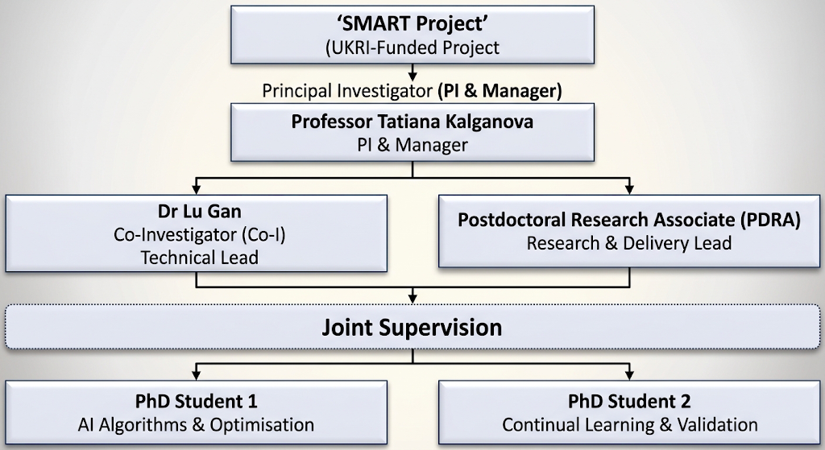



Person Specification

As part of the University’s commitment to the Disability Confident Scheme – Offer an Interview Commitment. Applicants who choose to apply through the scheme, and who meet the minimum criteria for the role, will be offered an interview.

Attributes | Criteria | Essential /Desirable
Education, qualifications & training | Degree in subject relevant to research  Working towards a PhD in appropriate Discipline (specify area)  OR  Equivalent research, industrial or commercial experience. (Minimum 4 years) | E  D
Experience | Some evidence of research attainment including examples of contributing to academic publications  Evidence of successful delivery of components of original research projects  Proven experience of planning research activities and preparing research proposals. | E  E  D
Knowledge Skills & Abilities | Comprehensive and up-to-date knowledge of the subject specialism  Knowledge of project-specific equipment, IT skills or techniques (specify as required)  Excellent verbal and written communication skills, particularly when demonstrating the results of own research to both specialists and non-specialists  Ability to draft research papers for publication in appropriate academic journals  Ability to work largely on own initiative with minimum supervision  Ability to give presentations at academic and non-academic conferences and meetings  Understanding of, and a commitment to, open research as appropriate to the discipline (open data, code, educational resources etc)  Evidence of collegiality, including willingness to support the career development of students and colleagues | E  E  E  E  E  E  E  E
Additional Requirements  (not included above) | Aligned with Brunel’s values of being open, courageous and inventive  Committed to fostering an equitable and inclusive workplace  A flexible approach to changing demands of a service | E  E  E

*Where a large pool of applicants meet the essential criteria, the desirable criteria will be used as part of the first stage of short listing.

JOB HAZARD DECLARATION
A job specific risk assessment has been undertaken, and recorded, for this post.
Yes ☒ No ☐
The risk assessment has identified the need for Health Surveillance.
Yes ☐ No ☒
If you have selected “Yes” then please specify:
- What type of surveillance is required and why?

- Whether or not you have sought advice from Occupational Health or the Health, Safety & Environment Team?

The work involved requires vaccination.
Yes ☐ No ☒
If you have selected “Yes” then please specify:
- What type of Vaccination is required and why?

- Whether or not you have sought advice from Occupational Health or the Health, Safety & Environment Team?

For inclusion with job description:
Please provide answers to the following questions. Please add additional items as necessary. For further advice please contact healthandsafety@brunel.ac.uk (“No” responses should be deleted before advertising.)

- This role involves working with Display Screen Equipment for extended periods of more than 1 hour per day.
Yes ☒ No ☐

- This role involves frequent manual handling and/or may be physically demanding.
Yes ☐ No ☒

- This role involves working outside for long periods of time.
Yes ☐ No ☒

- This role involves working at Height.
Yes ☐ No ☒

- This role involves work in confined spaces.
Yes ☐ No ☒

- This role involves working in a noisy environment.
Yes ☐ No ☒

- This role involves Travel.
Yes ☒ No ☐

- This role involves regular work with vibrating equipment.
Yes ☐ No ☒

- This role involves driving.
Yes ☐ No ☒

The information provided above is, to the best of my knowledge, true and accurate.

Name: prof Tatiana Kalganova | Signature: Tatiana Kalganova | Date: 12/10/2026

