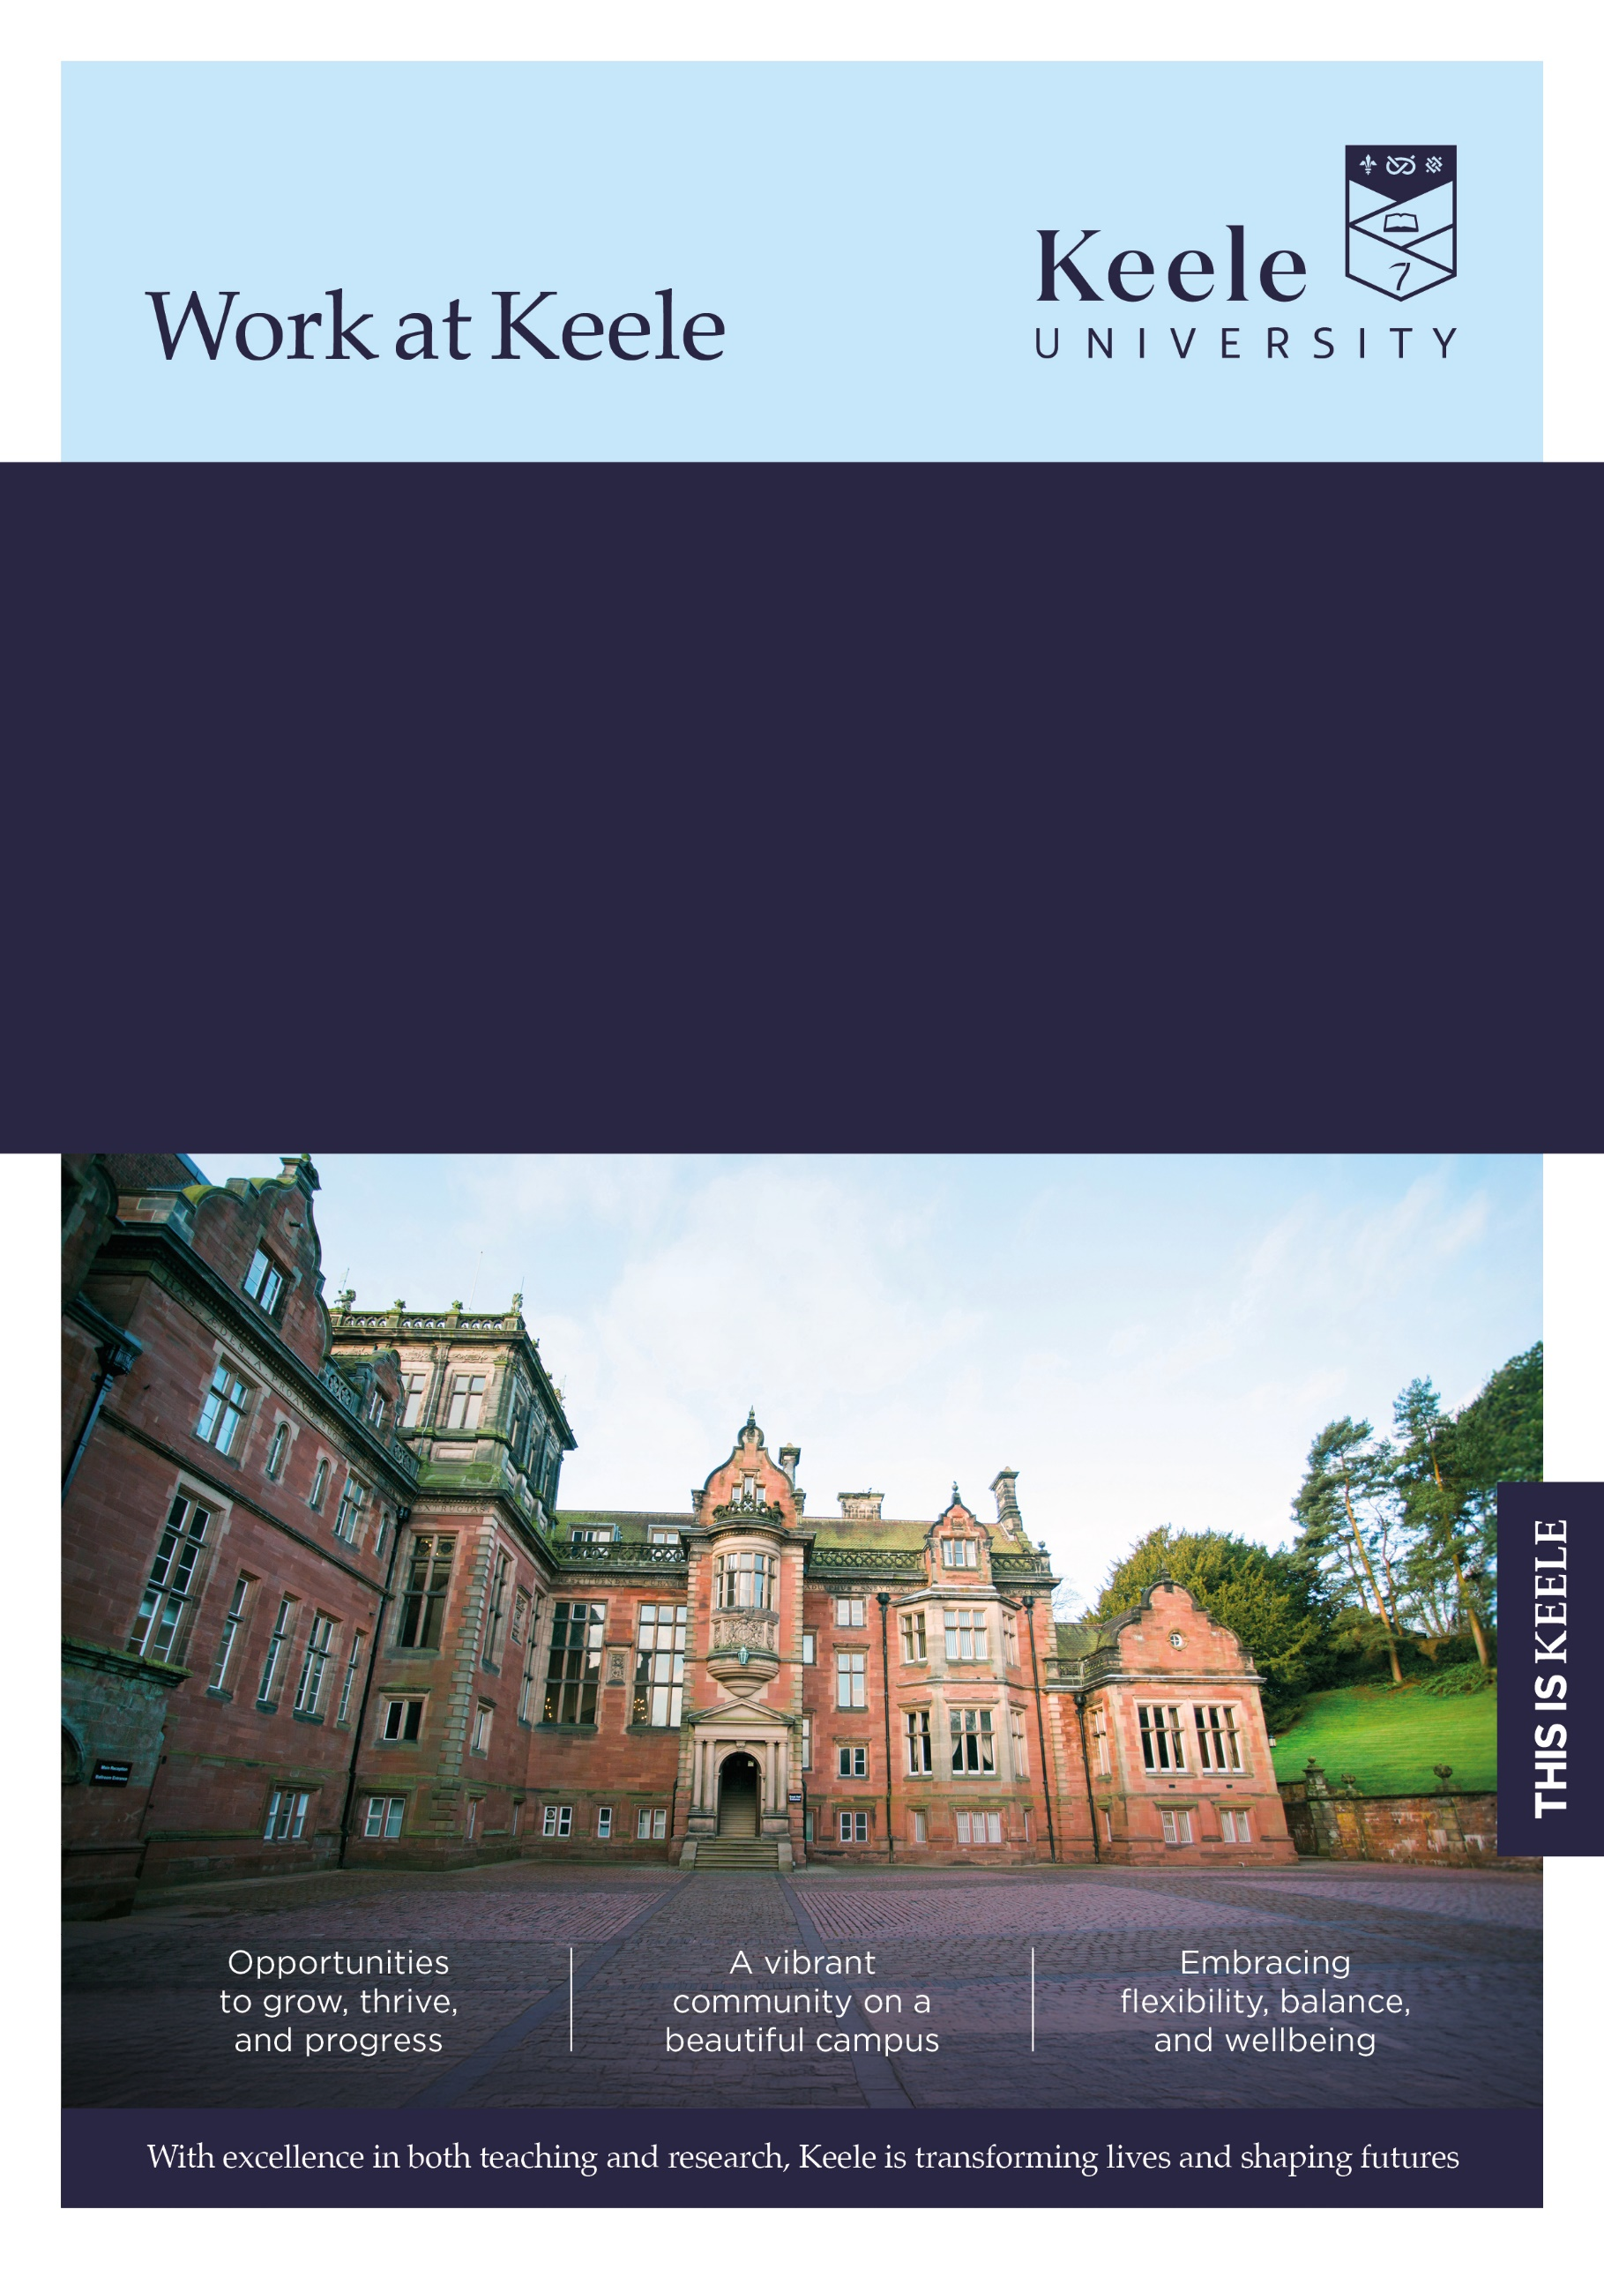
Faculty/Directorate: Faculty of Medicine and Health Sciences
Dept/School: School of Medicine
Location: Hybrid
Grade: 4
Salary Range: £25,179 - £27,241 (Pro rata)
Part Time (21.75 hours per week 0.6 FTE)
Term: Permanent
Responsible to: Team Co-ordinator
Job Ref: KU00005476

Faculty Undergraduate Courses Administrator

Thank you for considering a role at Keele University.

Inside this document, you'll discover key details about the job and our diverse and vibrant institution. We invite you to explore the impressive benefits that come with joining our community - just click here to learn more about our values and what makes Keele a fantastic place to work.

The Role

The post holder will be part of a team of undergraduate course administrators who will work across Schools within the Faculty supporting a defined range of programmes to provide an effective and efficient administration service to staff and students.

Main Duties and Responsibilities

  - Receive and respond to everyday enquiries from customers to provide a timely, courteous and effective service to key stakeholders, escalating more complex queries to senior colleagues.

  - Prepare and update key business documentation to a clear brief using established formats and standard software and/or University systems.
  - Collate, record, store and archive data and information to required standards to ensure the accuracy and safety of information.

  - Run and present standard reports to support effective Department/School/University information processes.

  - Prepare straightforward analysis of information and data as required.

  - Assess the impact of day-to-day routine problems that may arise, and devise a range of solutions to ensure appropriate resolution of customer queries or other issues.

- Provide a comprehensive administrative service to various committees/team meetings, including preparing agendas, taking minutes and liaison with internal and external colleagues, and documenting/undertaking follow-up actions where appropriate.

- Make venue, catering, travel and/or equipment arrangements for events, meetings and activities.

- Contribute to the planning of team activities and deadlines to ensure the smooth running and timeliness of service.
- Plan and prioritise own work tasks for weeks ahead to ensure work is completed to time and appropriate standard.
  - Maintain and administer appropriate University systems to ensure the data held is accurate and up to date.

- Liaise and communicate effectively with representatives from other service areas, professional organisations and external agencies, as required, in order to share and receive information relevant to the role activities.

- Work flexibly within the team, providing colleagues with general assistance and support to ensure the effective day-to-day operation of administrative service. Take opportunities to share ideas and skills across the team.

- Suggest improvements to current methods and processes and be willing to change practices to improve current ways of working.

- Actively participate in the organisation and running of University and School events such as open days, clearing, induction and graduation events.

This job description is not intended as an exhaustive list of duties or a restrictive definition of the post but rather should be read as a guide to the main priorities and typical areas of activity of the post-holder. These activities are subject to amendment over time as priorities and requirements evolve and as such it may be amended at any time by the line manager following discussion with the post holder.

In addition, University staff are expected to:

We believe that diversity in its many forms is a strength that underpins the exchange of ideas, innovation and debate. We are committed to providing an environment in which all members of our community can reach their full potential and are treated with dignity and respect.

Our policy and procedure framework has been developed to ensure that we meet our statutory obligations whilst also setting out the obligations of colleagues to contribute to providing an inclusive environment for all, irrespective of an individual’s background, views or beliefs.

All University staff are expected to:

Take reasonable care of the Health and Safety of yourself and that of any other person who may be affected by your acts or omissions at work.

Adhere to regulations and procedures relating to data protection and information security.

Co-operate with the University in ensuring as far as is necessary, that Statutory Requirements, Codes of Practice, University Policies and Procedures at both University and Departmental level are complied with.

Ensure robust procedures and processes are followed for services and products that are procured and undertaken in line with prevailing legislation, statutory obligations and policies.

Adhere to the University’s environmental policy and procedures and seek to implement mechanisms which will enhance environmental sustainability within your area of responsibility.

Undertake continuing Personal/Professional Development and to engage with appropriate development activities to ensure that your skills and knowledge enable you to meet current and future role requirements.

Contribute to the delivery of the University’s Vision and Values as appropriate to your role. Further information regarding the University’s Values and Behaviours Framework can be found on the Staff Intranet which has been put in place to underpin how we work together in delivering an environment which values both difference and inclusion



The Person
Selection Criteria | Essential (E) or  Desirable (D) | Evidenced by:  Application (A)  Interview (I)  Test (T)  Presentation (P)
Qualifications / Training
4 GCSEs (or equivalent) at  grade C or above including Maths and English  or  equivalent relevant experience | E | A
NVQ3 in Business Administration or working towards this. | D | A
Experience
Recent experience of working to administrative processes including: | E | A,I
Experience of data and systems administration | E | A, I
Experience of providing excellent customer service | E | A, I
Experience of managing time in order to meet deadlines | E | A, I
Experience of generating reports and straightforward analysis of data | E | A, I
Experience of organising meetings and undertaking associated administration including minute taking | E | A,I
Experience of administrative processes within an academic setting | D | A, I
Skills / Aptitudes / Competences
Excellent IT skills, including proficiency in the use of Microsoft 365, including Word and Excel and the ability to use databases. | E | A, I
Experience of systems and databases such as SCIMS (SITS), e-vision/a virtual learning platform | D | A,I
Ability to communicate effectively and establish good working relationships with a wide variety of stakeholders including staff, students and external stakeholders. | E | A, I
Good written communications skills | E | A, I
Ability to complete work accurately and with good attention to detail | E | A, I
Ability to work flexibly in response to changing requirements | E | A, I
Ability to act on own initiative while meeting the needs of the wider team | E | A, I
Ability to work independently and to prioritise a varied workload | E | A, I
Ability to work effectively as part of a team | E | A, I
Proficient understanding of office procedures and policies | E | A, I
Other
Understanding and awareness of confidentiality and its importance | E | A, I
Ability to work flexibly according to the demands of the role / to support the needs of the service | E | A, I
Committed to continuous improvement and professional development, undertaking training as required. | E | A,I

Further Information

Closing date for applications: 08/11/2026

How to Apply
For full post details and to apply, please visit: www.keele.ac.uk/jobs.

Keele University employees wishing to apply for this vacancy should login to Employee Self Service and click on the 'View current vacancies' link.

Eligibility to Work

This post is unlikely to meet the relevant criteria to allow the University to issue a Certificate of Sponsorship. Applications from candidates who require a Certificate of Sponsorship to work in the UK will be considered against the requirements stated in the recruitment documentation. Recruitment decisions will be made in accordance with the UK Visas and Immigration guidance.

References
You will be asked to supply details by two individuals (three if you are applying for an academic or research post), that can provide relevant and credible insights into your employment details and suitability for the role. This will include a reference from your current line manager (or most recent line manager if currently unemployed), and your next most recent employer (where applicable). In providing these details you are giving the University permission to request personal information about you from your referees, which may include confirmation of your previous salary, disciplinary and work history.

For graduates or candidates with limited work experience, references may be provided by individuals who can speak to your achievements and skills in other areas such as academia, volunteering or extracurricular activities.

With your consent, the University may request additional references if it is felt these are necessary to provide a more comprehensive understanding of your suitability for the role.

Further information regarding references can be found here: www.keele.ac.uk/jobs/vacanciesfaqs

Disability Confident
Keele University is committed to taking positive steps to employ, keep and develop the abilities of disabled staff and has been awarded the disability symbol. We undertake to offer all applicants with a disability and who meet the minimum essential criteria an interview. If you wish to be considered under this scheme, please indicate this by selecting ‘Yes’ in the Guaranteed Interview Scheme Section of your application. You can also provide specific information of any requirements / adjustments you may require to assist you during the recruitment process within this section. For advice or guidance please contact the Recruitment Team email: vacancies@keele.ac.uk.

The information you provide on your application will be forwarded to the recruiting area so that they may consider whether they can facilitate your requested adjustments. Please note that if you do not indicate that you wish to be considered under the Disability Confident scheme in your application, you will not be considered under this Scheme.

Alternative Formats
If you have any other requirements that will help you access the application or interview process, or require documents in alternative formats, please contact vacancies@keele.ac.uk.

About Keele

We're Keele and we're different. Founded 75 years ago to meet the demands of a new kind of society, economy and world, our principles resonate now more than ever.

We are a campus university with over 15,000 students, nestled in 600 acres of Staffordshire countryside and just an hour from Manchester and Birmingham. It's a big campus but a small and cosmopolitan community, with space to think and plenty to do.

Our research seeks to improve lives and address the most pressing challenges across our region, country, and world. Our academics are actively studying matters of global importance: from food security, climate change and smart energy, to neglected tropical diseases, global health and sustainable futures.

As well as world-leading research (Research Excellence Framework, 2021), Keele also sets the gold standard for teaching, with some of the most satisfied students in the country – in 2022, students ranked us “Britain’s best university” in the Student Crowd University Awards, and in 2023 we were awarded the highest rating of “Gold” overall in the Teaching Excellence Framework.

For more information about the benefits of working at Keele University, visit www.keele.ac.uk/jobs.



