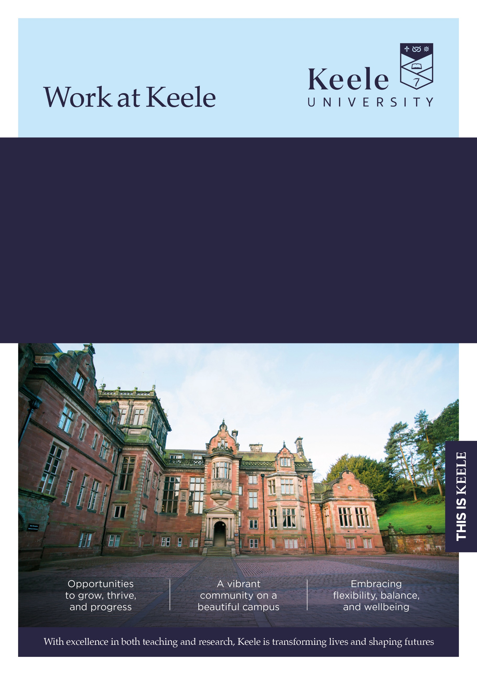
Faculty/Directorate: Business, Law, Humanities and Social Sciences
Dept/School: Humanities and Social Sciences
Location: Campus
Grade: 7a
Salary Range: £41,885, - £48,337 pro rata
Part Time: 0.5fte, 17.5 hours
Term: Permanent
Responsible to: Head of School of Humanities and Social Sciences
Job Ref: KU00005382

Lecturer in Creative Writing (Crime Fiction) (Education & Research)

Thank you for considering a role at Keele University.

Inside this document, you'll discover key details about the job and our diverse and vibrant institution. We invite you to explore the impressive benefits that come with joining our community - just click here to learn more about our values and what makes Keele a fantastic place to work.

The Role

The post holder will contribute to the delivery, development and enhancement of teaching, learning and research within the School of Humanities and Social Sciences. They will support undergraduate and postgraduate programmes in Creative Writing, with specialism in Crime Fiction, while contributing to the wider academic activities of the School as appropriate. Experience of, or current work as, a published crime fiction author would be a distinct advantage.
The role involves delivering high-quality teaching, undertaking research and scholarly activity, contributing to curriculum and module development, and supporting student success and engagement. The postholder will also participate in the academic, administrative and collegial responsibilities required to support the effective operation and ongoing development of the School and University. The post is available on an indefinite, part-time (0.5fte) basis from January 2027.

Main duties and responsibilities

Education & Learning

- Work with colleagues in the School to deliver an exceptional, inclusive learning environment for students.
- Teach and inspire students across both undergraduate and postgraduate programmes.
- Develop teaching materials, ensuring that content, methods of delivery and learning materials meet the defined learning objectives and needs of students.
- With support from colleagues, engage in the evaluation and development of new and existing programmes.
- Select appropriate assessment instruments and provide constructive feedback to students.
- Provide academic and pastoral support for students.
- Supervise undergraduate student dissertations/projects, appropriate to needs of the School and in line with workload expectations.
Research
- Develop and conduct individual and collaborative research projects, using new research techniques and methods that contribute meaningfully to Keele’s research community and to the broader academic field
- Publish original Crime Fiction
- Use creativity to analyse and interpret research data and draw conclusions on the outcomes.
- Prepare proposals and applications to external bodies for funding.
- Engage with external bodies to achieve research impact and knowledge exchange as appropriate to research area.
- Write good quality publications for appropriate journals and produce peer-reviewed outputs of sufficient quality to impact on national/international research in line with School expectations.
- Contribute to potential REF impact case study, as appropriate.
- Engagement with local, national and international media contributions that stimulate public debate and understanding of field.
- Could be expected to supervise or co-supervise postgraduate students.

Leadership, Management & Engagement
- Contribute to collaborative decision making with academic colleagues on course development, curriculum changes and the development of research activity.
- Contribute to School objectives in relation to TEF and NSS (and other surveys).
- To actively contribute to the School's recruitment activities, including participating in the School's programme of Open and Offer Holder Days, and outreach activity.
- Support and implement university processes and activities relating to equity, diversity and inclusion relating to student need, success and experience
- Contribute to internationalisation in line with School strategic plans.
Team Work
- Contribute to the development and delivery of the objectives of the School, including attendance and participation at School and subject meetings.
- Liaising closely with colleagues to develop teaching and research areas within the School establishing where appropriate, cross-discipline initiatives.
Communication
- Communicate effectively across a wide range of audiences.
- Liaise, establish and maintain positive links with external agencies and providers.
Other
- Support other administrative, research, teaching or external engagement activities as required by the School.
- Participate in relevant meetings, committees and working groups within the School, Faculty and University.
- Observe and define priorities in the achievement of strategic and operational objectives.
- Undertake professional development in higher education practice to develop continuing excellence in teaching, learning and assessment

This job description is not intended as an exhaustive list of duties or a restrictive definition of the post but rather should be read as a guide to the main priorities and typical areas of activity of the post-holder. These activities are subject to amendment over time as priorities and requirements evolve and as such it may be amended at any time by the line manager following discussion with the post holder.

In addition, University staff are expected to:

We believe that diversity in its many forms is a strength that underpins the exchange of ideas, innovation and debate. We are committed to providing an environment in which all members of our community can reach their full potential and are treated with dignity and respect.

Our policy and procedure framework has been developed to ensure that we meet our statutory obligations whilst also setting out the obligations of colleagues to contribute to providing an inclusive environment for all, irrespective of an individual’s background, views or beliefs.

All University staff are expected to:

Take reasonable care of the Health and Safety of yourself and that of any other person who may be affected by your acts or omissions at work.

Adhere to regulations and procedures relating to data protection and information security.

Co-operate with the University in ensuring as far as is necessary, that Statutory Requirements, Codes of Practice, University Policies and Procedures at both University and Departmental level are complied with.

Ensure robust procedures and processes are followed for services and products that are procured and undertaken in line with prevailing legislation, statutory obligations and policies.

Adhere to the University’s environmental policy and procedures and seek to implement mechanisms which will enhance environmental sustainability within your area of responsibility.

Undertake continuing Personal/Professional Development and to engage with appropriate development activities to ensure that your skills and knowledge enable you to meet current and future role requirements.

Contribute to the delivery of the University’s Vision and Values as appropriate to your role. Further information regarding the University’s Values and Behaviours Framework can be found on the Staff Intranet which has been put in place to underpin how we work together in delivering an environment which values both difference and inclusion.



Selection Criteria | Essential (E) or  Desirable (D) | Evidenced by:  Application (A)  Interview (I)  Test (T)  Presentation (P)
Qualifications / Training
PhD in Creative Writing or other relevant experience as a practitioner | E | A
Higher Education Teaching Qualification/Advance HE (FHEA) or commitment to work towards in the first two years of employment | E | A, I
Experience
Undertaking quality research in relevant field | E | A, I
Publishing experience as a crime fiction author | E | A, I
Experience of teaching and assessment in relevant subject area | E | A, I, P
Experience of applying for funding opportunities | D | A, I
Evidence of participation in programme design and management of undergraduate/postgraduate modules | D | A, I, P
Experience of learning technologies applications | D | A, I, P
Skills / Aptitudes / Competences
Ability to produce high-quality publications | E | A, I
Ability to deliver high-quality and engaging teaching in the subject area | E | A, I, P
Ability to contribute to the development of modules and programmes | E | A, I, P
Ability to support and guide students in a pastoral capacity | E | A, I, P
Ability to work effectively independently and as a team member | E | A, I
Excellent communication, presentation and interpersonal skills | E | A, I, P
Competent in the use of Microsoft packages | E | A, I
Ability to develop effective working relationships across a broad range of stakeholders | E | A, I
Ability and willingness to contribute to the administration of modules, programmes and School organisation | E | A, I
Evidence of innovation in research and teaching | D | A, I, P
Other
Ability to collaborate with academic colleagues and external stakeholders on areas of shared research | E | A, I
Commitment to continuing professional development | E | A, I
Knowledge of equity and inclusion challenges in the context of how these may impact academic content and issues relating to student need, success and experience. | E | A, I, P

Further Information

Closing date for applications: 09/11/2026

Interviews will be held on: 26/11/2026

How to apply
For full post details and to apply, please visit: www.keele.ac.uk/jobs.

Keele University employees wishing to apply for this vacancy should login to Employee Self Service and click on the 'View current vacancies' link.

Eligibility to work

This post may meet the relevant criteria to allow the University to issue a Certificate of Sponsorship to individuals who wish to come to work in the UK through the Skilled Worker Route of the UK Immigration System. For information on the sponsorship system, please visit the UK Visas and Immigration website at https://www.gov.uk/government/organisations/uk-visas-and-immigration. You are advised to assess your circumstances against the criteria set out in the UKVI policy guidance, available at https://www.gov.uk/browse/visas-immigration. UK ENIC provides advice and guidance on international qualifications at UK ENIC Visas and Nationality

References
You will be asked to supply details by two individuals (three if you are applying for an academic or research post), that can provide relevant and credible insights into your employment details and suitability for the role. This will include a reference from your current line manager (or most recent line manager if currently unemployed), and your next most recent employer (where applicable). In providing these details you are giving the University permission to request personal information about you from your referees, which may include confirmation of your previous salary, disciplinary and work history.

For graduates or candidates with limited work experience, references may be provided by individuals who can speak to your achievements and skills in other areas such as academia, volunteering or extracurricular activities.

With your consent, the University may request additional references if it is felt these are necessary to provide a more comprehensive understanding of your suitability for the role.

Further information regarding references can be found here: www.keele.ac.uk/jobs/vacanciesfaqs

Disability Confident
Keele University is committed to taking positive steps to employ, keep and develop the abilities of disabled staff and has been awarded the disability symbol. We undertake to offer all applicants with a disability and who meet the minimum essential criteria an interview. If you wish to be considered under this scheme, please indicate this by selecting ‘Yes’ in the Guaranteed Interview Scheme Section of your application. You can also provide specific information of any requirements / adjustments you may require to assist you during the recruitment process within this section. For advice or guidance please contact the Recruitment Team email: vacancies@keele.ac.uk.

The information you provide on your application will be forwarded to the recruiting area so that they may consider whether they can facilitate your requested adjustments. Please note that if you do not indicate that you wish to be considered under the Disability Confident scheme in your application, you will not be considered under this Scheme.

Alternative formats
If you have any other requirements that will help you access the application or interview process, or require documents in alternative formats, please contact vacancies@keele.ac.uk.

About Keele

We're Keele and we're different. Founded 75 years ago to meet the demands of a new kind of society, economy and world, our principles resonate now more than ever.

We are a campus university with over 15,000 students, nestled in 600 acres of Staffordshire countryside and just an hour from Manchester and Birmingham. It's a big campus but a small and cosmopolitan community, with space to think and plenty to do.

Our research seeks to improve lives and address the most pressing challenges across our region, country, and world. Our academics are actively studying matters of global importance: from food security, climate change and smart energy, to neglected tropical diseases, global health and sustainable futures.

As well as world-leading research (Research Excellence Framework, 2021), Keele also sets the gold standard for teaching, with some of the most satisfied students in the country – in 2022, students ranked us “Britain’s best university” in the Student Crowd University Awards, and in 2023 we were awarded the highest rating of “Gold” overall in the Teaching Excellence Framework.

For more information about the benefits of working at Keele University, visit www.keele.ac.uk/jobs.



