
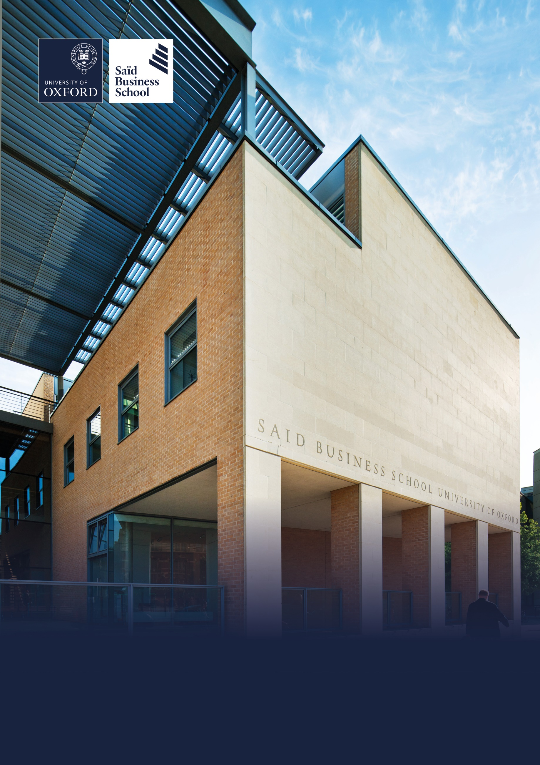

Hybrid (two days per week onsite), Park End Street, Oxford
Grade 5: £32,108 - £37,338 per annum including the Oxford University weighting of £1,730 per annum
Permanent, full time (36.5 hours per week)
Reporting to: MBA Recruitment and Admissions Manager
Saïd Business School, Social Science Division, University of Oxford

MBA Recruitment Advisor(Two Roles available)


The role
The Recruitment Advisor is responsible for executing the recruitment process, under the supervision of the MBA Recruitment & Admissions Manager, ensuring that it is operated in a timely and efficient manner. The post holder will utilise in-depth specialist knowledge of the programme and wider marketplace to provide advice to applicants and build an effective pipeline of incoming MBA students.

Responsibilities
- Responsible for answering prospective applicants’ enquiries and supporting their application journey

- Establish and manage strong relationships with prospective applicants and applicants. Provide high level guidance and advice to prospective applicants about their suitability for the various programmes sharing high quality applicants with the recruitment pod

- Manage drop-ins and candidates visits to school, liaising with Faculty and current students.

- Responsible for offering high level guidance to candidates in regards various programme, the business school and the wider university

- Undertake agreed activities that support the conversion and yield of offer holders into deposit-paid students

- Help organise large School events such as Open Day and Experience Weekends

- Review where required the text for the brochures, website and intranet and advice on improvements and changes

- Support admissions activities as and when required by the admissions pod

- Establish and manage strong relationships with prospective applicants. Provide informed guidance and advice to prospective applicants about their suitability for the MBA programme.
- Establish and manage relationships to a high level with the Recruitment, Marketing, Careers, Course and Alumni departments to enhance the application experience of prospective students

Selection criteria

Essential selection criteria
- Effective and engaging communicator both written and verbal.

- Highly developed planning and time management skills, with the ability to anticipate and address workflow challenges and deadlines

- Teamwork oriented

- Discretion, tact and ability to maintain confidentiality

- Resilience with the ability to question decisions made by others

- Proven organisational skills including the ability to work accurately with attention to detail

- Comfortable in a customer-facing role, with a strong personal commitment to customer care, an enthusiasm for meeting people and a cross-cultural awareness

- The ability to use initiative and to solve problems; to work in a busy, sometimes pressurised environment; having a flexible approach to work and the duties to be carried out

- Excellent IT skills, including previous experience of Word, Excel, PowerPoint, Outlook, and the internet

Desirable selection criteria
- Previous recruitment and admissions experience

- Degree in related field, or demonstrable experience working in business development, recruitment, sales, or relationship management

Pre-employment screening

Standard checks
If you are offered the post, the offer will be subject to standard pre-employment checks. You will be asked to provide: proof of your right-to-work in the UK; proof of your identity; and (if we haven’t done so already) we will contact the referees you have nominated. If you have previously worked for the University we will also verify key information such as your dates of employment and reason for leaving your previous role with the department/unit where you worked. You will also be asked to complete a health declaration so that you can tell us about any health conditions or disabilities for which you may need us to make appropriate adjustments.


Please read the candidate notes on the University’s pre-employment screening procedures at Pre-employment checks (https://hr.admin.ox.ac.uk/pre-employment-checks).


About the University of Oxford
Welcome to the University of Oxford. We aim to lead the world in research and education for the benefit of society both in the UK and globally. Oxford’s researchers engage with academic, commercial and cultural partners across the world to stimulate high-quality research and enable innovation through a broad range of social, policy and economic impacts.

We believe our strengths lie both in empowering individuals and teams to address fundamental questions of global significance, while providing all our staff with a welcoming and inclusive workplace that enables everyone to develop and do their best work. Recognising that diversity is our strength, vital for innovation and creativity, we aspire to build a truly diverse community which values and respects every individual’s unique contribution.

While we have long traditions of scholarship, we are also forward-looking, creative and cutting-edge. Oxford is one of Europe’s most entrepreneurial universities and we rank first in the UK for university spin-outs, and in recent years we have spun out 15-20 new companies every year. We are also recognised as leaders in support for social enterprise.

Join us and you will find a unique, democratic and international community, a great range of staff benefits and access to a vibrant array of cultural activities in the beautiful city of Oxford. For more information, please visit How we are run (https://www.ox.ac.uk/about/how-we-are-run).

Saïd Business School
Saïd Business School blends the best of new and old. We are a vibrant and innovative business school, but yet deeply embedded in an 800 year old world-class university. We create programmes and ideas that have global impact. We educate people for successful business careers, and as a community seek to tackle world-scale problems.

We deliver cutting-edge programmes, including the highly regarded MBA, Executive MBA, a number of specialist MScs, a portfolio of custom and open programmes and accredited diplomas for executives, and we undertake ground-breaking research that transform individuals, organisations, business practice and society. We are an international and outward looking School with our programme participants coming from more than 50 countries.

We seek to be a world-class business school community, embedded in a world-class University, tackling world-scale problems.

Sustainability
Saïd Business School is committed to the highest standards of environmental sustainability, preserving the planet for future generations and acting in a socially sustainable manner. As an employee you are expected to uphold these commitments in accordance with our Environmental Policy. You can learn more about our organisation’s sustainability efforts at Sustainability | Saïd Business School (https://www.sbs.oxford.edu/about-us/school/sustainability).

Diversity and Inclusion
Oxford Saïd is committed to fostering an inclusive culture which promotes equality, values diversity and maintains a working, learning and social environment in which the rights and dignity of all its staff and students are respected. We recognise that the broad range of experiences that a diverse staff and student body brings strengthens our research and enhances our teaching, and that in order for Oxford to remain a world-leading institution we must continue to provide a diverse, inclusive, fair and open environment that allows everyone to grow and flourish.

Oxford Saïd holds a bronze Athena Swan award to recognise advancement of gender equality: representation, progression and success for all.

Our Values
To better understand our Values, what behaviours demonstrate them and how they are involved in your everyday work we have created the below descriptors.

Transformational
We challenge constructively, provoke thought, and influence and inspire others to develop.

Respectful
We are caring, supportive, appreciative, embrace difference and value each other's opinions.

Entrepreneurial
We embrace and encourage change and innovation. We are creative, flexible and brave.

Collaborative
We are stronger together. We are inclusive, approachable, listen to others and value good communication.

Purposeful

We are a community who believe in sustainable growth, and are responsible, principled and transparent.

Excellence
We are professional, focused and aligned, and have a responsibility to do the very best we can.

Wellbeing
Saïd Business School acknowledge the importance of wellbeing, in enabling people to thrive at work and ensure a work-life balance. It provides a number of initiatives to help support wellbeing and would encourage you to participate. At an individual level, wellbeing means recognising what helps us remain resilient and taking appropriate steps. If we experience difficulties, doing our best to rectify them and making our line manager aware of aspects that they could support us with.

Further information about Saïd Business School is available at Saïd Business School (www.sbs.oxford.edu).

Social Sciences
Oxford Saïd is a department within the Social Sciences Division, one of four academic Divisions in the University, each with considerable devolved budgetary and financial authority; and responsibility for providing a broad strategic focus across its constituent disciplines.

The Social Sciences Division represents the largest grouping of social sciences in the UK: home to a number of outstanding departments and to the internationally ranked Law Faculty; all are committed to research to develop a greater understanding of all aspects of society, from the impact of political, legal and economic systems on social and economic welfare to human rights and security. That research is disseminated through innovative graduate programmes and enhances undergraduate courses. For more information please visit Social Sciences Division (https://www.socsci.ox.ac.uk).


How to apply
Applications are made through our online recruitment portal. Information about how to apply is available on our Jobs website at How to apply (https://www.ox.ac.uk/about/jobs/explore-our-careers/applications-process/how-to-apply).

Your application will be judged solely on the basis of how you demonstrate that you meet the selection criteria stated in the job description.

As part of your application you will be asked to provide details of two referees and indicate whether we can contact them now.

You will be asked to upload a CV and a supporting statement. The supporting statement must explain how you meet each of the selection criteria for the post using examples of your skills and experience. This may include experience gained in employment, education or during career breaks (such as time out to care for dependants).

Please upload all documents as PDF files with your name and the document type in the filename.

All applications must be received by midday UK time on the closing date stated in the online advertisement.

Information for internal candidates
If you currently work for the University please note that:

- As part of the referencing process, we will contact your current department to confirm basic employment details including reason for leaving.

- Although employees may hold multiple part-time posts, they may not hold more than the equivalent of a full time post. If you are offered this post, and accepting it would take you over the equivalent of full-time hours, you will be expected to resign from, or reduce hours in, your other post(s) before starting work in the new post.

- Before applying for this post, you are advised to read the Internal Mobility Principles (https://hr.admin.ox.ac.uk/internal-mobility-principles). The principles promote good practice for moving into professional services roles and are designed to provide clarity on expectations for managers and individuals.

Information for priority candidates
A priority candidate is a University employee who is seeking redeployment because they have been advised that they are at risk of redundancy, or on grounds of ill-health/disability. Priority candidates are issued with a redeployment letter by their employing department(s).

If you are a priority candidate, please ensure that you attach your redeployment letter to your application (or email it to the contact address on the advert if the application form used for the vacancy does not allow attachments).

If you need help
Application FAQs, including technical troubleshooting advice is available at Support with your online job application (https://staff.web.ox.ac.uk/recruitment-support-faqs).

Non-technical questions about this job should be addressed to HR.Recruitment@sbs.ox.ac.uk.

To return to the online application at any stage, please go to Job Search (www.recruit.ox.ac.uk).

Please note that you will receive an automated email from our online recruitment portal to confirm receipt of your application. Please check your spam/junk mail if you do not receive this email.


Important information for candidates

Data Privacy
Please note that any personal data submitted to the University as part of the job application process will be processed in accordance with the GDPR and related UK data protection legislation. For further information, please see the University’s Privacy Notice for Job Applicants at Job applicant privacy policy (https://compliance.admin.ox.ac.uk/job-applicant-privacy-policy).

The University’s Policy on Data Protection is available at Data protection policy (https://compliance.admin.ox.ac.uk/data-protection-policy).

The University’s policy on retirement
The University operates an Employer Justified Retirement Age (EJRA) for very senior research posts at grade RSIV/D35 and clinical equivalents E62 and E82 of 30 September before the 70th birthday. The justification for this is explained at The EJRA (https://hr.admin.ox.ac.uk/the-ejra).

For existing employees, any employment beyond the retirement age is subject to approval through the procedures. Please see The EJRA (https://hr.admin.ox.ac.uk/the-ejra).

There is no normal or fixed age at which staff in posts at other grades have to retire. Staff at these grades may elect to retire in accordance with the rules of the applicable pension scheme, as may be amended from time to time.

Equality of opportunity
The University of Oxford is committed to equal opportunity and to being a place where everyone belongs and is supported to succeed. We recognise how the diversity of our community enriches our ability to deliver on our academic mission.

We welcome applications from individuals from all backgrounds, including those underrepresented within higher education. No applicant or member of staff shall be unlawfully discriminated against on the basis of age, disability, gender reassignment, marriage or civil partnership, pregnancy or maternity, race, religion or belief, sex or sexual orientation.

Employment with the University and progression within employment will be determined according to personal merit and the application of criteria related to the duties and conditions of the post. In all cases, the primary consideration will be the ability to perform the job.

As stated in the University’s Equality Policy and Equality, Diversity and Inclusion Strategic Plan, our commitment to equality and diversity goes hand in hand with our commitment to academic freedom and free speech.


Oxford Saïd Exclusive Benefits

Wellbeing initiatives
Oxford Saïd runs an annual Wellbeing Day for all staff. In addition to this, there is yoga, healthy food deliveries, health MOTs and a range of other ad hoc programmes. Our excellent catering facilities provide a high standard of food, including healthy eating and vegetarian options at a subsidised cost.

Staff Summer and Christmas parties
Oxford Saïd like to reward all of their staff for their great work and their Christmas and Summer parties are our way of saying thank you. The Christmas party is for all staff and the summer party is for staff and their immediate family members, because we know how important family is to all of us.

Employee Assistance provider
Spectrum.Life is an employee assistance and wellbeing consultancy that works in partnership with the Business School to provide staff and their immediate family with a free 24-hour per day helpline providing confidential information and counselling services on personal issues.

University of Oxford Benefits

Annual leave
38 days (inc. public holidays). Long service additional annual leave – up to 5 days per annum, pro rata for part time employees. Previous service within higher education sector can be recognised. An additional scheme enables staff to request to purchase up to 10 additional days in each holiday year.

Salary and salary sacrifice schemes
The University salary and grading structure allows for annual incremental progression until a scale-bar point is reached. This incremental progression is automatic. Additionally, there are salary sacrifice schemes for bicycles and electric cars. See Staff benefits (https://hr.admin.ox.ac.uk/staff-benefits).

Pension
If you are on an academic or academic related pay scale (grade 6 or above), you are automatically a member of USS. Employer contribution is 14.5% and Employee contribution is 6.1%.

If you are on a pay scale other than academic or academic related (grade 1-5) you are automatically a member of OSPS. Employee contribution can be between 4%- 8% and Employer contribution 10%-14%.

University discounts
All University staff can purchase a TOTUM discount card for £14.99 for 12 months (£24.99 for 2 years, £34.99 for 3 years) which gives access to numerous exclusive offers and discounts from many popular retailers. There are a wide range of other discounts from external companies available using a university card.

University Club
Membership of the University Club is free for all University staff. The University Club offers social, sporting and hospitality facilities. Staff can also use the University Sports Centre on Iffley Road at discounted rates, including a fitness centre, powerlifting room and swimming pool. See The University Club (www.club.ox.ac.uk) and Oxford University Sport (https://www.sport.ox.ac.uk).

Access to Oxford buildings
Free access to a number of Oxford colleges, Botanic Gardens, Harcourt Arboretum, Wytham Woods and discount at numerous restaurants/shops.



Saïd Business School
University of Oxford
Park End Street
Oxford, OX1 1HP
Saïd Business School, University of Oxford
United Kingdom
www.sbs.oxford.edu

All information is correct at the time of going to press.

Please check our website for the most up-to-date information.

