

Position Title | Senior Technician (Model Making and Manufacturing) | Position No. | 10549
College/Department/ Directorate | Professional Services/Student Journey/Technical Services
Grade | Grade 5 - Technician  Grade 6 - Senior Technician
Reporting To | Technical Manager - Design & Manufacturing
Date reviewed | September 2026

Role Summary
The post holder will have practical experience in model making, machining and workshop-based manufacturing processes, with the ability to support the production of models and prototypes using a range of materials and manufacturing techniques with the Design and Manufacturing workshops within CEDPS.
Working as part of the wider Technical Services team, the post holder will play a key role in supporting the safe, compliant and effective operation of the Design and Manufacturing workshops. Through the application of technical knowledge, practical workshop skills and manufacturing expertise, they will contribute to a positive and engaging student experience, supporting the development of models, prototypes and project work, consultancy projects, as well as supporting research initiatives.
The post holder will promote high standards of health and safety in accordance with Brunel University of London policies and current legislation. They will provide supervised access to workshop machinery and equipment, deliver equipment inductions, support competency assessments and maintain accurate records to ensure safe and effective workshop use.
The role will provide day-to-day technical support to students and staff, offering guidance on material selection, manufacturing techniques, fabrication processes and model assembly plans. The post holder will be expected to develop and maintain competence across a broad range of workshop equipment, including hand and power tools, saws, lathes, mills, laser cutters, CNC machinery, spray booths and other model-making equipment.
The post holder will contribute to routine equipment maintenance, stock control, consumables management, workshop administration and the preparation of facilities for teaching, research and student projects. They will help maintain a safe, organised and professional workshop environment that supports creativity, innovation and practical learning.
The post holder will actively promote a culture of creativity, innovation and practical learning, encouraging students to develop confidence in design, manufacturing and prototyping processes. They will contribute to the continued development of the University's technical provision and will provide support for exhibitions, outreach activities, open days and showcase events, including Made in Brunel, representing the Design and Manufacturing workshops and their capabilities to a range of internal and external stakeholders.

Key duties and responsibilities

- Supports practical teaching activities and workshop-based learning across Design and Manufacturing disciplines.

- Sets and monitors technical standards for self and where appropriate, a small team in area of specialty, ensuring personal familiarity with the relevant equipment and software is maintained.

- Proactively contributes to the development of new or improved methods / techniques / equipment systems / facilities.

- Assists and advises students and staff in preparation and use of equipment and advises on safe systems and techniques.

- Supports learning and education through training, development and demonstration of equipment/ techniques and student facilitation at a specialist level.

- Carries out a range of repairs, maintenance and servicing diagnosing faults and problems.

- Adheres to and advises others on H&S policy and practice with good knowledge of regulations such as COSHH and Risk Assessment. Takes responsibility for ensuring room and project level risk assessments are complete, up to date and of suitable quality.

- Provides guidance to colleagues through on-the-job training/mentoring.

- Prepares and carries out a range of tests/experiments/diagnostics.

- Analyses and interprets data and presents findings.

- Extracts information from databases, identifying trends.

- Investigates and devises solutions to facilitate the service, support teaching etc.

- Writes short reports and detailed instruction documents.

- Manages day-to-day operational issues, making decisions on everyday matters, within area of responsibility/expertise.

- Plans and priorities work schedule and agrees specification/timeline for work to be done.

- Undertake compliance roles such as Fire Marshall, First Aider etc. as required.

- Liaises with the wider University and external consultants / suppliers, builds professional networks and can influence decision making.

- Be proactive in ensuring students and staff receive positive experience and courteous service.

- Advises on pricing and all aspects of purchasing and procurement; consulting with staff as required.

- Responsible for the procurement, stock control, and management of laboratory consumables and equipment, ensuring compliance with university procurement policies.

- Provides support to academic staff with their research requirements.

- Participates in Open Days and other key events as required.

Competencies of a Grade 6 Senior Technician pathway:

- Taking a leading role in the day-to-day technical operations and coordination of resources and facilities within the relevant area (i.e. all of the above)

- Develops, adapts and refines work practices in area of specialty, writing appropriate guidance documents / Standard Operating Procedures (SOP’s).
- Advises students and staff in the preparation and use of equipment; on safe systems and techniques at a specialist level and leads on demonstration / student facilitation ensuring courteous service delivery.
- Sets and monitors technical standards for self and where appropriate, other technical colleagues in area of specialty, making decisions as required.

- May coordinate / lead a small team and / or be responsible for service delivery, making decisions in regard to areas of responsibility, allocating work to colleagues and providing instruction, guidance and training as required.

- Carrying out complex analyses, interpreting results and recommending conclusions, presenting results, as appropriate.

- Apply technical knowledge to assess design feasibility and advise on appropriate manufacturing, fabrication, modelling and prototyping methods.

- Exercise technical judgement in selecting and adapting established manufacturing processes, materials, production methods and assembly techniques to meet project requirements.

- Investigate and resolve design and manufacturing problems, evaluating available options and recommending practical solutions within their area of technical expertise.

Other Duties:

- Undertake any other reasonable duties as required and commensurate with the grade of post in accordance with university and departmental policies, procedures and codes of conduct.

- Adhere to and comply with the provisions of the Data Protection Act and the Health and Safety at Work Act in accordance with university policies.

- Promote the University’s Environmental Policy and demonstrate commitment to it through actions and decision making.

- Actively participate in on going professional development activities as requested.

Our Values:
Our values play out across everything we do. We hold ourselves accountable to the highest standards in all our activities and decisions. They add value to both student and colleague experience at Brunel, helping us to deliver our strategy and plans.

Open We are welcoming and believe in the power of diversity. We are transparent in our decisions and deliver on what we say.

Courageous We seek and take on ambitious challenges. We are brave and committed to thinking differently. Nothing stops us from going after our goals.

Inventive: We are purposeful in an ever-changing world. Collaborating and innovating to reach our full potential and to change lives - and the world - for the better. We celebrate breakthroughs and strive for the best.

Organisational Structure Chart:

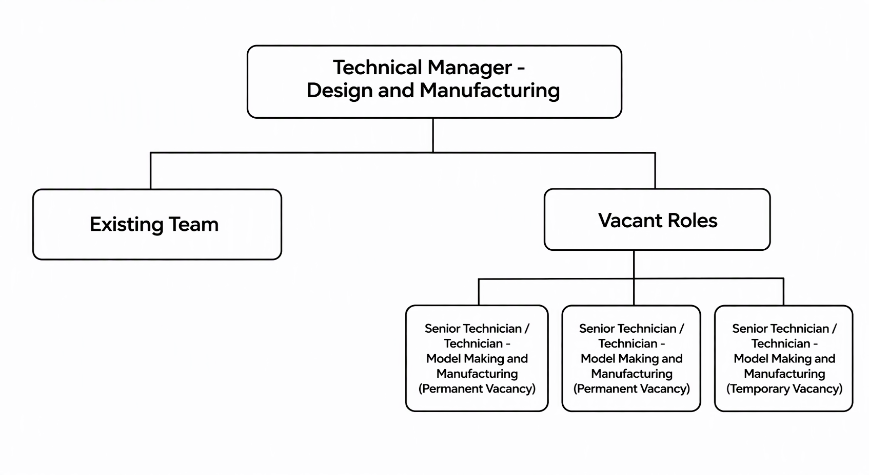



Person Specification

As part of the University’s Commitment to the Disability Confident Scheme – Offer an Interview Commitment, applicants who choose to apply through the scheme and who meet the minimum criteria for the role will be offered an interview.

Criteria |  | Essential /Desirable*
Education, qualifications and training | GCSE Maths & English grade 4 (C) or above/ equivalent  Technical qualification/ HNC/ NVQ 3 or degree or equivalent industrial experience  (G6 Senior Tech - Technical qualification/HNC/NVQ 4 or degree level)  Relevant practical experience in a technical/workshop-based environment  First Aider or willing to undertake training | E  E  E  E  D
Experience | Good prior work experience of a technical nature (eg. Product/ industrial design, model-making, prototyping, or machining/ manufacturing processes)  Experience of producing high-quality models and prototypes using a range of materials, including polyurethane resin board, natural timbers, sheet materials, plastics or metals.  Experiance using a range of specialist equipment eg. CAD / CAM programmes, manual machinery operative (Snr)  Experience of working with students and staff in a technical/practical environment  Supervisory experience (Snr)  A good understanding of H&S regulations and procedures  Experience of working with a variety of technical specialists from different disciplines (Snr)  Good general and specialist ICT skills | E  E  (E)D  D  (E)D  E  (E)D  E
Knowledge and Skills | Excellent standard of written and spoken English  Well-developed knowledge of H&S policies, including risk assessment and COSHH  Depth and breadth of knowledge in a relevant specialist area (Snr)  Able to effectively lead and motivate a team (Snr)  Able to work effectively within a team.  Knowledge of relevant materials and their appropriate use in the production of models and prototypes.  Able to demonstrate initiative to effectively resolve problems.  Demonstrate a proactive approach in supporting [a relevant function].  Able to work with minimal supervision  Demonstrate attention to detail in the completion of tasks as specified  Able to build productive working relationships with stakeholders (such as staff and students)  Able to effectively delegate tasks and make decisions  Ability to work with a variety of technical specialist from different disciplines  Ability to instruct and deliver information or briefing to the appropriate audience (Snr)  Able to communicate effectively with students and staff  Ability to instruct and demonstrate techniques to taught students (Snr)  Write and / or update Standard Operating Procedures (SOP) (Snr)  Ability to assist with the evaluation of practical assessments as required (Snr) | E  E  (E)D  (E)D  E  E  E  E  E  E  E  E  D  D  E  E  E  E
Attributes | Willing to work outside normal working hours on limited occassions  Able to undertake the manual handling requirements outlined in the job hazard assessment  Proactive engagement with health surveillance and monitoring  Able to wear required PPE  Aligned with Brunel’s values of being open, courageous and inventive  Committed to fostering an equitable and inclusive workplace  A flexible approach to changing demands of a service | E  E  E  E  E  E  E

*Where a large pool of applicants meet the essential criteria, the desirable criteria will be used as part of the first stage of short listing.

JOB HAZARD DECLARATION
A job specific risk assessment has been undertaken, and recorded, for this post.
Yes ☒ No ☐
The risk assessment has identified the need for Health Surveillance.
Yes ☒ No ☐
If you have selected “Yes” then please specify:
- What type of surveillance is required and why?
Lung, skin, and hearing as per a long-term precautionary measure in appropriate cases.

- Whether or not you have sought advice from Occupational Health or the Health, Safety & Environment Team?
Yes

The work involved requires vaccination
Yes ☐ No ☒

For inclusion with job description:
Please provide answers to the following questions. Please add additional items as necessary. For further advice please contact healthandsafety@brunel.ac.uk

- This role involves working with Display Screen Equipment for extended periods of more than 1 hour per day
Yes ☒ No ☐

- This role involves frequent manual handling and/or may be physically demanding
Yes ☒ No ☐
Lifting, pushing and pulling loads of up to 25kg may be required on occasion for short periods. (material handling).
Able to use (with correct training) manual handling aids such as pump trucks, sack barrows, sheet trolleys etc.

- This role involves working outside for long periods of time
Yes ☐ No ☒

- This role involves working at Height
Yes ☒ No ☐

Ladder use on occasion >300mm

- This role involves work in confined spaces
Yes ☒ No ☐

- This role involves working in a noisy environment
Yes ☒ No ☐

- This role involves Travel
Yes ☐ No ☒

- This role involves regular work with vibrating equipment
Yes ☐ No ☒

- This role involves driving
Yes ☐ No ☒

The information provided above is, to the best of my knowledge, true and accurate.

Name: Andrea Rodrigues | Signature: a. rodrigues | Date: 23/9/2026

