

Digital Assessment Training and Engagement Co-ordinator
Student Administration, Education Services

Closing date: 15 November 2026
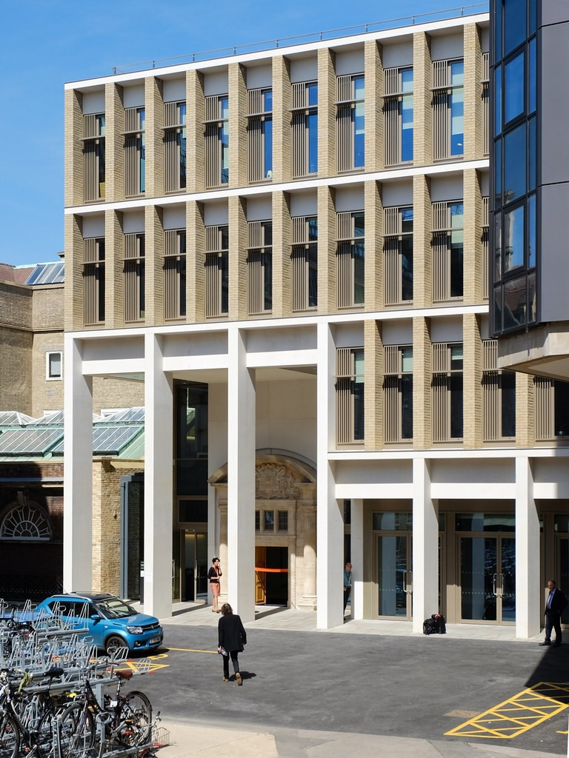



Job Reference:AB51490






Exams Coordinator

Purpose of the role

Salary:
£34,630 - £40,704 appointment is usually bottom of the salary range.
In addition to the base salary stated above, the successful candidate for this post will receive an additional 2.5% supplement to their pay
Contract: - Fixed Term (until 31 July 2028)

Location: - Central Cambridge

Department: - Student Administration, Education Services

Responsible to:
Head of Digital Launch

Working pattern:
Full-time
The Digital Assessment Training and Engagement
Co-ordinator will play a key role in supporting the University's transition to digital assessment and helping to deliver a high-quality, inclusive and sustainable assessment experience for students and staff.

Working within the Digital Assessment Programme, the role holder will lead the development and delivery of training, communications and stakeholder engagement activities that support the successful implementation and adoption of the digital assessment service across the Collegiate University.

The role holder will work closely with academic and professional services colleagues, Colleges, students and external partners to promote engagement with digital assessment platforms, support organisational change, and ensure stakeholders have the knowledge, confidence and resources required to use new services effectively.

The role will contribute to the continuous improvement of digital assessment provision by gathering feedback, evaluating impact and identifying opportunities to enhance user experience and service effectiveness.

Main duties and responsibilities
Engagement and Stakeholder Management
- Develop and deliver engagement activities that support the implementation and adoption of the digital assessment service.
- Build and maintain effective working relationships with stakeholders across Colleges, Departments, Faculties and central institutions.
- Act as a key point of contact for engagement and adoption matters relating to digital assessment.
- Work collaboratively with colleagues across the University to understand stakeholder requirements and identify barriers to successful adoption.
- Represent the Digital Assessment Programme at meetings, workshops and events as required.
Training and User Support
- Design, develop and deliver training programmes for staff and students using digital assessment platforms.
- Create and maintain a range of training materials, including guidance documents, online resources, presentations, videos and workshop content.
- Co-ordinate training activities across multiple stakeholder groups and delivery channels.
- Evaluate the effectiveness of training provision and identify opportunities for continuous improvement.
- Support users in developing confidence and capability in the use of digital assessment platforms and associated processes.
Communications and Change Management
- Develop and implement communications plans to support programme objectives and service adoption.
- Produce high-quality communications tailored to a range of audiences, including senior leaders, academic staff, professional services staff and students.
- Ensure communications are timely, accurate, accessible and aligned with University policies and standards.
- Contribute to change management activities that support the transition to new ways of working.
- Monitor and evaluate engagement and communication activities, using feedback and insight to inform future approaches.
Service Development and Continuous Improvement
- Gather and analyse user feedback to identify opportunities for service enhancement.
- Contribute to the development of policies, procedures and guidance relating to digital assessment services.
- Support pilot activities, service evaluations and implementation projects.
- Maintain records and reporting mechanisms that demonstrate engagement, participation and impact.
- Identify and share good practice in digital assessment adoption and stakeholder engagement.
General Responsibilities
- Work collaboratively with colleagues across Education Services and the wider University.
- Contribute to the achievement of departmental and programme objectives.
- Undertake other duties commensurate with the grade of the post as reasonably required.
The above outlines the duties required at the current time to indicate the level of responsibility. It is not intended to be a comprehensive or exhaustive list and may be varied by University management to include other reasonable requests which are up to the same skill level, and of the same type, already undertaken and which do not change the general character of the job or the overall level of responsibility.

Person specification

Criteria | Essential | Desirable
Experience
Significant experience leading stakeholder engagement, change management or service adoption programmes. | ✓
Experience influencing senior stakeholders and achieving outcomes through collaboration and negotiation. | ✓
Experience developing operational policy, standards or service frameworks. | ✓
Experience using data and performance metrics to drive service improvement and strategic decision-making. |  | ✓
Skills
Ability to influence and challenge stakeholders, including senior academic and professional services staff | ✓
Ability to translate strategic objectives into operational delivery plans | ✓
Ability to support organisational change across multiple stakeholder groups. | ✓
Qualifications
Educated to degree level or equivalent experience | ✓
Additional Requirements
Experience of Digital Assessment, preferably in a higher or further education environment |  | ✓
Given the timing of the examination season, the post holder must be flexible. Some evening, weekend and bank holiday working may be required. | ✓

Behavioural Attributes

Attribute | Level
Valuing Diversity | A
Achieving Results | C
Communication | C
Innovation and Change | C
Negotiating and Influencing | C
People Development | C
Relationship Building | C
Strategic Focus | C

This section summarises the behavioural attributes (or competencies) that we expect the role holder to be able to demonstrate, at what level and whether this is an essential or desirable requirement. Full definitions are at: https://www.hr.admin.cam.ac.uk/policies-procedures/behavioural-attributes

Please review these and provide specific examples in your application of how you have demonstrated these attributes in your work, education or other experience. It will assist your application if you explain the situation, what you did and what the outcomes were.

Professional Services Values

Developed by professional services staff, our values underpin everything we do. By living the values in the work we do, we hope to foster an environment where staff feel empowered. The values encourage staff to; work together and share skills to create a sense of community, act with integrity, take an inclusive and fair approach and develop honest and open relationships that are underpinned by our shared values. We encourage applicants to consider these values within their application.



Student Administration
This role is based within the Student Administration section of Education Services, Academic Division.
Student Administration is a centralised department providing administration and specialist services that support the academic purposes of the University and is responsible for all administrative aspects of the student journey from registration to student progression, examination and graduation,
and comprises six main sections:
- Examinations and Mitigation
- International Students Office
- Office for Student Conduct, Complaints and Appeals
- Postgraduate Administration
- Space modelling and allocation
- Student Records



Education Services

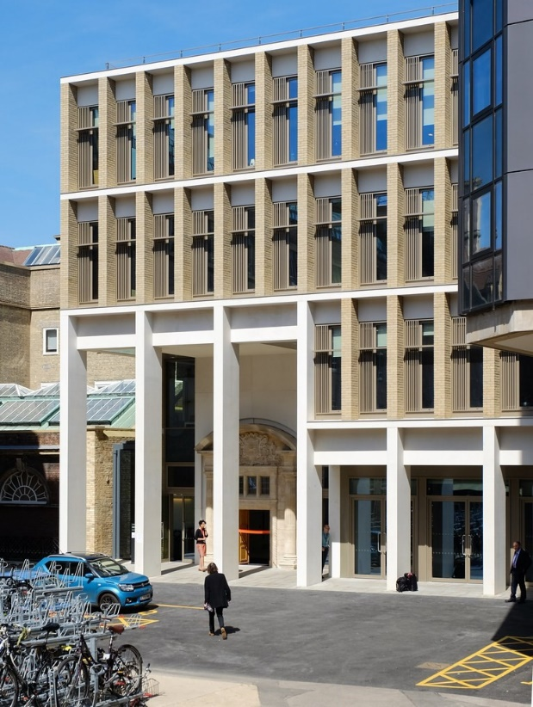


Based at the purpose built Student Services Centre which opened in April 2019, Education Services brings together the teams that provide key services to students.
Education Services sits within the wider Academic Division of the University’s
Professional Services and is made up of the following teams:
- Access & Admissions
(Including Cambridge Admissions Office, Postgraduate Admissions Office and Student Funding).
- Student Support
(Including Accessibility and Disability Resource Centre, Student Wellbeing, Mental Health Advice Service and University Counselling Service)
- Student Administration
(including Exam Operations and Mitigating Circumstances, International Student Office, Postgraduate Administration, Student Records, Office for Student Conduct, Complaints & Appeals and Space modelling & Allocation.)
- Education and Student Outcomes
(including Education Quality and Policy Office, Careers Service, Postgraduate Research and the Cambridge Centre for Teaching and Learning).
These departments are supported by the SSC Support Team which delivers a shared service in the following areas:
- Financial Administration; Human Resources support, including recruitment administration; Reception and Facilities Management; Health and Safety

Terms of appointment

Appointment
Appointment will be made on a fixed term basis.
Appointments will be subject to the satisfactory completion of a six-month probationary period.

References
Offers of appointment will be subject to the receipt of satisfactory references.

Salary
The salary range for this role
is £34,630 - £40,704 and appointment is usually bottom of the salary range. In addition to the base salary stated above, the successful candidate for this post will receive an additional 2.5% supplement to their pay

Hours of Work
and Working Pattern
The hours of work for the
position are full-time, Monday to Friday. Between April and June, some evening, weekend and
Bank Holiday working may be required.

Pension
You will automatically be enrolled to become a member of USS (Universities Superannuation Scheme) – a defined benefits pension scheme. For further information please visit:
www.pensions.admin.cam.ac.uk

Annual leave
Full-time employees are entitled to annual paid leave of 41 days inclusive of public holidays.

Right to work in the UK
We have a legal responsibility to ensure that you have the right to work in the UK before you can start working for us. If you do not have the right to work in the UK already, any offer of employment we make to you will be conditional upon you gaining it

Health declaration
Once an offer of employment has been made the successful candidate will be required to complete a work health declaration form.

Information if you have a disability
The University welcomes applications from individuals with disabilities. We are committed to ensuring fair treatment throughout the recruitment process. We will make adjustments to enable applicants to compete to the best of their ability wherever it is reasonable to do so and, if successful, to assist them during their employment.
Information for disabled applicants is available at http:// www.admin.cam.ac.uk/offices/
hr/staff/disabled/

We encourage you to declare any disability that you may have, and any reasonable adjustments that you may require, in the section provided for this purpose in the application form. This will enable us to accommodate your needs throughout the process as required. However, applicants and employees may declare a disability at any time.
If you prefer to discuss any special arrangements connected with a disability, please contact, the Department Administrator, who is responsible for recruitment to this position.

The University


The University of Cambridge is one of the world’s oldest and most successful universities. We are a renowned centre for research, education, and scholarship that makes a significant contribution to society. The University is consistently ranked amongst the top universities in the world. Our affiliates have won more Nobel Prizes than any other University.

Our sustained pursuit of academic excellence is built on a long history of first- class teaching and research within a distinctive collegiate system. For eight centuries our ideas and innovations have shaped the world. Our principal goal is to remain one of the world’s leading universities in an increasingly competitive global higher education sector. Today the University of Cambridge is at the centre of a cluster of over 4,300 businesses employing 58,000 people.
Our capital investment projects include the West Cambridge site, the North West Cambridge development and the growth of the Biomedical Campus in the south of the city. The North West Cambridge development includes the opening of a primary school – the first in the UK to be managed by a University. So we are deeply
embedded in, and committed to serving, our local community. These are all conspicuous signs of a University that is not only adapting to new needs, but also anticipating the future.

Our mission is to contribute to society through
the pursuit of education, learning, and research at the highest international levels of excellence. Our core values are:

  - freedom of thought and expression; and
  - freedom from discrimination.

About us


The University is one of the world's leading academic centres. It comprises 150 faculties and departments, together with a central administration and other institutions. Our
institutions, museums and collections
are a world-class resource for researchers, students and members of the public representing one of the country’s highest concentrations of internationally important collections.
The University has an annual income of £2 billion. Research income, won competitively
from the UK Research Councils, the European Union (EU), major charities and industry, exceeds £500 million per annum and continues to grow.

The Colleges and the University remain committed to admitting the best students regardless of their background and to investing considerable resources both in widening access and financial support. The 31 Colleges are self-governing, separate legal entities which appoint their own staff. Many academic staff are invited to join a College as a Teaching Fellow, which provides a further social and
intellectual dimension. The Colleges admit students, provide student accommodation and deliver small group teaching.
The University awards degrees and its faculties and departments provide lectures and seminars for students and determine the syllabi for
teaching and conducting research.

Our instinct for seeking out excellence and setting up enduring and mutually beneficial collaborations has led us to establish strategic partnerships across the globe. Whether it is the successful Cambridge-Africa Programme involving universities in Ghana, Uganda and elsewhere on the African continent; or the close association with the government of India to pursue new research in crop science; or the creation, with Germany’s Max Planck Institutes, of a Cambridge-based centre for the study of ethics, human economy and social change – international partnerships are now an
inextricable part of the University’s make-up.

“Cambridge graduates and researchers have made – and continue to make – a colossal contribution to human knowledge and the understanding of the world around us. Their work touches on the lives and livelihoods of everyone from patients diagnosed with life-
threatening diseases, to residents of areas critically affected by climate change, to children growing up in conflict zones. It has a lasting impact on our society, our economy and our culture: the world is truly a better place thanks to their efforts.”

Stephen Toope, Vice Chancellor 2019

Working at the University

Working at Cambridge you will join a diverse, talented and innovative community, with more than 18,000 students and over 16,000 staff from all walks of life and corners of the world.

The University continually explores strategies to attract and retain the best people. It is committed to supporting its staff to achieve
their best. We are a fair, diverse and inclusive society and we believe our staff are our greatest asset. There is strong commitment
to developing institutional leadership and supporting and encouraging staff development at all levels.

We offer a variety of roles including academic, research, professional, managerial and support roles. We also offer extensive benefits and excellent learning
opportunities within a stimulating working environment.

The University’s estate is undergoing the most significant transformation in its history. Cambridge has been able to create a new science and technology campus to the west of the city centre, and is now expanding further to the north west of Cambridge including investing in affordable homes for University key workers and community facilities. Even with our continued development, the University remains within walking or cycling distance across the campus. The University is a major partner on the Cambridge Biomedical Campus and we continue to redevelop our historic city centre sites demonstrating our determination to ensure that we can offer the best facilities and opportunities for our staff and students.

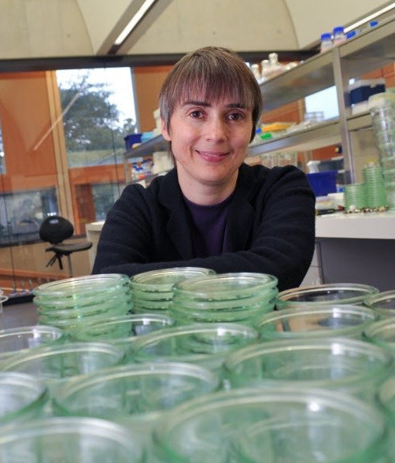

Equality & diversity
The University has built its excellence on the diversity of its staff and student community. We aim to be a leader in fostering equality and inclusion, and in promoting respect and a sense of belonging for all. We encourage applications
from all sections of society. All appointments are made on the basis of merit. We have an Equal Opportunities Policy, along with a range of diversity networks for women, black and minority ethnic and lesbian, gay, bisexual and
transgender staff. More details are available here: http://www.equality.admin.cam.ac.uk/

The University has a bronze Race Equality Charter aware, with framework for improving the representation, progression and success of minority ethnic staff and students within higher education. Furthermore, the University’s Athena SWAN award recognises and celebrates good practice in recruiting, retaining and promoting women.

Living in Cambridge

Cambridge is rich in cultural diversity. From beautiful University and College buildings, museums and art galleries, quaint gardens and punts on the River Cam, to a vibrant restaurant and café
scene, our employees are surrounded by the wonderful features of this unique city.

You can find a wide-range of high street shops and 3 shopping centres, with independent
alternatives at the historic market and nestled within the passageways in the city centre. You will find a cinema, bowling alley, a nightclub and various live performances At the Cambridge Leisure Park, with further entertainment options at the Corn Exchange,
Arts Theatre and the ADC Theatre. Further information can be found on the Visit
Cambridge website.

Relocation Support
The University recognises the importance of helping individuals to move and settle into a new area. We provide support and guidance to those relocating internationally or
domestically to take up a post at the University of Cambridge, liaising with other University offices and selected partners to ensure comprehensive relocation support is available. This includes: accommodation, childcare, schools, banking, immigration and transport. If you would like further information, please visit https://www.accommodation.cam.ac.uk/. The Shared Equity Scheme and the Reimbursement of Relocation Expenses
Scheme provide financial assistance to qualifying new members of staff with the costs of relocating to Cambridge.


If you prefer the faster pace of life, London is a 45 minute train journey away. For those
travelling from overseas, Stansted Airport is just 45 minutes away and Heathrow Airport under 2 hours away. The University is a short distance from a host of other attractions such as Ely Cathedral, Newmarket Races and various wildlife parks and stately homes.
Cambridge is also within easy reach of the beautiful Broads and coastlines of Norfolk and Suffolk.

Accommodation Service
The University Accommodation Service helps staff, students and visiting scholars who are affiliated to the University in their search for suitable accommodation in Cambridge. The dedicated accommodation team can provide access to a wide range of University-owned
furnished and unfurnished properties, and has a database of private sector accommodation available for short and long-term lets. For further information and to register with this free service please visit https://
www.accommodation.cam.ac.uk/

What Cambridge can offer


We offer a comprehensive reward package to attract, motivate and retain high performing staff at all levels and in all areas of work.
The University offers a wide range of competitive benefits, from family leave entitlement, to shopping and travel discount schemes. Our generous annual leave package contributes to the positive wellbeing of our University employees.
Sabbatical leave enables academics to
focus on research and scholarship, whilst still maintaining their full salary. The University also has a career break scheme for academic and academic-related staff, with additional flexible working policies for all other staff.


Pay and benefits
The University salary structure includes automatic service-related pay progression in many of its grades and an annual cost of living increase. In addition to this, employees are rewarded for outstanding contribution through a number of regular pay progression schemes. The University offers attractive pensions schemes for employees, with an additional benefit of a salary exchange arrangement providing
tax and national insurance savings. Payroll giving is also a simple, tax-efficient way
for employees to make monthly donations to charity.

CAMbens employee benefits
We offer a CAMbens scheme for University employees, providing access to online and in
-store shopping discounts and cashback. With more than 2,000 participating retailers,
employees can save money on a wide range of household expenses, from groceries
and clothes, to holidays and insurance and much more. A range of local discounts are also available, helping employees to save money whilst also supporting local Cambridge businesses and a CAMbens Cycle to Work salary sacrifice scheme is also available, which enables employees to save money on transport costs. A 10% discount rate on the purchase of train season tickets, bulk buy tickets and an interest free travel to work loan are also available for staff of the University.

What Cambridge can offer


Family-friendly policies
The University recognises the importance of supporting its staff. We have a range of family- friendly policies to aid employees’ work-life
balance including a generous maternity, adoption and shared parental leave entitlement of 18 weeks full pay and emergency family care support via My Family Care.

Other family-friendly support includes:
Our highly regarded workplace nurseries, a childcare salary exchange scheme and a high quality holiday Playscheme may be available to help support University employees with caring responsibilities (subject to demand and qualifying criteria). Further childcare information can be
found here: https://www.childcare.admin.cam.ac.uk/

The Newcomers and Visiting Scholars Group is an organisation within the University run by volunteers whose aim is to help newly arrived wives, husbands, partners and families of Visiting Scholars and members of the University to settle in Cambridge and give them an opportunity to meet local people. The Office of Postdoctoral
Affairs supports the postdoctoral community within Cambridge. Further details are available here: https://www.opda.cam.ac.uk/

Your wellbeing
The University’s Sport Centre, Counselling
Services and Occupational Health are just some of the support services available to University employees to promote their physical and mental wellbeing. There are many societies in Cambridge catering for almost every taste and
interest. Whether you want to take part in a sport, participate in music or drama, pursue a hobby, or join a political group, you will almost certainly find that a society exists for this purpose. The University also hosts the Cambridge Science
Festival and Cambridge Festival of Ideas, as well as Open Cambridge weekend, which together attract over 50,000 visitors per year. The festivals are a great opportunity to get your first taste of public engagement, through volunteering, supporting hands-on activities or proposing a talk.

Development opportunities
We support new employees to settle in through various activities. The encouragement of career development for all staff is one of the University's values and we put this into practice through various services and initiatives. Our Personal and Professional Development Department provides development opportunities and courses for all University employees. These include face-to-face sessions, online learning modules and webinars. Employees may also apply for financial support to undertake training that will lead to a qualification. We offer reduced staff fees for University of Cambridge graduate courses and the opportunity to attend lectures and seminars held by University departments and institutions. The CareerStart@Cam programme also supports employees in assistant staff roles who do not hold higher education qualifications to develop their skills, experience and qualifications.



How to apply
Applications should be submitted online via the University of Cambridge jobs page www.jobs.cam.ac.uk by clicking “Apply online” in the job advert. You will need an email
address to register for our online system.

Conversations about flexible working are encouraged at the University of Cambridge. Please feel free to discuss flexibility prior to applying (using the contact information below) or at interview if your application is successful.

Informal enquiries are welcomed and should be directed to: Jenny Green, Head of Exam Operations

Email: Jenny.Green@admin.cam.ac.uk Emily.King@admin.cam.ac.uk

If you have any queries or issues regarding the application process please contact the SSC Recruitment Team at sscjobs@admin.cam.ac.uk

The closing date for applications is Sunday 15 November 2026
The interview dates for the role are Tuesday 23 and
Wednesday 24 November 2026

UNIVERSITY OF
CAMBRIDGE

