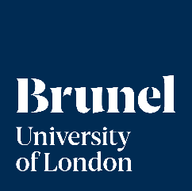

Position Title | Research Fellow | Position No. 17096
College/Department | College of Engineering, Design and Physical Sciences (CEDPS) /  Department of Engineering /  Brunel Interdisciplinary Power Systems (BIPS) Research Centre
Grade | R1 30 - 36
Reporting To | Dr Marko Aunedi, Senior Lecturer in Electronic and Electrical Engineering
Date reviewed | October 2026

About the project:

We are looking to recruit a researcher to work in parallel on two related research projects, “Climate Resilient Heat Electrification for Net-Zero Emission Whole Energy Systems (RENEW)” funded by UKRI, and “Benefits and Lifecycle-analysis of Underground Energy Storage Technologies for net zero (BLUEST)” funded by UKERC, both carried out in collaboration with Newcastle University, Imperial College London and Birmingham University. Both projects are coordinated by Dr Marko Aunedi on behalf of Brunel University of London in the UK.
This fixed-term research position is based at Brunel University of London and will investigate the role of Long-Duration Energy Storage (LDES) in cost-effective decarbonisation of the UK’s energy sector, as well as cost-effective, climate-resilient pathways for the UK’s integrated electricity and heat sectors, enhancing energy supply security against extreme conditions, as specified in the agreed research plans for RENEW and BLUEST projects, respectively. The objective of the role is to support research activities within Brunel Interdisciplinary Power Systems (BIPS) Research Centre at Brunel University of London, aimed at studying various aspects of LDES deployment and climate-resilient energy system design and operation under various decarbonisation pathways.

Summary of role:

Under supervision of the Principal Investigator(s) the post-holder will:

- Perform research and technical duties associated with the RENEW and BLUEST projects.
- Produce high-quality original research.
- Analyse input and output data associated with modelling energy systems while considering extreme weather events.
- Contribute to writing reports and producing deliverables as required for the duration of the project.
- Disseminate outcomes and results of the project in international journals and conference publications etc.
- Take the initiative in planning and organising research activities.
- Provide guidance to staff and students, support the work of small research teams and have direct engagement with clients/sponsors.
- Carry out basic project management tasks, prepare reports and liaise with project partners and funders as necessary.
- Perform other additional research and scholarly duties in line with Brunel University of London guidelines.

Main accountabilities and responsibilities:

- Take a proactive role in planning and undertaking the research project, individually and/or jointly, to meet the project deliverables and the Department/Institute, College and University research strategy.

- Document research activities, including collection, analysis and interpretation of all data, maintaining records and databases, preparing technical reports and papers, as appropriate.

- Establish and maintain your personal research profile and reputation, and those of the University, through: (a) building a track record of high-quality research outputs; (b) enhancing the impact of research; and, (c) undertaking activities that enhance your reputation as a researcher.

- Assist in the development and implementation of a strategy to deliver the project.

- Presentation of work at international and national conferences, seminars and workshops to enhance your research profile.

- Supports the PI in identifying potential funding sources and assist with preparing funding proposals, to support dissemination of your research and future projects and impact. May seek appropriate opportunities to apply for external Fellowships and small grants where eligible.

- Pro-actively develop and maintain collaborations with colleagues across the University, as appropriate, and the wider community (Academic, Governmental, NGO, Industrial Partners).

- Proactively support research activities within your project team, research group or centre, and Department or Institute, to enhance the research culture across the University.

- Assist in the effective development of less experienced members of the project team (e.g. undergraduate and/or postgraduate students, doctoral researchers) through organisation, supervision, mentoring and training, as appropriate.

- Perform administrative tasks related to your research project.

- Where appropriate to the role and project develop teaching/supervisory skills through contributing to teaching/supervisory activities.

- Keep up to date with recent advances in your area of expertise and the wider discipline.

- Engage in personal, professional and career development, to enhance your specialist and transferable skills in accordance with your desired career trajectory.

- Postholder may be engaged to work on a specific project however will be expected to support the Principal Investigator on other projects, if required.

Management of Staff and Students:

Provide guidance to staff and students and supervise work of small research team including Research Assistants and Technicians.

Other Duties:

The job description is not exhaustive. The post holder may be required to undertake other duties of a similar level and responsibility:

- Undertake any other reasonable duties as required and commensurate with the grade of post. in accordance with university and departmental policies, procedures and codes of conduct.
- Adhere to and comply with the provisions of the Data Protection Act and the Health and Safety at Work Act in accordance with university policies.
- Promote the University’s Environmental Policy and demonstrate commitment to it through actions and decision making.
- Actively participate in on going professional development activities as requested.

Our Values:
Our values play out across everything we do. We hold ourselves accountable to the highest standards in all our activities and decisions. They add value to both student and colleague experience at Brunel, helping us to deliver our strategy and plans.

Open We are welcoming and believe in the power of diversity. We are transparent in our decisions and deliver on what we say.

Courageous We seek and take on ambitious challenges. We are brave and committed to thinking differently. Nothing stops us from going after our goals.

Inventive: We are purposeful in an ever-changing world. Collaborating and innovating to reach our full potential and to change lives - and the world - for the better. We celebrate breakthroughs and strive for the best.

Organisational Structure Chart:

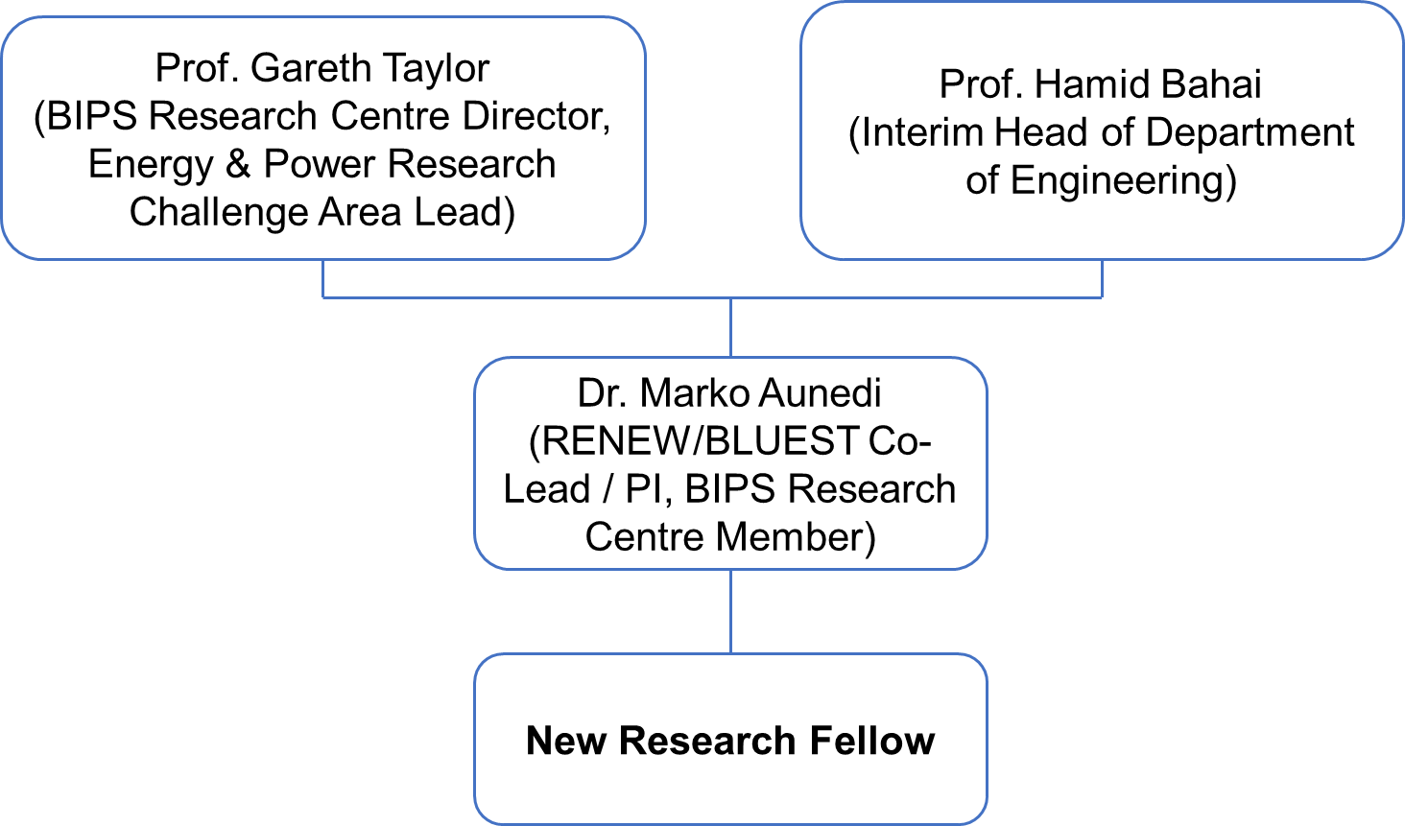



Person Specification

As part of the University’s commitment to the Disability Confident Scheme – Offer an Interview Commitment. Applicants who choose to apply through the scheme, and who meet the minimum criteria for the role, will be offered an interview.

Attributes | Criteria | Essential /Desirable
Education, qualifications & training | PhD in appropriate Discipline (energy system modelling and optimisation, power system analysis, renewable energy, transmission and distribution system operation, energy storage, low-carbon energy technologies, energy economics or other related areas)  OR  Equivalent research, industrial or commercial experience. (Minimum 4 years). | E
Experience | Evidence of relevant research or work experience relevant to energy system modelling and optimisation.  Evidence of research attainment including examples of contributing to high quality academic research outputs  Evidence of successful delivery of components of original research projects  Experience of contributing to organising and supervising a project team  Proven experience of planning research activities and preparing research proposals. | E  E  E  E  E
Knowledge Skills & Abilities | Comprehensive and up-to-date knowledge of the subject specialism  Knowledge/experience of computer-based research tools for optimisation and simulation and development of open-source research materials.  Excellent verbal and written communication skills, particularly when demonstrating the results of own research to both specialists and non-specialists  Ability to prepare research outputs for publication or dissemination in appropriate academic outlets  Ability to work largely on own initiative with minimum supervision  Ability to give presentations at academic and non-academic conferences and meetings  Understanding of, and a commitment to, open research as appropriate to the discipline (open data, code, educational resources etc)  Evidence of collegiality, including willingness to support the career development of students and colleagues | E  D  E  E  E  E  E  E
Additional Requirements (not included above) | Aligned with Brunel’s values of being open, courageous and inventive  Committed to fostering an equitable and inclusive workplace  A flexible approach to changing demands of a service | E  E  E

*Where a large pool of applicants meet the essential criteria, the desirable criteria will be used as part of the first stage of short listing.

JOB HAZARD DECLARATION
A job specific risk assessment has been undertaken, and recorded, for this post.
Yes ☒ No ☐
The risk assessment has identified the need for Health Surveillance.
Yes ☐ No ☒
If you have selected “Yes” then please specify:
- What type of surveillance is required and why?

- Whether or not you have sought advice from Occupational Health or the Health, Safety & Environment Team?

The work involved requires vaccination
Yes ☐ No ☒
If you have selected “Yes” then please specify:
- What type of Vaccination is required and why?

- Whether or not you have sought advice from Occupational Health or the Health, Safety & Environment Team?

For inclusion with job description:
Please provide answers to the following questions. Please add additional items as necessary. For further advice please contact healthandsafety@brunel.ac.uk (“No” responses should be deleted before advertising.)

- This role involves working with Display Screen Equipment for extended periods of more than 1 hour per day
Yes ☒ No ☐

- This role involves frequent manual handling and/or may be physically demanding
Yes ☐ No ☒

- This role involves working outside for long periods of time
Yes ☐ No ☒

- This role involves working at Height
Yes ☐ No ☒

- This role involves work in confined spaces
Yes ☐ No ☒

- This role involves working in a noisy environment
Yes ☐ No ☒

- This role involves Travel
Yes ☒ No ☐

- This role involves regular work with vibrating equipment
Yes ☐ No ☒

- This role involves driving
Yes ☐ No ☒

The information provided above is, to the best of my knowledge, true and accurate.

Name: Dr. Marko Aunedi |   Signature: | Date: 23/10/2026

