Accounts Assistant
Department of Chemical Engineering and Biotechnology

Closing date: 9th November 2026

Job Reference: NQ51506
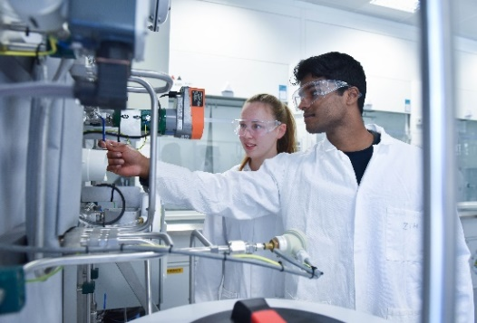
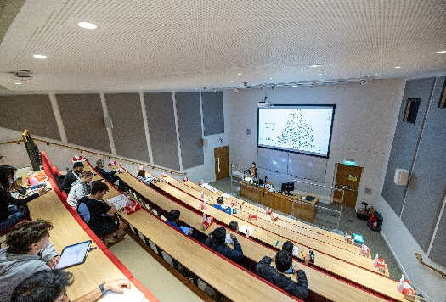

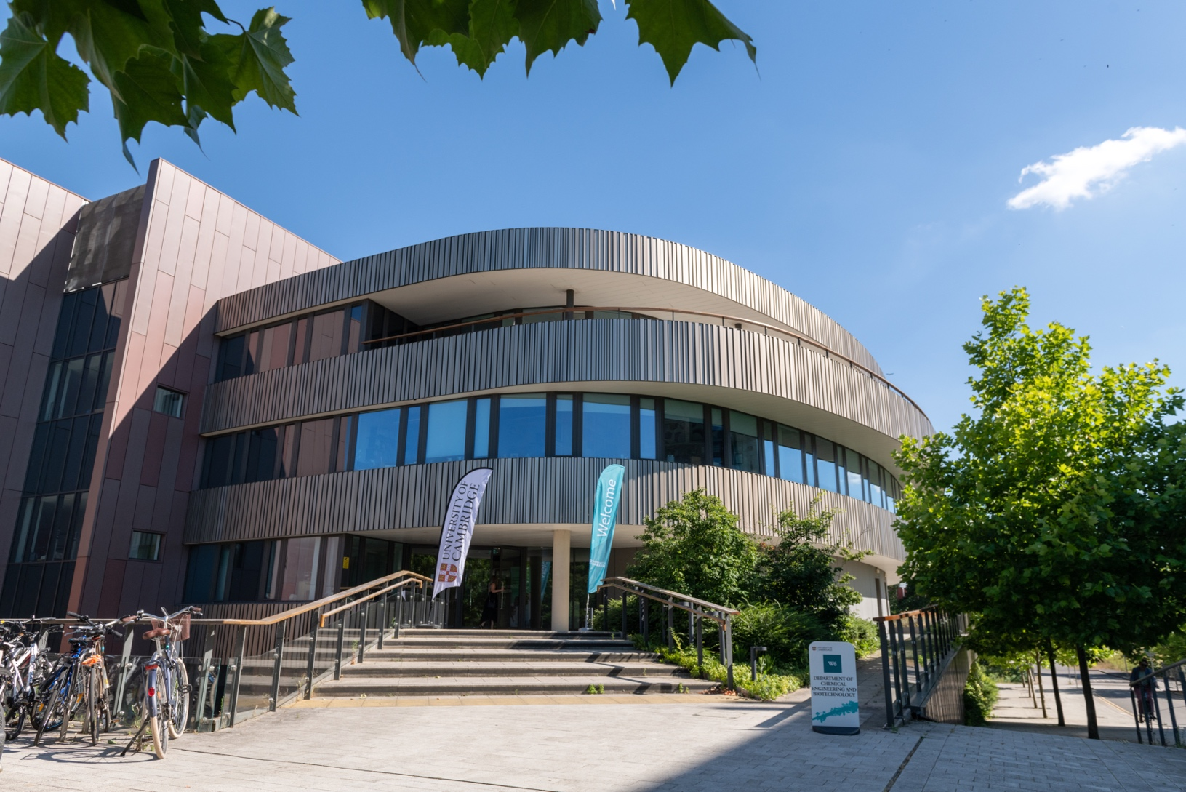





Accounts Assistant

Salary:

£27,319 - £31,236

Contract:

Permanent

Location:

West Cambridge

Department:

Department of Chemical Engineering and Biotechnology

Responsible to:

Departmental Finance Manager

Working Pattern:

Full Time with flexible hybrid options considered.

Purpose of the role
The role will undertake the administration of accounts and maintain financial records within the Department in order to contribute to the management of Departmental finances. The postholder will also assist in the provision of a largely autonomous accounting and purchasing service, responsible for the processing of about 4500 invoices per annum of total value £2M. Grant income is £6M per annum. The postholder will have purchasing responsibility up to £5,000, and will undertake cash management, journal transfers, and various accounting reports.
The postholder will also provide cover in Stores during periods of leave of Stores personnel. Due to the nature of the work manual handling training will need to be completed for this role. Key tasks in Stores includes assisting members of the Department in the ordering via the online system and receipting goods.
Main responsibilities

1. Process supplier invoices; credit notes via SoftCo. Monitor the SoftCo queues daily to ensure invoices are processed in a timely manner; manually code and match invoices to purchase orders; process expense claims investigate invoice holds; amend distributions against supplier invoices; reconcile statements; resolve supplier or staff queries including queries related to VAT;
arrange set up of credit accounts with suppliers; set up suppliers on the supplier database and carry out month-end procedures.

2. Review and investigate open purchase orders and close or cancel as required, check that purchase order matches the invoice, liaise with suppliers with regard to goods received, returns and anomalies.

Run commitment reports for grant holders or receive them from the Finance Co-Ordinator and resolve all of the aged commitments therein.

Help stores personnel with funds check failures, or other reasons for failure of purchase order progress.

Approve requisitions placed on the system by staff.

3. Raise customer invoices and credit notes, set up customer receivables activities, collect and bank monies received and resolve queries, obtain information relating to income activity to allocate correct VAT treatment and perform credit control month-end procedures.

4. Run and review UFS reports and export data into excel, run COGNOS reports for budget holders and investigate and resolve queries raised.





8.Maintain, file and archive financial records, ensure there is accessible and comprehensive documentation for audit purposes, maintain supplier databases checking that information held is correct.

9.Take occasional responsibility for the running of Stores during leave periods of Stores personnel. .Key tasks in Stores includes being present in Stores during opening hours,
being present in Stores to take in deliveries. Assisting members of the Department in the ordering via the online system and receipting goods.

Main responsibilities (continued)
5. Year-end reports: Run reports in Accounts Payable Purchasing and Accounts receivable to ensure everything is up to date when the modules close. Check inter-departmental recharges are carried out accurately. Check the supplier statement reconciliations are completed and submitted on time.
Assist with year-end grants & GL reporting, investigate anomalies, process journals.

6.Individual Engagements and Payments (Ind-E-Pay)
Set up service suppliers, determining employment tax status on an engagement-by-engagement and raise payments to service suppliers via Ind-E-Pay system.

7. Be a first point of contact for financial matters, liaise with departmental staff and give advice and guidance regarding financial procedures, deal with daily telephone and email queries from suppliers, attend Finance User Group meetings as necessary.

Person Specification

Criteria | Essential | Desirable
Education
AAT Intermediate qualified (or equivalent level attained)
Educated to ‘A’ Level standard or equivalent
Specialist knowledge, skills and Experience
Demonstrate knowledge of facts, principles, processes and general concepts related to Finance/Accounts Administration.
Knowledge of purchasing processes and online purchasing systems e.g. iProcurement or similar
Interpersonal & communications skills
Excellent communications skills
Relevant experience
Experience in working in an accounts environment
Experience in using standard Microsoft Office packages (particularly Excel)
Experience of using relevant reporting tools
Excellent organisation skills
High level of accuracy and attention to details

This section summarises the behavioural attributes (or competencies) that we expect the role holder to be able to demonstrate, at what level and whether this is an essential or desirable requirement.
Full definitions are at: https://www.hr.admin.cam.ac.uk/policies-procedures/behavioural-attributes
Please review these and provide specific examples in your application of how you have demonstrated these attributes in your work, education or other experience. It will assist your application if you explain the situation, what you did and what the outcomes were.

Behavioural Attributes

Attribute | Level
Valuing Diversity | A
Achieving Results | C
Communication | C
Innovation and Change | C
Negotiating and Influencing | D
People Development | C
Relationship Building | C
Strategic Focus | D


The Department of Chemical Engineering and Biotechnology at Cambridge has an international reputation for advancing molecular science and technology at the boundaries where chemistry, physics, mathematics, and biology meet. It is setting the pace for scientists, engineers, industrialists, and entrepreneurs to solve a range of complex global challenges across energy, the environment, and healthcare.
The Department has forged a number of significant industry partnerships and has pioneered the commercialisation of its cutting-edge research, recognising the vital relationship between knowledge transfer and economic growth.
The quality, depth and breadth of the Department’s teaching have received international acclaim. Its training produces graduates of exceptional calibre with the vision and flexibility to apply their skills across a variety of fields and sectors, from commerce and high finance to industry and medicine.
Key information
The Department operates on the West Cambridge site. The department houses 30 academic, ~50 academic-related and assistant support staff, ~75 post-doctoral workers and ~150 research students. There are also ~50 MPhil students and ~150 undergraduates. The Department’s research income was over £8.9 M in 2021-22. The department currently ranks 5th in the world in its discipline, and 1st in Europe (QS University rankings), and came second in the latest UK Research Excellence Framework Exercise (REF 2021).

Department of Chemical Engineering and Biotechnology

The School of Technology is one of the six Schools in Cambridge. It comprises: the Department of Engineering; the Judge Business School; the Department of Chemical Engineering and Biotechnology; the Department of Computer Science and Technology; and the Cambridge Institute for Sustainability Leadership. The School employs over 1,500 people and has a student population of nearly 3,300 (between undergraduates and postgraduates).
About the School Office
The School Office interfaces with a number of institutions both externally and internally, such as the EPSRC and the central administration. It has especially close contact with the Academic Division, Finance Division, the Research Office and Human Resources Division as well as the Departments within the School.
It is responsible for proposing, consulting and implementing School-wide polices and administrative procedures, ensuring compliance within the general governance framework, and financial control.
Governance
The School of Technology Office is responsible for a large number of School-level committees which in turn support the decision-making at the Council of the School, the School’s governing body.
The Head of School together with the Heads of Department work together to drive the strategic planning for the School including all teaching, research and operational activities which are funded by all sources of income, for approval by the Council of the School. The evaluation and assessment of major new initiatives and capital projects also falls under the governance of the School. New initiatives and capital projects also falls under the governance of the School.
More details of the School’s committees are here: https://www.tech.cam.ac.uk/Committees
The School’s Strategic plans are here: https://www.tech.cam.ac.uk/school/planning
What we do:
● Finance: Supporting financially-informed decision-making and planning within the School and ensuring Financial Regulations and other policies and procedures are implemented and maintained at Departmental level. Providing support and advice to Departments on financial matters, accounting processes and procedures relating to the use and management of the University’s Finance System. Key link with the Finance Division.
● Research: Responsible for the development and management of School-wide policies and initiatives to improve research grant income and application success rates in the School.
● Education: Coordinating activities to support undergraduate and postgraduate education in the School through its Undergraduate Committee and Graduate School Committee. Responsible for addressing strategic education issues. Supporting a range of Doctoral Training opportunities including the Centers for Doctoral Training and ICASE awards both funded by the Engineering and Physical Sciences Research Council (EPSRC), as well as the WD Armstrong studentship awards.
● Human Resources: Supports management and staff by providing HR management information; case support; guidance on the application of HR policies and procedures. The HR Business Manager takes the lead on significant HR projects and complex employment issues.

The School of Technology

Terms of Appointment
Tenure and probation
The appointment will be made on a permanent basis.
Appointments will be subject to satisfactory completion of a six-month probationary period.

Hours of Work and Working Pattern
The hours of work for the position are 36.5 hours per week, working Monday – Friday.

Pension
You will automatically be enrolled to become a member of CPS (Contributory Pension Scheme) – a defined benefit and defined contribution pension scheme. For further information please visit: www.pensions.admin.cam.ac.uk/.

Annual leave
Full time employees are entitled to annual paid leave of 36 days inclusive of public holidays. For part-time employees, annual leave will be pro rata’d based on days worked.
General information
Pre-employment checks

Right to work in the UK
We have a legal responsibility to ensure that you have the right to work in the UK before you can start working for us. If you do not have the right to work in the UK already, any offer of employment we make to you will be conditional upon you gaining it.

Health declaration
Once an offer of employment has been made the successful candidate will be required to complete a work health declaration form.

Qualifications
The person specification for this position lists qualifications that are essential and/or desirable. Please note that if you are offered the post you will be asked to provide your relevant original certificates of these qualifications.

References
Offers of appointment will be subject to the receipt of satisfactory references.

Equality and Diversity
We particularly encourage underrepresented minority ethnic candidates to apply for this vacancy as they are currently under-represented at this level within our University.
Information if you have a disability
The University welcomes applications from individuals with disabilities. We are committed to ensuring fair treatment throughout the recruitment process. We will make adjustments to enable applicants to compete to the best of their ability wherever it is reasonable to do so and, if successful, to assist them during their employment. Information for disabled applicants is available at http:// www.admin.cam.ac.uk/offices/hr/staff/ disabled/

We encourage you to declare any disability that you may have, and any reasonable adjustments that you may require, in the section provided for this purpose in the application form. This will enable us to accommodate your needs throughout the process as required. However, applicants and employees may declare a disability at any time.
If you prefer to discuss any special arrangements connected with a disability, please contact the HR Manager at CEB on hr@ceb.cam.ac.uk, who is responsible for recruitment to this position.


The University
The University of Cambridge is one of the world’s oldest and most successful universities. We are a renowned centre for research, education, and scholarship that makes a significant contribution to society. The University is consistently ranked amongst the top universities in the world. Our affiliates have won more Nobel Prizes than any other University.
Our sustained pursuit of academic excellence is built on a long history of first-class teaching and research within a distinctive collegiate system. For eight centuries our ideas and innovations have shaped the world. Our principal goal is to remain one of the world’s leading universities in an increasingly competitive global higher education sector. Today the University of Cambridge is at the centre of a cluster of over 4,300 businesses employing 58,000 people.
Our capital investment projects include the West Cambridge site, the North West Cambridge development and the growth of the Biomedical Campus in the south of the city. The North West Cambridge development includes the opening of a primary school – the first in the UK to be managed by a University. So we are deeply embedded in, and committed to serving, our local community. These are all conspicuous signs of a University that is not only adapting to new needs, but also anticipating the future.

Our mission is to contribute to society through the pursuit of education, learning, and research at the highest international levels of excellence. Our core values are:

• freedom of thought and expression; and

• freedom from discrimination.
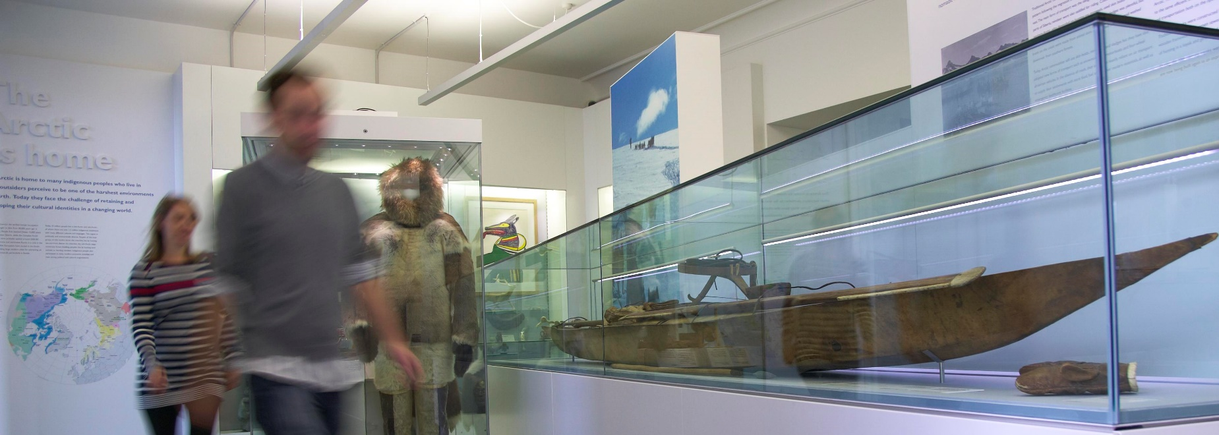
“Cambridge graduates and researchers have made – and continue to make – a colossal contribution to human knowledge and the understanding of the world around us. Their work touches on the lives and livelihoods of everyone from patients diagnosed with life-threatening diseases, to residents of areas critically affected by climate change, to children growing up in conflict zones. It has a lasting impact on our society, our economy and our culture: the world is truly a better place thanks to their efforts.”
Stephen Toope, Vice Chancellor 2019

The University is one of the world's leading academic centres. It comprises 150 faculties and departments, together with a central administration and other institutions. Our institutions, museums and collections are a world-class resource for researchers, students and members of the public representing one of the country’s highest concentrations of internationally important collections.
The University has an annual income of £2 billion. Research income, won competitively from the UK Research Councils, the European Union (EU), major charities and industry, exceeds £500 million per annum and continues to grow.
The Colleges and the University remain committed to admitting the best students regardless of their background and to investing considerable resources both in widening access and financial support. The 31 Colleges are self-governing, separate legal entities which appoint their own staff. Many academic staff are invited to join a College as a Teaching Fellow, which provides a further social and intellectual dimension. The Colleges admit students, provide student accommodation and deliver small group teaching.
The University awards degrees and its faculties and departments provide lectures and seminars for students and determine the syllabi for teaching and conducting research.
Our instinct for seeking out excellence and setting up enduring and mutually beneficial collaborations has led us to establish strategic partnerships across the globe. Whether it is the successful Cambridge-Africa Programme involving universities in Ghana, Uganda and elsewhere on the African continent; or the close association with the government of India to pursue new research in crop science; or the creation, with Germany’s Max Planck Institutes, of a Cambridge-based centre for the study of ethics, human economy and social change – international partnerships are now an inextricable part of the University’s make-up.

About Us
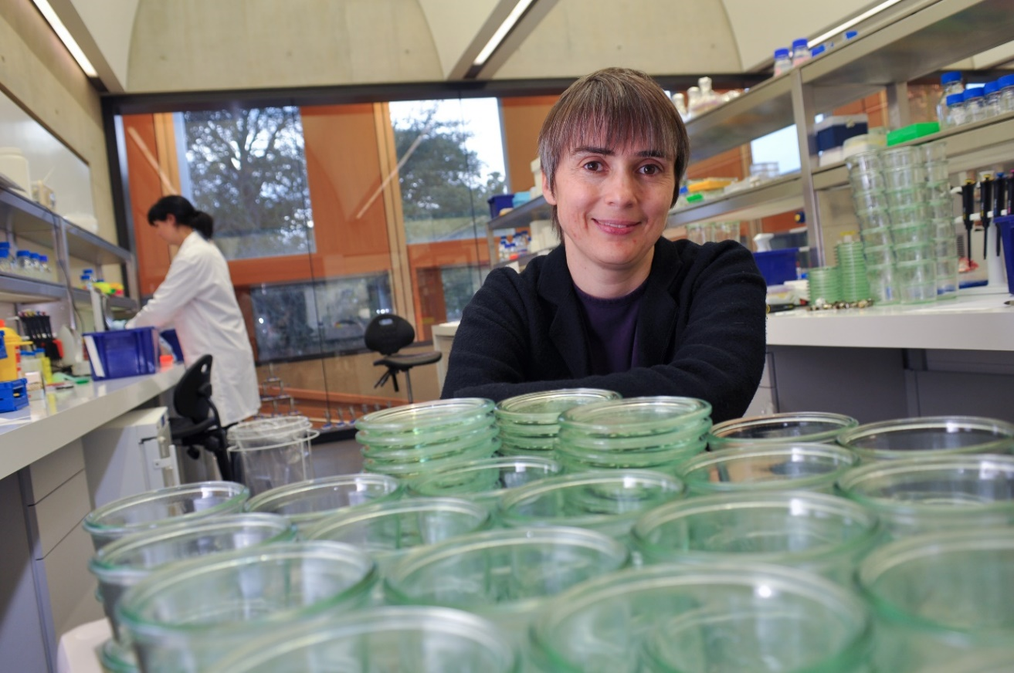

Working at the University
Working at Cambridge you will join a diverse, talented and innovative community, with more than 18,000 students and over 16,000 staff from all walks of life and corners of the world.
The University continually explores strategies to attract and retain the best people. It is committed to supporting its staff to achieve their best. We are a fair, diverse and inclusive society and we believe our staff are our greatest asset. There is strong commitment to developing institutional leadership and supporting and encouraging staff development at all levels.
We offer a variety of roles including academic, research, professional, managerial and support roles. We also offer extensive benefits and excellent learning opportunities within a stimulating working environment.
The University’s estate is undergoing the most significant transformation in its history. Cambridge has been able to create a new science and technology campus to the west of the city centre, and is now expanding further to the north west of Cambridge including investing in affordable homes for University key workers and community facilities. Even with our continued development, the University remains within walking or cycling distance across the campus. The University is a major partner on the Cambridge Biomedical Campus and we continue to redevelop our historic city centre sites demonstrating our determination to ensure that we can offer the best facilities and opportunities for our staff and students. Equality & diversity
The University has built its excellence on the diversity of its staff and student community. We aim to be a leader in fostering equality and inclusion, and in promoting respect and a sense of belonging for all. We encourage applications from all sections of society. All appointments are made on the basis of merit. We have an Equal Opportunities Policy, along with a range of diversity networks for women, black and minority ethnic and lesbian, gay, bisexual and transgender staff. More details are available here: http://www.equality.admin.cam.ac.uk/
The University has a bronze Race Equality Charter aware, with framework for improving the representation, progression and success of minority ethnic staff and students within higher education. Furthermore, the University’s Athena SWAN award recognises and celebrates good practice in recruiting, retaining and promoting women.



Living in Cambridge
Cambridge is rich in cultural diversity. From beautiful University and College buildings, museums and art galleries, quaint gardens and punts on the River Cam, to a vibrant restaurant and café scene, our employees are surrounded by the wonderful features of this unique city.
You can find a wide-range of high street shops and 3 shopping centres, with independent alternatives at the historic market and nestled within the passageways in the city centre. You will find a cinema, bowling alley, a nightclub and various live performances At the Cambridge Leisure Park, with further entertainment options at the Corn Exchange, Arts Theatre and the ADC Theatre. Further information can be found on the Visit Cambridge website.
If you prefer the faster pace of life, London is a 45 minute train journey away. For those travelling from overseas, Stansted Airport is just 45 minutes away and Heathrow Airport under 2 hours away. The University is a short distance from a host of other attractions such as Ely Cathedral, Newmarket Races and various wildlife parks and stately homes. Cambridge is also within easy reach of the beautiful Broads and coastlines of Norfolk and Suffolk.
Relocation Support
The University recognises the importance of helping individuals to move and settle into a new area. We provide support and guidance to those relocating internationally or domestically to take up a post at the University of Cambridge, liaising with other University offices and selected partners to ensure comprehensive relocation support is available. This includes: accommodation, childcare, schools, banking, immigration and transport. If you would like further information, please visit https://www.accommodation.cam.ac.uk/. The Shared Equity Scheme and the Reimbursement of Relocation Expenses Scheme provide financial assistance to qualifying new members of staff with the costs of relocating to Cambridge.

Accommodation Service
The University Accommodation Service helps staff, students and visiting scholars who are affiliated to the University in their search for suitable accommodation in Cambridge. The dedicated accommodation team can provide access to a wide range of University-owned furnished and unfurnished properties, and has a database of private sector accommodation available for short and long-term lets. For further information and to register with this free service please visit https://www.accommodation.cam.ac.uk/




What Cambridge can offer
We offer a comprehensive reward package to attract, motivate and retain high performing staff at all levels and in all areas of work.
The University offers a wide range of competitive benefits, from family leave entitlement, to shopping and travel discount schemes. Our generous annual leave package contributes to the positive wellbeing of our University employees. Sabbatical leave enables academics to focus on research and scholarship, whilst still maintaining their full salary. The University also has a career break scheme for academic and academic-related staff, with additional flexible working policies for all other staff.
Pay and benefits
The University salary structure includes automatic service-related pay progression in many of its grades and an annual cost of living increase. In addition to this, employees are rewarded for outstanding contribution through a number of regular pay progression schemes. The University offers attractive pensions schemes for employees, with an additional benefit of a salary exchange arrangement providing tax and national insurance savings. Payroll giving is also a simple, tax-efficient way for employees to make monthly donations to charity.
CAMbens employee benefits
We offer a CAMbens scheme for University
employees, providing access to online and in-store shopping discounts and cashback. With more than 2,000 participating retailers, employees can save money on a wide range of household expenses, from groceries
and clothes, to holidays and insurance and much more. A range of local discounts are also available, helping employees to save money whilst also supporting local Cambridge businesses and a CAMbens Cycle to Work salary sacrifice scheme is also available, which enables employees to save money on transport costs. A 10% discount rate on the purchase of train season tickets, bulk buy tickets and an interest free travel to work loan are also available for staff of the University.



What Cambridge can offer
Family-friendly policies
The University recognises the importance of
supporting its staff. We have a range of family-friendly policies to aid employees’ work-life balance including a generous maternity, adoption and shared parental leave entitlement of 18 weeks full pay and emergency family care support via My Family Care.
Other family-friendly support includes:
Our highly regarded workplace nurseries, a childcare salary exchange scheme and a high quality holiday Playscheme may be available to help support University employees with caring responsibilities (subject to demand and qualifying criteria). Further childcare information can be found here: https://www.childcare.admin.cam.ac.uk/
The Newcomers and Visiting Scholars Group is an organisation within the University run by volunteers whose aim is to help newly arrived wives, husbands, partners and families of Visiting Scholars and members of the University to settle in Cambridge and give them an opportunity to meet local people. The Office of Postdoctoral Affairs supports the postdoctoral community within Cambridge. Further details are available here: https://www.opda.cam.ac.uk/
Your wellbeing
The University’s Sport Centre, Counselling Services and Occupational Health are just some of the support services available to University employees to promote their physical and mental wellbeing. There are many societies in Cambridge catering for almost every taste and interest. Whether you want to take part in a sport, participate in music or drama, pursue a hobby, or join a political group, you will almost certainly find that a society exists for this purpose. The University also hosts the Cambridge Science Festival and Cambridge Festival of Ideas, as well as Open Cambridge weekend, which together attract over 50,000 visitors per year. The festivals are a great opportunity to get your first taste of public engagement, through volunteering, supporting hands-on activities or proposing a talk.

Development opportunities
We support new employees to settle in through various activities. The encouragement of career development for all staff is one of the University's values and we put this into practice through various services and initiatives. Our Learning and Organisational Development Department provides development opportunities and courses for all University employees. These include face-to-face sessions, online learning modules and webinars. Employees may also apply for financial support to undertake training that will lead to a qualification. We offer reduced staff fees for University of Cambridge graduate courses and the opportunity to attend lectures and seminars held by University departments and institutions. The CareerStart@Cam programme also supports employees in assistant staff roles who do not hold higher education qualifications to develop their skills, experience and qualifications.


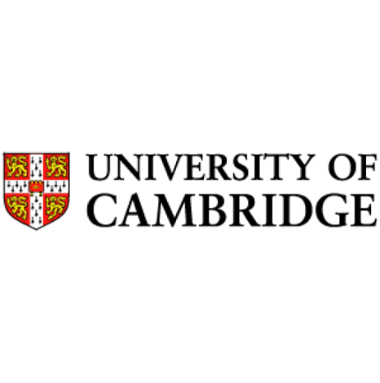

How to apply

Applications should be submitted online via the University of Cambridge jobs page www.jobs.cam.ac.uk by clicking “Apply online” in the job advert. You will need an email
address to register for our online system.

Conversations about flexible working are encouraged at the University of Cambridge. Please feel free to discuss flexibility prior to applying (using the contact information below) or at
interview if your application is successful.

Informal enquiries are welcomed and should be directed to Mrs Jeanette Almond, HR Administrator.
Email: hr@ceb.cam.ac.uk

The closing date for applications is the 9th November 2026.

In person interviews are scheduled for the week commencing 16th November 2026.

CAMBRIDGE
UNIVERSITY OF

