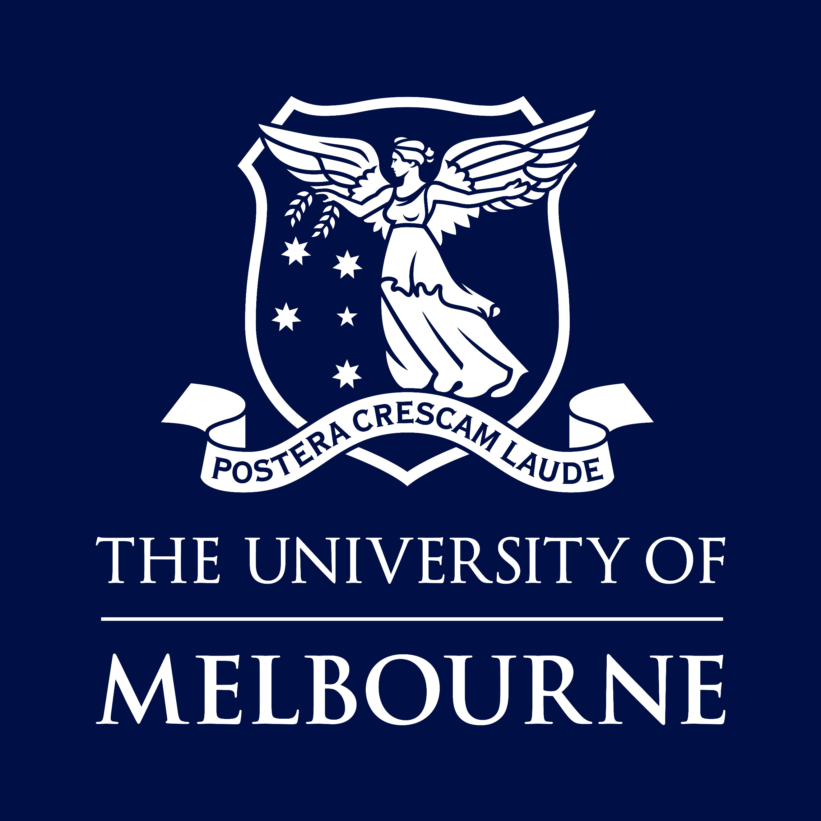

POSITION DESCRIPTION

School of Geography, Earth and Atmospheric Science
Faculty of Science
Research Fellow in the Political Ecology of Fire and Climate Change Adaptation in the Philippines and Timor-Leste
Position No | 3556954
Classification | Level A
Salary | $87,266 - $118,416 per annum (pro rata for part-time)  (*PhD entry level $110,319 p.a.)
Superannuation | Employer contribution of 17%
WORKING HOURS | Part time (0.8 FTE) (4 days of the week)
BASIS OF EMPLOYMENT | Fixed term available for 12 months, starting Feb 28 2027  FLEXIBLE EMPLOYMENT  The University of Melbourne is strongly committed to supporting diversity and flexibility in the workplace. Applications for part-time or other flexible working arrangements will be welcomed and will be fully considered subject to meeting the inherent requirements of the position.
Other Benefits | https://about.unimelb.edu.au/careers/staff-benefits
How to Apply | Online applications are preferred. Go to http://about.unimelb.edu.au/careers, select the relevant option (‘Current Opportunities’ or ‘Jobs available to current staff’), then find the position by title or number.
contact  For enquiries only | Professor Wolfram Dressler  Email wolfram.dressler@unimelb.edu.au  Please do not send your application to this contact
For information about working for the University of Melbourne, visit our website:
about.unimelb.edu.au/careers

Acknowledgement of Country
The University of Melbourne acknowledges the Traditional Owners of the unceded land on which we work, learn and live: the Wurundjeri Woi Wurrung and Bunurong peoples (Burnley, Fishermans Bend, Parkville, Southbank and Werribee campuses), the Yorta Yorta Nation (Dookie and Shepparton campuses), and the Dja Dja Wurrung people (Creswick campus).
The University also acknowledges and is grateful to the Traditional Owners, Elders and Knowledge Holders of all Indigenous nations and clans who have been instrumental in our reconciliation journey.
We recognise the unique place held by Aboriginal and Torres Strait Islander peoples as the original owners and custodians of the lands and waterways across the Australian continent, with histories of continuous connection dating back more than 60,000 years. We also acknowledge their enduring cultural practices of caring for Country.
We pay respect to Elders past, present and future, and acknowledge the importance of Indigenous knowledge in the Academy. As a community of researchers, teachers, professional staff and students we are privileged to work and learn every day with Indigenous colleagues and partners.

Position Summary

Should this position be advertised; to meet Immigration Labour Market Testing it is important to include Minimum qualifications and required work experience (such as relevant research areas, project experience).
The ideal candidate is a junior research fellow with a strong background in the critical ethnography of fire politics, cultural burning, gendered livelihoods, and climate change adaptation in Southeast Asia, particularly the Philippines and Timor-Leste. They should demonstrate a deep understanding of agrarian change and political ecology, cultural sensitivity and respect for local knowledge and practices, and the ability to conduct ethnographic fieldwork in remote rural settings under challenging conditions. The candidate should also have a demonstrated capacity to collaborate and publish within an interdisciplinary team of researchers, while engaging effectively with local communities and practitioners across both countries.
We encourage applicants from under-represented groups, including Aboriginal and Torres Strait Islander people. To allow us to consider performance relative to opportunity, we also invite applicants to provide a brief statement (up to 1 page) that describes circumstances that may have affected their career development or progression, including career interruptions or delays, periods of part time work, or forms of bias they have experienced.

Key Responsibilities
As with all positions, career achievements will be interpreted relative to opportunity, including career disruptions due to caring responsibilities, time in industry, illness etc.
The position description should be read alongside Academic Career Benchmarks and Indicators. A level A academic is acquiring skills and building academic achievements (oriented towards the benchmarks).

Research and research training
The appointee will be expected to:
- You are expected to significantly contribute towards the research effort of the team and to develop your research expertise with an increasing degree of autonomy
- Under the guidance and support of Senior Academic staff conduct internationally competitive research, resulting in publications in high impact journals
- Contribute to and publish academic papers and other scholarly outputs to a high academic standard in accordance with the research expectations of the University of Melbourne
- Actively participate in research seminars and conferences to disseminate research findings as opportunities arise
- Contribute to the preparation, or where appropriate individual preparation of research proposal submissions to internal or external funding bodies as relevant
- Undertake administrative functions and obligations primarily connected with the staff member’s area of research
- Contribute to and assist in the co-supervision and training of research students primarily at undergraduate level
- Engage with relevant professional and industry bodies and stakeholders to foster collaborative partnerships

education and learning
The appointee will be expected to:
- Contribute to training, scientific mentoring and supervision of students
- Contribute to the effective supervision of junior research staff in the appointee’s area of expertise

leadership and service
The appointee will be expected to:
- Actively participate at School meetings and with guidance, contribute to planning activities or committee work to support capacity building in the School/discipline
- Actively participate in activities within the School and Faculty to support Diversity and Inclusion
- Contribute to, or present research to the public to elevate public awareness of educational and scientific developments and promote critical enquiry and public debate within the community where appropriate
- Effective demonstration and promotion of University values including diversity and inclusion and high standards of ethics and integrity
- Actively contribute to School activities such as Open day to promote student engagement

other duties
The appointee will be expected to:
- Perform other tasks as requested by the supervisor or the Head of School
- Actively participate in the University Professional Development Framework
- Ensure timely completion of required University compliance courses and declarations, such as, but not limited to, Appropriate Workplace Behaviour, PDF for Staff and Supervisors and OH &S training courses, Conflict of Interest declarations and Foreign Interest disclosures
- Occupational Health and Safety (OH&S) and Environmental Health and Safety (EH&S) responsibilities as outlined in section 4

- Selection Criteria

2.1 EDUCATION/QUALIFICATIONS
- Completion (or near completion) of a PhD between 2020-2026 in Human Geography, Anthropology, Development Studies, or a related discipline.

2.2 ESSENTIAL
- Required skills and attributes:
- Demonstrated knowledge of and experience in ethnographic research methods, political ecology, agrarian studies, and postcolonial and decolonial theory, particularly in Southeast Asian contexts.
- Strong ethnographic research skills and an understanding of Indigenous ethnoecologies, customary practices and human–environment relations, particularly those concerning fire, land management and burning practices.
- Demonstrated cultural sensitivity, respect for Indigenous knowledge systems and customary institutions, and a commitment to ethical, collaborative and culturally appropriate research with Indigenous and rural communities.
- Fluency in, or a demonstrated willingness to learn, Filipino, Tetum and relevant Indigenous languages spoken in the research areas.
- Willingness and capacity to undertake extended ethnographic fieldwork in remote and isolated rural settings, often under challenging physical and logistical conditions.
- Demonstrated research aptitude and a record of publication in relevant fields, particularly human geography, anthropology and political ecology, commensurate with career stage and opportunities.
- Demonstrated ability to prepare high-quality research reports and manuscripts for publication in leading international journals.
- Strong commitment to developing an independent academic research career, with the capacity to contribute to collaborative research projects and scholarly publications.
- Excellent written and oral communication skills in local languages and English, including the ability to present research findings effectively at regional and international conferences, workshops and community forums.
- Demonstrated ability to work collaboratively and respectfully within multidisciplinary and cross-cultural research teams, including with Indigenous researchers, local communities, NGOs and other research partners.
- Experience engaging with relevant community organisations, professional bodies and other stakeholders to establish and sustain equitable, productive research partnerships.
- Demonstrated commitment to diversity, equity and inclusion in academic research, fieldwork and university settings, including sensitivity to cultural differences, local protocols and power relations.
- Excellent organisational and project management skills, including the ability to coordinate fieldwork, manage competing priorities, meet deadlines and deliver research outputs on schedule.
- Demonstrated capacity to design, implement and complete rigorous research projects with limited supervision, while contributing constructively to broader collaborative research objectives.

2.3 DESIRABLE
- The ability to attract external funding through grant applications and/or support in funded joint projects with others internal or external to the University
- Experience in assisting with supervision of students undertaking undergraduate or higher degree research projects

2.4 OTHER JOB-RELATED INFORMATION
- Occasional work out of ordinary hours, travel, etc.
- This position requires the incumbent hold a current and valid Working with Children Check. The University of Melbourne is dedicated to safeguarding the welfare of all community members, especially those most vulnerable. As part of our commitment to child safety and in line with the Victorian Child Safe Standards, this position will be required to hold a valid Employee WWCC, regardless of where in the University an employee may work or what work they do (Mandatory for all employees)

Equal Opportunity, Diversity and Inclusion
The University is an equal opportunity employer and is committed to providing a workplace free from all forms of unlawful discrimination, harassment, bullying, vilification and victimisation. The University makes decisions on employment, promotion, and reward on the basis of merit.
The University is committed to all aspects of equal opportunity, diversity and inclusion in the workplace and to providing all staff, students, contractors, honorary appointees, volunteers and visitors with a safe, respectful and rewarding environment free from all forms of unlawful discrimination, harassment, vilification and victimisation. This commitment is set out in our Diversity and Inclusion Strategy 2030 that addresses diversity and inclusion, equal employment opportunity, discrimination, sexual harassment, bullying and appropriate workplace behaviour. All staff are required to comply with all University policies.
The University values diversity because we recognise that the differences in our people’s age, race, ethnicity, culture, gender, nationality, sexual orientation, physical ability and background bring richness to our work environment. Consequently, the People Strategy sets out the strategic aim to drive diversity and inclusion across the University to create an environment where the compounding benefits of a diverse workforce are recognised as vital in our continuous desire to strive for excellence and reach our strategic targets.

Occupational Health and Safety (OHS)
All staff are required to take reasonable care for their own health and safety and that of other personnel who may be affected by their conduct.
OHS responsibilities applicable to positions are published at:
https://safety.unimelb.edu.au/people/community/responsibilities-of-personnel
These include general staff responsibilities and those additional responsibilities that apply for Managers and Supervisors and other Personnel.

Governance
The Vice-Chancellor is the Chief Executive Officer of the University and responsible to Council for the good management of the University.
Comprehensive information about the University of Melbourne and its governance structure is available at https://about.unimelb.edu.au/strategy/governance

Strategy 2030: Resilience
As set out in the University of Melbourne's Strategy 2030, our purpose is to benefit society through the transformative impact of our education and research. This can only be achieved by building a resilient institution, empowering our people, and working toward shared ambitions.
Our aspiration for 2030 is to be a world-leading, globally connected Australia university with students at the heart of everything we do. Strategy 2030 provides a sharp focus to advance our shared ambitions and guide us through to 2030.
It elevates three core ambitions:
• Exceptional Education: Educating our outstanding students to thrive in complexity
• Transformational Research: Creating knowledge, fostering innovation and transforming lives
• Our Resilient University: Serving and connecting Country, people and community
The strategy identifies our University’s distinctive capabilities including Indigenous scholarship, world-class curriculum, our diverse community and our global research networks and precincts.

Four focus areas for action guide decision-making and ensure the University is equipped for challenges ahead. These are: Empowering people and performance, Improving student experience, Partnering for impact and Leading with a future-focus.
For more information, visit https://about.unimelb.edu.au/strategy/strategy-2030

- Other Information

7.1 ORGANISATION UNIT - SCHOOL OF GEOGRAPHY EARTH AND ATMOSPHERIC SCIENCES (SGEAS)
https://sgeas.unimelb.edu.au/
The School of Geography, Earth and Atmospheric Sciences was formally established in 2021, following the merger of the Schools of Geography and Earth Sciences. The new School synergises discipline strengths in geography, atmospheric science and geoscience. The School offers undergraduate and graduate research programs in these core discipline areas, and in the multi-disciplinary fields of Climate Change, Environmental Science and Archaeological Science. The research within the School is built upon extensive expertise in geography, geoscience and atmospheric science, ranging from the social sciences through to the quantitative physical sciences. In addition to internationally recognised discipline expertise, we have strengths in a number of multi-disciplinary areas including climate change; resource futures; space, place and social change; environmental hazards; Indigenous knowledge; and Earth system interactions. With strengths in both the spatial (local to global) and temporal (deep time as well as recent) dimensions of environmental change, the School is committed to achieving a better future for our students, society and the environment. We are committed to advancing reconciliation with Indigenous Australians through involvement with the Indigenous Knowledges Institute which is hosted within the Faculty of Science, research and teaching partnerships with Indigenous communities, and archaeological science. The School contributes strongly to the key areas of Place, Community, Education, Discovery, and Global in the University’s Advancing Melbourne Strategy.

7.2 FACULTY OF SCIENCE
www.science.unimelb.edu.au
Science at Melbourne is a global leader across discovery and applied scientific research and education. Science begins with curiosity, and we are dedicated to understanding the universe from the level of sub-atomic particles to the solar system. We aim to be leaders who positively impact the community locally and globally, addressing major societal issues from climate change to disease. Our discoveries help build an understanding of the world around us.
Our strength is our breadth of expertise. The Faculty is home to seven schools: Agriculture, Food & Ecosystem Sciences; BioSciences; Chemistry; Geography, Earth & Atmospheric Sciences; Mathematics & Statistics; Physics; and Melbourne Veterinary School.
The Faculty is also custodian of the Bio21 Molecular Science and Biotechnology Institute, Melbourne Energy Institute, Melbourne Biodiversity Institute, Oceania Institute, Office for Environmental Programs, Australian Mathematical Sciences Institute (AMSI) and the Indigenous Knowledge Institute and home to numerous Centres.
We are committed to the values of curiosity, excellence, impact and integrity. With deep disciplinary knowledge our faculty is uniquely positioned to take a globally leading role in understanding, exploring and shaping our world and humanity, within a truly comprehensive Faculty of Science.
We have more than 150 years of experience in pioneering scientific thinking and analysis, leading to outstanding teaching and learning and offer a curriculum based on highly relevant research. We aim to train students with the knowledge and intellectual flexibility to drive the industries of tomorrow and lead across all levels of society.
We offer a range of undergraduate, honours, graduate and research degrees, enrolling and supervising 12,239 undergraduates, 3,384 Master’s students and over 1,000 PhD researchers in 2025.
We are dedicated to delivering transformative educational outcomes, underpinned by research, and an inclusive and inspiring student experience.
Excellence comes in many forms and diversity of thought, perspective and disciplines is essential to deliver globally leading science. At the core of our success is our focus on an inclusive environment for all in our community. Our Faculty’s focus on equity, inclusion and belonging is grounded in our endeavour to ensure we are best placed to advance research, teaching and serve diverse national and global communities.
As a Science community we sit across five of the University’s campuses – Parkville, Dookie, Burnley, Creswick and Werribee. This reach provides us with a unique perspective that is beneficial to our teaching and research. It also means we can offer our students a greater variety of learning experiences and internships to engage with industry partners to solve real-world issues.

7.3 THE UNIVERSITY OF MELBOURNE
Established in 1853, the University of Melbourne is a leading international university with a tradition of excellence in teaching and research. The main campus in Parkville is recognised as the hub of Australia’s premier knowledge precinct comprising eight hospitals, many leading research institutes and a wide-range of knowledge-based industries. With outstanding performance in international rankings, the University is at the forefront of higher education in the Asia-Pacific region and the world.
The University of Melbourne employs people of outstanding calibre and offers a unique environment where staff are valued and rewarded.
Further information about working at The University of Melbourne is available at http://about.unimelb.edu.au/careers

