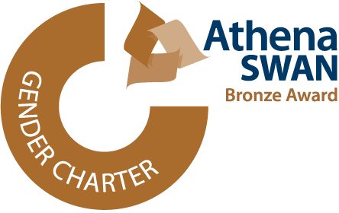
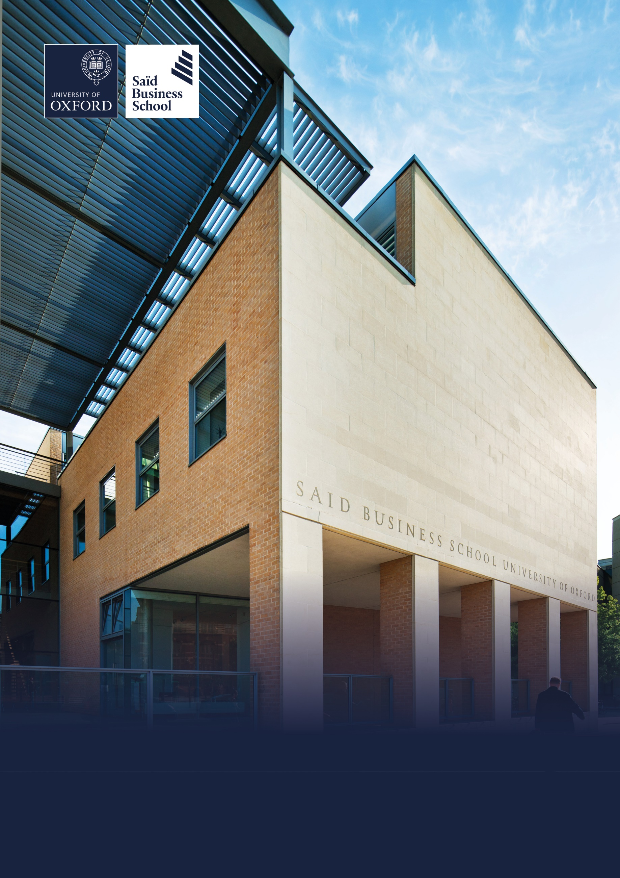

Hybrid (two days per week onsite), Global Leadership Centre and Park End Street, Oxford
Grade 9: £57,721 - £66,608 per annum including the Oxford University Weighting of £1,730 per annum
Permanent, full time (37.5 hours per week)
Saïd Business School, University of Oxford
Associate Director, Clients and Markets


The role

The Associate Director, Clients and Markets is a senior role within the Government and Public Value function within Executive Education at Said Business School, reporting to the Director, Government and Public Value. The postholder will be responsible for leading substantial, profitable, and enduring high-quality commercial relationships with large and medium sized organisations globally (companies, public sector organisations and government entities).
The Clients and Markets team are the driving force in enabling Executive Education to achieve its growth ambitions to double revenue in 3 years, and to realise its full potential as a leading player in the global Executive Education market. The Associate Director, Clients and Markets reports to the Director, Government and Public Value who leads a small team of sales and relationship professionals responsible for designing and implementing the overarching growth and business development strategy for that function.
Within that team of sales professionals, the Associate Director will be responsible for developing relationships with a portfolio of existing clients and for establishing new relationships with desirable organisations (as determined by the Director, GPV). A typical client portfolio will comprise a combination of existing client relationships worth £250k to £750k per year and may also include high potential clients where the team sees an opportunity to deliver accelerated revenue growth. In addition, the Associate Director will be responsible for an agreed portfolio of target organisations Executive Education wishes to develop a new strategic relationship with.

Therefore, it is likely that the Associate Director will be responsible for a portfolio of £1m-£2m revenue, and to grow that by £750k to £1m revenue each year.
The Associate Director, Clients and Markets will be required to work proactively to win and then develop these high value relationships with existing and high-potential / high-growth clients. This will involve rigorous account development and senior stakeholder engagement as well as networking and prospecting for potential business with new C-suite level contacts. They will be leading on larger opportunities, both drawing from our pre-existing ‘off-the-shelf’ propositions and customising learning solutions. It will be important for the post-holder to be able to direct sales of all types of Executive Education products, now and in the future, and to lead on the consultative sales process which underpins the sale of customised learning solutions.
The Associate Director, Clients and Markets will lead Executive Education responses to proposal requests which are a strong match for SBS’s capabilities, working in close partnership with the Commercial, Learning Innovation and Impact Teams as well as Associate Fellows and Faculty. These proposals might come through proactive, outreach and relationship development work or via inbound RFP’s which are sent into the team via an enquiry.
The Associate Director, Clients and Markets will play an ongoing role in managing the commercial relationship between Executive Education and their clients. The implementation of contracted services and day-to-day relationship management required to successfully deliver any programme will be provided by colleagues within the Client Engagement and Delivery Team and supported by colleagues in Learning Innovation and Impact / wider Associate learning community.
The Associate Director will lead this matrix team, being ultimately accountable for the ongoing success and growth of the relationship overall and act as sponsor to the client.

Responsibilities
- Manage a client portfolio of c. £1m to £2m revenue and add >£750k-£1m of incremental revenue from extending existing relationships or winning new clients each academic year.
- Take overall accountability for these client relationships, including quality and profitability of solutions provided and overall satisfaction with SBS, acting as a sponsor and implementing appropriate relationship governance.
- Lead on strategic account development of existing relationships and ‘high potential’ relationships – ensuring we maximise our sales of Executive Education offerings to these clients.
- Lead on prospecting for new business opportunities in target client organisations within agreed market.
- Lead on qualifying, pitching, winning, contracting and then mobilising new clients / programmes; ensuring the programme delivery teams are set up for success and that both the client and SBS business needs are understood and met.
- Lead the sales strategy and relationship process to win new clients and secure programmes, through proactive relationship development and leading bids and proposals, working closely with the commercial bid team, faculty and learning innovation and impact.
- Introduce and refer to other School offerings as appropriate, to promote our Open and Online Programmes.
- Role model sales excellence – recognised as an expert in the team, with knowledge and skills to win and develop client relationships through the highest quality interactions.
- Build effective mutually respectful relationships with stakeholders across Executive Education and collaborate closely with the Commercial Team in the production of high-quality bids and proposals.
- Understand the learning and Executive Education marketplace and develop your personal brand as a contributor in the industry.
- Represent Executive Education at networking events and SBS events.

Essential selection criteria
- Demonstrable experience of leading strategic, high-value clients and building deep and sustainable relationships with senior stakeholders in large organisations.
- Demonstrable experience of selling transformational learning programmes through knowledge of academic research, market intelligence and knowledge of consumer trends.
- Track record of exceeding revenue / growth targets through a focused approach to strategic sales and relationship development
- Understanding of consultative sales processes; qualifying, proposal writing and pitching effectively
- Commercially astute, effective at managing commercial bid processes and negotiations with senior clients.
- Displays an in-depth understanding of L&D and Exec Ed marketplace and contribute to discussions about organisational learning strategy and practice credibly with senior HR / L&D professionals.
- Excellent interpersonal skills including the ability to collaborate effectively with internal customers and external stakeholders.
- Outstanding written and oral communication skills with experience of writing and presenting proposals and pitches.
- A good team worker who demonstrates project management and leadership capabilities within a collaborative working culture.
- The ability to work under pressure and deliver assignments to internal customers and departmental stakeholders in a complex environment and organise often demanding work assignments to meet client demands.
- Track record of leading and coaching others to improve their effectiveness in client relationship management and account management processes
- Strong professional networking capability, and confidence working with a variety of internal and external stakeholders.

Desirable selection criteria
- Educated to degree level or equivalent, with a relevant professional qualification and/or membership of relevant professional body.
- Previous experience of working in the Executive Education department of an academic institution.
- Some experience of government, public sector or public sector healthcare.
- Experience of leading business development and sales activity within the learning industry.
- Understanding of principles of organisational development and L&D.
- Demonstrate our brand values: Transformational, Collaborative, Purposeful, Entrepreneurial, Respectful and Excellence in all interactions and outputs.

Pre-employment screening

Standard checks

If you are offered the post, the offer will be subject to standard pre-employment checks. You will be asked to provide: proof of your right-to-work in the UK; proof of your identity; and (if we haven’t done so already) we will contact the referees you have nominated. You will also be asked to complete a health declaration so that you can tell us about any health conditions or disabilities for which you may need us to make appropriate adjustments.

Please read the candidate notes on the University’s pre-employment screening procedures at Pre-employment Checks
(https://www.jobs.ox.ac.uk/pre-employment-checks).


About the University of Oxford
Welcome to the University of Oxford. We aim to lead the world in research and education for the benefit of society both in the UK and globally. Oxford’s researchers engage with academic, commercial and cultural partners across the world to stimulate high-quality research and enable innovation through a broad range of social, policy and economic impacts.

We believe our strengths lie both in empowering individuals and teams to address fundamental questions of global significance, while providing all our staff with a welcoming and inclusive workplace that enables everyone to develop and do their best work. Recognising that diversity is our strength, vital for innovation and creativity, we aspire to build a truly diverse community which values and respects every individual’s unique contribution.

While we have long traditions of scholarship, we are also forward-looking, creative and cutting-edge. Oxford is one of Europe’s most entrepreneurial universities and we rank first in the UK for university spin-outs, and in recent years we have spun out 15-20 new companies every year. We are also recognised as leaders in support for social enterprise.

Join us and you will find a unique, democratic and international community, a great range of staff benefits and access to a vibrant array of cultural activities in the beautiful city of Oxford. For more information, please visit Organisation | University of Oxford (www.ox.ac.uk/about/organisation).

Saïd Business School
Saïd Business School blends the best of new and old. We are a vibrant and innovative business school, but yet deeply embedded in an 800 year old world-class university. We create programmes and ideas that have global impact. We educate people for successful business careers, and as a community seek to tackle world-scale problems.

We deliver cutting-edge programmes, including the highly regarded MBA, Executive MBA, a number of specialist MScs, a portfolio of custom and open programmes and accredited diplomas for executives, and we undertake ground-breaking research that transform individuals, organisations, business practice and society. We are an international and outward looking School with our programme participants coming from more than 50 countries.

We seek to be a world-class business school community, embedded in a world-class University, tackling world-scale problems.

Sustainability
Saïd Business School is committed to the highest standards of environmental sustainability, preserving the planet for future generations and acting in a socially sustainable manner. As an employee you are expected to uphold these commitments in accordance with our Environmental Policy. You can learn more about our organisation’s sustainability efforts at Sustainability | Saïd Business School (https://www.sbs.ox.ac.uk/about-us/school/sustainability).

Diversity and Inclusion
Oxford Saïd is committed to fostering an inclusive culture which promotes equality, values diversity and maintains a working, learning and social environment in which the rights and dignity of all its staff and students are respected. We recognise that the broad range of experiences that a diverse staff and student body brings strengthens our research and enhances our teaching, and that in order for Oxford to remain a world-leading institution we must continue to provide a diverse, inclusive, fair and open environment that allows everyone to grow and flourish.

Oxford Saïd holds a bronze Athena Swan award to recognise advancement of gender equality: representation, progression and success for all.

Our Values
To better understand our Values, what behaviours demonstrate them and how they are involved in your everyday work we have created the below descriptors.

Transformational
We challenge constructively, provoke thought, and influence and inspire others to develop.

Respectful
We are caring, supportive, appreciative, embrace difference and value each other's opinions.

Entrepreneurial
We embrace and encourage change and innovation. We are creative, flexible and brave.

Collaborative
We are stronger together. We are inclusive, approachable, listen to others and value good communication.

Purposeful

We are a community who believe in sustainable growth, and are responsible, principled and transparent.

Excellence
We are professional, focused and aligned, and have a responsibility to do the very best we can.

Wellbeing
Saïd Business School acknowledge the importance of wellbeing, in enabling people to thrive at work and ensure a work-life balance. It provides a number of initiatives to help support wellbeing and would encourage you to participate. At an individual level, wellbeing means recognising what helps us remain resilient and taking appropriate steps. If we experience difficulties, doing our best to rectify them and making our line manager aware of aspects that they could support us with.

Further information about Saïd Business School is available at Saïd Business School (www.sbs.oxford.edu).

Social Sciences
Oxford Saïd is a department within the Social Sciences Division, one of four academic Divisions in the University, each with considerable devolved budgetary and financial authority; and responsibility for providing a broad strategic focus across its constituent disciplines.

The Social Sciences Division represents the largest grouping of social sciences in the UK: home to a number of outstanding departments and to the internationally ranked Law Faculty; all are committed to research to develop a greater understanding of all aspects of society, from the impact of political, legal and economic systems on social and economic welfare to human rights and security. That research is disseminated through innovative graduate programmes and enhances undergraduate courses. For more information please visit Social Sciences Division (https://www.socsci.ox.ac.uk).


Important information for candidates

Data Privacy
Please note that any personal data submitted to the University as part of the job application process will be processed in accordance with the GDPR and related UK data protection legislation. For further information, please see the University’s Privacy Notice for Job Applicants at Job applicant privacy policy (https://compliance.admin.ox.ac.uk/job-applicant-privacy-policy).

The University’s Policy on Data Protection is available at Data protection policy (https://compliance.admin.ox.ac.uk/data-protection-policy).

The University’s policy on retirement
The University operates an Employer Justified Retirement Age (EJRA) for very senior research posts at grade RSIV/D35 and clinical equivalents E62 and E82 of 30 September before the 70th birthday. The justification for this is explained at The EJRA (https://hr.admin.ox.ac.uk/the-ejra).

For existing employees, any employment beyond the retirement age is subject to approval through the procedures. Please see The EJRA (https://hr.admin.ox.ac.uk/the-ejra).

There is no normal or fixed age at which staff in posts at other grades have to retire. Staff at these grades may elect to retire in accordance with the rules of the applicable pension scheme, as may be amended from time to time.

Equality of opportunity
The University of Oxford is committed to equal opportunity and to being a place where everyone belongs and is supported to succeed. We recognise how the diversity of our community enriches our ability to deliver on our academic mission.

We welcome applications from individuals from all backgrounds, including those underrepresented within higher education. No applicant or member of staff shall be unlawfully discriminated against on the basis of age, disability, gender reassignment, marriage or civil partnership, pregnancy or maternity, race, religion or belief, sex or sexual orientation.

Employment with the University and progression within employment will be determined according to personal merit and the application of criteria related to the duties and conditions of the post. In all cases, the primary consideration will be the ability to perform the job.

As stated in the University’s Equality Policy and Equality, Diversity and Inclusion Strategic Plan, our commitment to equality and diversity goes hand in hand with our commitment to academic freedom and free speech.


Oxford Saïd Exclusive Benefits
Wellbeing initiatives

Oxford Saïd runs a fortnightly Wellbeing Wednesday when staff are encouraged to take time (one hour for full-time staff and half an hour for part-time staff) during the working day to focus on their wellbeing in addition to their lunch break. We also have excellent catering facilities that provide a high standard of food, including healthy eating and vegetarian options at a subsidised cost.

Staff Summer and Christmas parties

Oxford Saïd like to reward all their staff for their great work and their Christmas and Summer parties are our way of saying thank you. The Christmas party is for all staff, and the summer party is for staff and their immediate family members, because we know how important family is to all of us.

Employee Assistance provider

Spectrum Life is an employee assistance and wellbeing consultancy that works in partnership with the Business School to provide staff and their immediate family with a free 24-hour per day helpline providing confidential information and counselling services on personal issues.

University of Oxford Benefits

Annual leave
38 days (inc. public holidays). Long service additional annual leave – up to 5 days per annum, pro rata for part time employees. Previous service within higher education sector can be recognised. An additional scheme enables staff to request to purchase up to 10 additional days in each holiday year.

Salary and salary sacrifice schemes
The University salary and grading structure allows for annual incremental progression until a scale-bar point is reached. This incremental progression is automatic. Additionally, there are salary sacrifice schemes for bicycles and electric cars. See Staff benefits (https://hr.admin.ox.ac.uk/staff-benefits).

Pension
If you are on an academic or academic related pay scale (grade 6 or above), you are automatically a member of USS. Employer contribution is 14.5% and Employee contribution is 6.1%.

If you are on a pay scale other than academic or academic related (grade 1-5) you are automatically a member of OSPS. Employee contribution can be between 4%- 8% and Employer contribution 10%-14%.

University discounts
All University staff can purchase a TOTUM discount card for £14.99 for 12 months (£24.99 for 2 years, £34.99 for 3 years) which gives access to numerous exclusive offers and discounts from many popular retailers. There are a wide range of other discounts from external companies available using a university card.

University Club
Membership of the University Club is free for all University staff. The University Club offers social, sporting and hospitality facilities. Staff can also use the University Sports Centre on Iffley Road at discounted rates, including a fitness centre, powerlifting room and swimming pool. See The University Club (www.club.ox.ac.uk) and Oxford University Sport (https://www.sport.ox.ac.uk).

Access to Oxford buildings
Free access to a number of Oxford colleges, Botanic Gardens, Harcourt Arboretum, Wytham Woods and discount at numerous restaurants/shops.



Saïd Business School
University of Oxford
Park End Street
Oxford, OX1 1HP
Saïd Business School, University of Oxford
United Kingdom
www.sbs.oxford.edu

All information is correct at the time of going to press.

Please check our website for the most up-to-date information.

