
Job Description

Position | Research Fellow | Position no: | 17110
College / Directorate / Institute | College of Engineering, Design and Physical Sciences  Department of Engineering
Grade | R1
Contract type | Fixed-Term 18 months
Full time/Part time | Full time
Accountable to | Sotirios Argyroudis
Reports | Sotirios Argyroudis
Internal stakeholders | Academic Staff
External stakeholders | Project partners and stakeholders
Date reviewed | Oct 2026

Summary

We are seeking a highly motivated Research Fellow to contribute to CLIMABUILD, a Horizon Europe research project developing innovative methodologies and digital decision-support solutions to enhance the resilience, sustainability and climate adaptability of buildings and the wider built environment. The role will focus particularly on developing mathematical and computational models of sustained resilience, integrating lifecycle performance, climate resilience, whole-life carbon and circularity, and contributing to the assessment and optimisation of climate-responsive, low-carbon building renovation strategies.
Working closely with the Project Principal Investigator, Co-Investigators and international consortium partners, the postholder will contribute to high-quality scientific research and publications, support the coordination and delivery of project activities, and strengthen research dissemination and impact. The position is offered initially for 18 months, with the possibility of extension, subject to funding and project requirements.

Main accountabilities:

To undertake original, high-quality research on the resilience and sustainability of the built environment, focusing on quantitative modelling, lifecycle assessment and computational methods. To contribute to the development of scientific methodologies, research publications and project deliverables, and support the coordination, dissemination and impact of the CLIMABUILD project.

Post Profile

Under supervision of the Principal Investigator(s) the post-holder will:

- produce high-quality original research
- take the initiative in planning and organising research and dissemination activities
- support project management and administrative tasks
- support the work of small research teams and have direct engagement with stakeholders and the project’s co-creation community.
Duties and responsibilities:

- Take a proactive role in planning and undertaking the research project, individually and/or jointly, to meet the project deliverables and the Department/Institute, College and University research strategy.

- Develop and apply mathematical and computational models of sustained resilience, including lifecycle performance indicators and archetypes representing deterioration, disruption, recovery, adaptation and renovation of buildings and building portfolios.

- Develop and implement quantitative methods for assessing the lifecycle resilience and sustainability of renovation strategies, incorporating whole-life carbon, embodied and operational environmental impacts, circularity, durability and comparisons with business-as-usual scenarios.

- Contribute to computational modelling, uncertainty and sensitivity analysis, multi-criteria assessment, and the integration of research outputs into digital twins, knowledge graphs and AI-enabled decision-support systems, including LLM- and RAG-based approaches, in collaboration with project partners.

- Document research activities, including collection, analysis and interpretation of all data, maintaining records and databases, preparing technical reports and papers, as appropriate.

- Establish and maintain your personal research profile and reputation, and those of the University, through: (a) building a track record of high-quality research outputs; (b) enhancing the impact of research; and, (c) undertaking activities that enhance your reputation as a researcher.

- Assist in the development and implementation of a strategy to deliver the project, including planning, scheduling, and organising project meetings, maintaining documentation of project activities, progress, deliverables, and milestones. Preparing internal and external reports as required by the funding body.

- Presentation of work at international and national conferences, seminars and workshops to enhance your research profile. Organisation of seminars and co-creation events.

- Supports the PI in identifying potential funding sources and assist with preparing funding proposals, to support dissemination of your research and future projects and impact. May seek appropriate opportunities to apply for external Fellowships and small grants where eligible.

- Pro-actively develop and maintain collaborations with colleagues across the University, as appropriate, and the wider community (Academic, Governmental, NGO, Industrial Partners).

- Proactively support research activities within your project team, research group or centre, and Department or Institute, to enhance the research culture across the University.

- Assist in the effective development of less experienced members of the project team (e.g. undergraduate and/or postgraduate students, doctoral researchers) through organisation, supervision, mentoring and training, as appropriate.

- Perform administrative tasks related to your research project, including coordination of work packages and tasks, partner communication, reporting obligations, collection and reporting on project Key Performance Indicators (KPIs)

- Where appropriate to the role and project develop teaching/supervisory skills through contributing to teaching/supervisory and training activities

- Keep up to date with recent advances in your area of expertise and the wider discipline.

- Engage in personal, professional and career development, to enhance your specialist and transferable skills in accordance with your desired career trajectory.

- Postholders may be engaged to work on a specific project however will be expected to support the Principal Investigator on other projects if required

Management of Staff and Students (Responsibilities and Accountability)

- Provide guidance to staff and students and supervises work of small research team including Research Assistants and Technicians.

Brunel Values
Open
We are welcoming and believe in the power of diversity. We are transparent in our decisions and deliver on what we say.
Courageous
We seek and take on ambitious challenges. We are brave and committed to thinking differently. Nothing stops us from going after our goals.
Inventive
We are purposeful in an ever-changing world. Collaborating and innovating to reach our full potential and to change lives - and the world - for the better. We celebrate breakthroughs and strive for the best

University Employment Policy:

- Undertake any other reasonable duties as required and commensurate with the grade of post.

- Adhere to and comply with the provisions of the Data Protection Act and the Health and Safety at Work Act in accordance with University policies.

- Undertake all duties and responsibilities in compliance with the rules and regulations encompassing equal opportunities to help foster a diverse workforce.

- Adhere, comply and work in accordance with University and Departmental policies, procedures and codes of conduct.

- Promote the University’s Environmental Policy and demonstrate commitment to it through actions and decision making.

- Actively participate in on-going professional development activities as requested

Organisational Chart
The organisational chart comprises of the role, the manager of the role and any direct reports to the role.

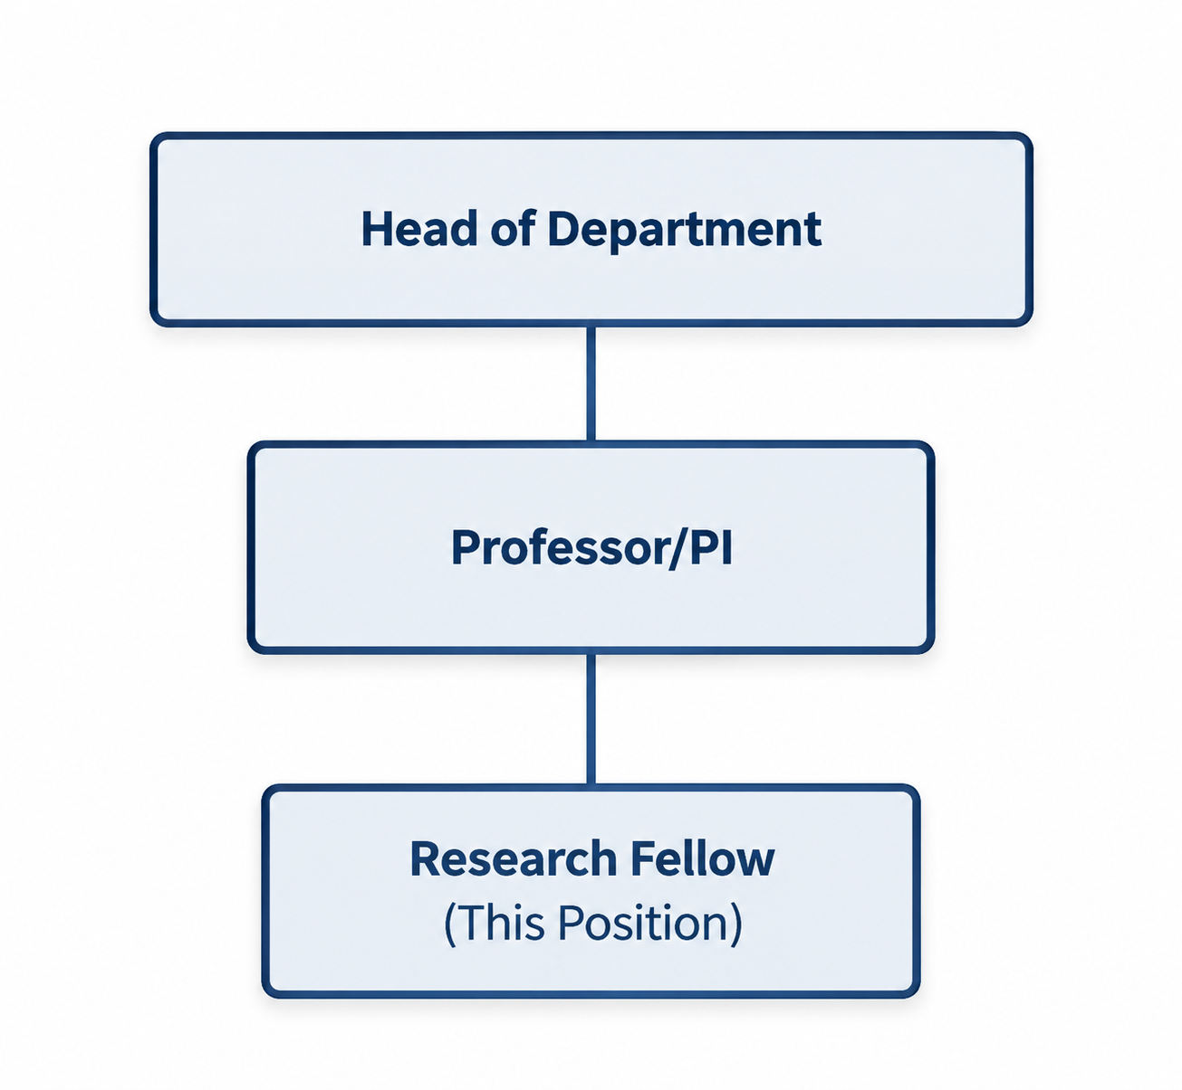



Disabled applicants meeting the Essential criterion will be guaranteed an interview as part of the University’s commitment to the Disability Confident Scheme.

Person Specification

Attributes | Criteria | Essential /Desirable | How measured (to be updated by recruiting manager)
Education, qualifications & training | PhD in appropriate Discipline (Civil, Environmental, Infrastructure Engineering, Computer Science or a closely related discipline)  OR  Equivalent research, industrial or commercial experience. (Minimum 4 years). | E | Application form
Experience | Evidence of research attainment including examples of contributing to high-quality academic research outputs  Evidence of successful delivery of components of original research projects  Experience of contributing to organising and supervising a project team  Proven experience of planning research activities and preparing research proposals.  Experience working on externally funded, multi-partner, or international research projects.  Experience engaging with stakeholders, industry partners, or communities of practice. | E  E  E  E  D  D | Application form, Interview  Application form,  Interview  Application form,  Interview  Application form,  Interview  Application form,  Interview  Application form,  Interview
Knowledge Skills & Abilities | Sound knowledge of resilience and sustainability assessment of buildings and infrastructure, including lifecycle performance, climate adaptation, whole-life carbon and circularity.  Knowledge of at least one of the following: life-cycle assessment (LCA), whole-life carbon (WLC), climate-risk or resilience assessment, or lifecycle performance modelling.  Ability to develop or apply quantitative computational models, simulations or data-driven approaches to assess the performance, resilience or sustainability of buildings and infrastructure.  Strong analytical and programming skills, including experience with Python, MATLAB, R or equivalent tools for scientific modelling, data analysis and reproducible research.  Understanding of digital technologies and AI-enabled decision-support systems, including digital twins, knowledge graphs and Large Language Models (LLMs), with awareness of Retrieval-Augmented Generation (RAG) and their potential applications in engineering research, knowledge management and data-driven decision-making.  Excellent written and verbal communication skills, including the ability to prepare scientific publications, technical reports and presentations for specialist and non-specialist audiences.  Ability to undertake research independently, critically evaluate results and maintain well-documented, open and reproducible research practices.  Experience in probabilistic modelling, uncertainty and sensitivity analysis, multi-criteria decision analysis or multi-objective optimisation.  Familiarity with dynamic life-cycle assessment, lifecycle costing, circularity assessment or relevant standards and frameworks (e.g., EN 15978, EN 15804 and EU Level(s)).  Experience in developing or integrating computational models with digital platforms or AI-enabled applications, including LLMs, RAG, knowledge graphs, digital twins, BIM/GIS, application programming interfaces (APIs) or intelligent decision-support systems. | E  E  E  E  E  E  E  D  D  D | Application form,  Interview  Application form,  Interview  Application form,  Interview  Application form,  Interview  Application form,  Interview  Application form,  Interview  Application form,  Interview  Application form,  Interview  Application form,  Interview  Application form,  Interview
Additional Requirements (not included above) | Willingness to undertake occasional UK and international travel for project meetings, workshops and dissemination activities, subject to reasonable adjustments.  Ability to work effectively and collaboratively within an international and interdisciplinary research environment, engaging with academic, industry and other project partners. | E  E | Interview  Interview

JOB HAZARD DECLARATION

A job specific risk assessment has been undertaken, and recorded, for this post.

Yes ☒ No ☐

The risk assessment has identified the need for Health Surveillance.

Yes ☐ No ☒

If you have selected “Yes” then please specify:

- What type of surveillance is required and why?

- Whether or not you have sought advice from Occupational Health or the Health, Safety & Environment Team?

The work involved requires vaccination

Yes ☐ No ☒

If you have selected “Yes” then please specify:

- What type of Vaccination is required and why?

- Whether or not you have sought advice from Occupational Health or the Health, Safety & Environment Team?

For inclusion with job description:

Please provide answers to the following questions. Please add additional items as necessary. For further advice please contact healthandsafety@brunel.ac.uk (“No” responses should be deleted before advertising.)

- This role involves working with Display Screen Equipment for extended periods of more than 1 hour per day
Yes ☒ No ☐

- This role involves frequent manual handling and/or may be physically demanding
Yes ☐ No ☒

- This role involves working outside for long periods of time
Yes ☐ No ☒

- This role involves working at Height
Yes ☐ No ☒

- This role involves work in confined spaces
Yes ☐ No ☒

- This role involves working in a noisy environment
Yes ☐ No ☒

- This role involves Travel
Yes ☐ No ☒

- This role involves regular work with vibrating equipment
Yes ☐ No ☒

- This role involves driving
Yes ☐ No ☒

The information provided above is, to the best of my knowledge, true and accurate.

Name:  Sotirios Argyroudis | Signature:  Sotirios Argyroudis | Date:  16 Oct 2026

