
Job Description

Position | Research Assistant | Position no: | 17110
College / Directorate / Institute | College of Engineering, Design and Physical Sciences  Department of Engineering
Grade | R1
Contract type | Fixed-Term 18 months
Full time/Part time | Full time
Accountable to | Sotirios Argyroudis
Reports | Sotirios Argyroudis
Internal stakeholders | Academic Staff
External stakeholders | Project partners and stakeholders
Date reviewed | Oct 2026

Summary

We are seeking a highly motivated Research Assistant to contribute to CLIMABUILD, a Horizon Europe research project developing innovative methodologies and digital decision-support solutions to enhance the resilience, sustainability and climate adaptability of buildings and the wider built environment. The role will support research activities involving resilience and sustainability assessment, computational modelling, lifecycle performance, whole-life carbon and climate-responsive, low-carbon building renovation strategies. Working closely with the Project Principal Investigator, Co-Investigators and international consortium partners, the postholder will assist in developing and applying quantitative research methods, collecting and analysing data, supporting computational modelling and contributing to digital and AI-enabled decision-support applications. The role will also support the preparation of research publications, project deliverables, coordination activities and dissemination outputs.
The position is offered initially for 18 months, with the possibility of extension, subject to funding and project requirements.

Main accountabilities:

To contribute to research on the resilience and sustainability of the built environment by supporting quantitative modelling, lifecycle assessment, data analysis and the application of computational and digital methods. To assist in the development of research methodologies, publications and project deliverables, and support the coordination, dissemination and impact of the CLIMABUILD project.

Post Profile

- Under supervision of the Principal Investigator(s) the post-holder will:

- Contribute to original research through data collection, analysis, computational modelling and preparation of research outputs.

- Take initiative in supporting the planning and organisation of research and dissemination activities.

- Support project management, documentation and administrative tasks.

- Work collaboratively within the research team and engage with international project partners, stakeholders and the project's co-creation community.

Duties and responsibilities:

- Assist in undertaking the research project, individually and/or jointly, to meet project deliverables and contribute to the Department/Institute, College and University research strategy.

- Support the development and application of mathematical and computational models for assessing the resilience, sustainability and lifecycle performance of buildings and infrastructure, including deterioration, disruption, recovery, adaptation and renovation scenarios.

- Assist in the collection, processing and analysis of data relevant to building and infrastructure performance, climate risks, lifecycle assessment, whole-life carbon, circularity and renovation strategies.

- Contribute to the implementation and testing of quantitative and data-driven methods, computational simulations, scenario analysis and performance indicators, using appropriate programming and modelling tools.

- Support research activities involving digital technologies and AI-enabled decision-support applications, including digital twins, knowledge graphs, Large Language Models (LLMs) and Retrieval-Augmented Generation (RAG), in collaboration with project partners.

- Document research activities, including data collection, analysis and interpretation, maintaining research records and databases, preparing figures, technical reports and draft research papers, as appropriate.

- Contribute to the preparation of scientific publications, conference papers and other research outputs, supporting the development of a personal research profile and the University's research impact.

- Assist in planning, scheduling and organising project meetings, workshops and research activities, maintaining documentation of project progress, deliverables and milestones, and preparing reports as required by the funding body.

- Support collaborations with colleagues across the University and external academic, governmental, industry and community partners, including participation in stakeholder engagement, Living Labs and co-creation activities.

- Support research dissemination through preparation of presentations, project materials, workshops, seminars and conference contributions.

- Perform administrative tasks related to the research project, including partner communication, monitoring of project activities, reporting obligations and collection of information on project Key Performance Indicators (KPIs).

- Contribute positively to research activities within the project team, research group or centre, and Department or Institute, and assist colleagues and students with relevant research activities where appropriate.

- Where appropriate to the role and project, develop teaching and supervisory skills through contributing to teaching, training or student-support activities.

- Keep up to date with recent advances in the relevant research area and engage in personal, professional and career development to enhance specialist and transferable skills.

- Postholders may be engaged to work on a specific project but may also be expected to support the Principal Investigator on other projects, as required and appropriate to the grade.

Management of Staff and Students (Responsibilities and Accountability)

Provide guidance and assistance to students and colleagues on relevant aspects of research activities, under the supervision of the Principal Investigator. The post does not normally involve formal line-management responsibilities.

Brunel Values
Open
We are welcoming and believe in the power of diversity. We are transparent in our decisions and deliver on what we say.
Courageous
We seek and take on ambitious challenges. We are brave and committed to thinking differently. Nothing stops us from going after our goals.
Inventive
We are purposeful in an ever-changing world. Collaborating and innovating to reach our full potential and to change lives - and the world - for the better. We celebrate breakthroughs and strive for the best

University Employment Policy:

- Undertake any other reasonable duties as required and commensurate with the grade of post.

- Adhere to and comply with the provisions of the Data Protection Act and the Health and Safety at Work Act in accordance with University policies.

- Undertake all duties and responsibilities in compliance with the rules and regulations encompassing equal opportunities to help foster a diverse workforce.

- Adhere, comply and work in accordance with University and Departmental policies, procedures and codes of conduct.

- Promote the University’s Environmental Policy and demonstrate commitment to it through actions and decision making.

- Actively participate in on-going professional development activities as requested

Organisational Chart
The organisational chart comprises of the role, the manager of the role and any direct reports to the role.

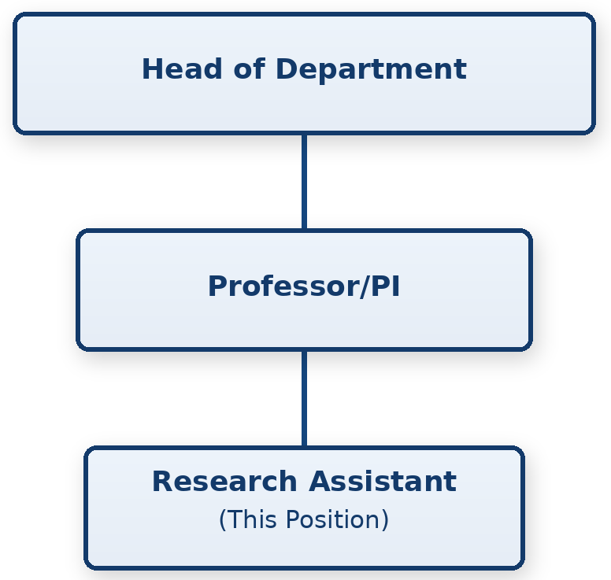



Disabled applicants meeting the Essential criterion will be guaranteed an interview as part of the University’s commitment to the Disability Confident Scheme.

Person Specification

Attributes | Criteria | Essential /Desirable | How measured (to be updated by recruiting manager)
Education, qualifications & training | Degree in an appropriate discipline (Civil, Environmental, Building or Infrastructure Engineering, Computer Science or a closely related discipline).  Relevant postgraduate qualification or working towards a PhD in an appropriate discipline, or equivalent research, industrial or commercial experience. | E  D | Application form
Experience | Evidence of contributing to research activities, including the preparation of research outputs, technical reports or other research materials.  Experience of undertaking research tasks or contributing to components of research projects, including data collection, analysis or computational modelling.  Experience working collaboratively within a research team and supporting the organisation of research activities.  Experience contributing to the planning of research activities and preparation of research reports, documentation or project materials.  Experience working on externally funded, multi-partner or international research projects.  Experience engaging with stakeholders, industry partners or communities of practice. | E  E  E  E  D  D | Application form, Interview  Application form,  Interview  Application form,  Interview  Application form,  Interview  Application form,  Interview  Application form,  Interview
Knowledge Skills & Abilities | Good understanding of resilience and sustainability assessment of buildings and infrastructure, including lifecycle performance, climate adaptation, whole-life carbon and circularity.  Knowledge of at least one of the following: life-cycle assessment (LCA), whole-life carbon (WLC), climate-risk or resilience assessment, or lifecycle performance modelling.  Ability to support the development or application of quantitative computational models, simulations or data-driven approaches to assess the performance, resilience or sustainability of buildings and infrastructure.  Good analytical and programming skills, including familiarity with Python, MATLAB, R or equivalent tools for scientific modelling, data analysis and reproducible research.  Awareness of digital technologies and AI-enabled decision-support systems, including digital twins, knowledge graphs, Large Language Models (LLMs) and Retrieval-Augmented Generation (RAG), and their potential applications in engineering research and data-driven decision-making.  Good written and verbal communication skills, including the ability to contribute to scientific publications, technical reports and presentations for specialist and non-specialist audiences.  Ability to undertake research tasks independently with appropriate guidance, critically evaluate results and maintain well-documented, open and reproducible research practices.  Familiarity with probabilistic modelling, uncertainty and sensitivity analysis, multi-criteria decision analysis or multi-objective optimisation.  Familiarity with dynamic life-cycle assessment, lifecycle costing, circularity assessment or relevant standards and frameworks (e.g., EN 15978, EN 15804 and EU Level(s)).  Experience or familiarity with computational models, digital platforms or AI-enabled applications, including LLMs, RAG, knowledge graphs, digital twins, BIM/GIS, application programming interfaces (APIs) or intelligent decision-support systems | E  E  E  E  E  E  E  D  D  D | Application form,  Interview  Application form,  Interview  Application form,  Interview  Application form,  Interview  Application form,  Interview  Application form,  Interview  Application form,  Interview  Application form,  Interview  Application form,  Interview  Application form,  Interview
Additional Requirements (not included above) | Willingness to undertake occasional UK and international travel for project meetings, workshops and dissemination activities, subject to reasonable adjustments.  Ability to work effectively and collaboratively within an international and interdisciplinary research environment, engaging with academic, industry and other project partners. | E  E | Interview  Interview

JOB HAZARD DECLARATION

A job specific risk assessment has been undertaken, and recorded, for this post.

Yes ☒ No ☐

The risk assessment has identified the need for Health Surveillance.

Yes ☐ No ☒

If you have selected “Yes” then please specify:

- What type of surveillance is required and why?

- Whether or not you have sought advice from Occupational Health or the Health, Safety & Environment Team?

The work involved requires vaccination

Yes ☐ No ☒

If you have selected “Yes” then please specify:

- What type of Vaccination is required and why?

- Whether or not you have sought advice from Occupational Health or the Health, Safety & Environment Team?

For inclusion with job description:

Please provide answers to the following questions. Please add additional items as necessary. For further advice please contact healthandsafety@brunel.ac.uk (“No” responses should be deleted before advertising.)

- This role involves working with Display Screen Equipment for extended periods of more than 1 hour per day
Yes ☒ No ☐

- This role involves frequent manual handling and/or may be physically demanding
Yes ☐ No ☒

- This role involves working outside for long periods of time
Yes ☐ No ☒

- This role involves working at Height
Yes ☐ No ☒

- This role involves work in confined spaces
Yes ☐ No ☒

- This role involves working in a noisy environment
Yes ☐ No ☒

- This role involves Travel
Yes ☐ No ☒

- This role involves regular work with vibrating equipment
Yes ☐ No ☒

- This role involves driving
Yes ☐ No ☒

The information provided above is, to the best of my knowledge, true and accurate.

Name:  Sotirios Argyroudis | Signature:  Sotirios Argyroudis | Date:  16 Oct 2026

