

Position Title | Senior Technician (Biomechanics) | Position No.
College/Department/ Directorate | Student Journey – Technical Services
Grade | Grade 5 - Technician  Grade 6 - Senior Technician
Reporting To | Technical Manager (Sport, Health and Exercise Sciences)
Reports
Date reviewed | Nov 2026

Summary:

This post will ensure the safe, smooth, and efficient operation of the biomechanics teaching and research facilities within the Departments of Sport, Health and Exercise Sciences (SHES), and Health Sciences. It will ensure all activities and operations comply with all relevant regulations while providing an excellent experience for students, staff, and visitors.
The post holder will support or lead student-facing activities (especially UG and PGT) and consultancy projects, as well as supporting research initiatives. Daily responsibilities include: managing the full lifecycle of resources; setting up teaching spaces; supporting practical teaching activities; assisting students, at all levels, in their project work (such as training and supporting them in the use of equipment and software); training / inducting academic staff. Additionally, the post holder will contribute to the broader technical operations of SHES and Health Sciences.

Accountabilities and responsibilities of a Grade 5 Technician:
- Preparing and setting-up practical teaching classes. This will include (i) anticipating demand for resources; (ii) ordering consumables and equipment; (iii) setting up and clearing away and (iv) being available to assist and support academic staff.

- Proactively contributing to the development of new or improved methods / techniques / equipment systems.

- Training staff and students in the use of standard equipment (e.g., force platform, 3D motion capture).

- Carries out a range of repairs, maintenance and servicing, diagnosing faults and problems.

- Adheres to and advises others on H&S policy and practice with very good knowledge of regulations such as COSHH and risk assessment. Takes responsibility for ensuring room and project level risk assessments are complete, up to date and of suitable quality.

- Ensures record keeping systems are appropriate, up to date and complete.
- Undertake compliance roles such as Fire Marshall, First Aider etc. as required.

- Engages with University IT systems and processes to facilitate the work of the role.

- Liaises with the wider University and or external consultants / suppliers, builds professional networks and can influence decision making.

- Advises on pricing and all aspects of purchasing and procurement; consulting with staff as required.

- Responsible for the procurement, stock control, and management of laboratory consumables and equipment, ensuring compliance with University procurement policies.

- Participates on Open Days and other key events as required.

Accountabilities and responsibilities of a Grade 6 Senior Technician:
- Develops, adapts and refines work practices in area of specialty, writing appropriate guidance documents / SOPs.
- Advises students and staff in the preparation and use of equipment; on safe systems and techniques at a specialist level and leads on demonstration / student facilitation.

- May coordinate / lead a small team and / or be responsible for service delivery, making decisions in regard to areas of responsibility, allocating work to colleagues and providing instruction, guidance and training as required.

- Supporting academic staff with their research requirements.

- Setting and monitoring technical standards for self and where appropriate, a small team in area of specialty, ensuring personal familiarity with the relevant equipment and software is maintained.

- Carrying out complex analyses, interpreting results and recommending conclusions, presenting results, as appropriate.

Other Duties

Undertake any other reasonable duties as required and commensurate with the grade of post in accordance with university and departmental policies, procedures and codes of conduct.

Adhere to and comply with the provisions of the Data Protection Act and the Health and Safety at Work Act in accordance with university policies.

Promote the University’s Environmental Policy and demonstrate commitment to it through actions and decision making.

Actively participate in on going professional development activities as requested.

Our Values:
Our values play out across everything we do. We hold ourselves accountable to the highest standards in all our activities and decisions. They add value to both student and colleague experience at Brunel, helping us to deliver our strategy and plans.

Open We are welcoming and believe in the power of diversity. We are transparent in our decisions and deliver on what we say.

Courageous We seek and take on ambitious challenges. We are brave and committed to thinking differently. Nothing stops us from going after our goals.

Inventive: We are purposeful in an ever-changing world. Collaborating and innovating to reach our full potential and to change lives - and the world - for the better. We celebrate breakthroughs and strive for the best.

Organisational Structure Chart:

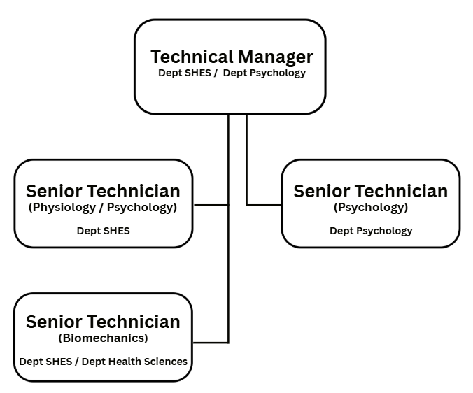



Person Specification

As part of the University’s Commitment to the Disability Confident Scheme – Offer an Interview Commitment, applicants who choose to apply through the scheme and who meet the minimum criteria for the role will be offered an interview.

Criteria |  | Essential /Desirable*
Education, qualifications and training | Degree with major focus on Biomechanics (or significant experience in this area).  Registration with the Science Council at RSciTech or above (or ability to achieve within 12 months) (Essential at Snr).  Evidence of relevant professional development since gaining your degree (Essential at Snr).  Portable Appliance Testing and / or First Aider qualification (or willingness to undertake training). | E  D  D  E
Experience | Good prior work experience of a relevant technical nature, post degree.  Ability to work as part of a team.  Supervisory / line-management / laboratory management experience (Essential at Snr).  Understanding of a range of relevant specialist equipment and software (e.g. motion capture systems, force plates, EMG, instrumented treadmills/walkways and dynamometers) (Essential at Snr).  Familiarity with general and specialist software (e.g. eye movement analysis; relevant coding languages such as Matlab or Python) (Essential at Snr). | E  E  D  D  D
Knowledge and Skills | Excellent standard of written and spoken English.  Strong knowledge and understanding of H&S regulations, and procedures.  Depth and breadth of knowledge in biomechanics, with the ability to instruct and demonstrate techniques to taught students information or briefing to various audiences (Essential at Snr).  Write and / or update Standard Operating Procedures (SOP) (Essential at Snr).  Able to build productive working relationships with stakeholders.  Able to effectively delegate tasks and make decisions (Essential at Snr).  Good understanding of financial and procurement practices.  Able to work with minimal supervision.  Demonstrate a proactive approach to supporting a relevant function.  Good general and specialist ICT skills. | E  E  D  D  E  D  E  E  E  E
Attributes | Aligned with Brunel’s values of being open, courageous and inventive.  Committed to fostering an equitable and inclusive workplace.  A flexible approach to changing demands of a service.  Willing to work outside of normal working hours on occasions.  Ability to undertake manual handling tasks. | E  E  E  E  E

*Where a large pool of applicants meet the essential criteria, the desirable criteria will be used as part of the first stage of short listing.

JOB HAZARD DECLARATION
A job specific risk assessment has been undertaken, and recorded, for this post.
Yes ☒ No ☐
The risk assessment has identified the need for Health Surveillance.
Yes ☐ No ☒
If you have selected “Yes” then please specify:
- What type of surveillance is required and why?

- Whether or not you have sought advice from Occupational Health or the Health, Safety & Environment Team?

The work involved requires vaccination
Yes ☐ No ☒
If you have selected “Yes” then please specify:
- What type of Vaccination is required and why?

- Whether or not you have sought advice from Occupational Health or the Health, Safety & Environment Team?

For inclusion with job description:
Please provide answers to the following questions. Please add additional items as necessary. For further advice please contact healthandsafety@brunel.ac.uk (“No” responses should be deleted before advertising.)

- This role involves working with Display Screen Equipment for extended periods of more than 1 hour per day
Yes ☒ No ☐

- This role involves frequent manual handling and/or may be physically demanding
Yes ☒ No ☐

- This role involves working outside for long periods of time
Yes ☐ No ☒

- This role involves working at Height
Yes ☒ No ☐

- This role involves work in confined spaces
Yes ☐ No ☒

- This role involves working in a noisy environment
Yes ☐ No ☒

- This role involves Travel
Yes ☐ No ☒

- This role involves regular work with vibrating equipment
Yes ☐ No ☒

- This role involves driving
Yes ☐ No ☒

The information provided above is, to the best of my knowledge, true and accurate.

Name: Amelia Dingley | Signature: A.Dingley | Date: 30/10/26

