Neurodiversity and Disability Adviser
Student Support

Closing Date: 22nd November 2026

Job Reference: AW51561
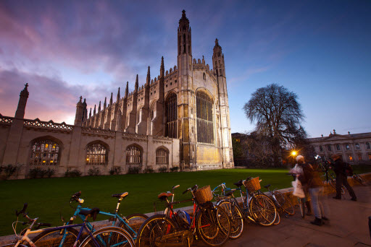




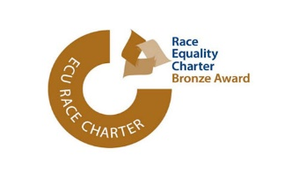




Neurodiversity and Disability Adviser

Salary:
£36,320-£46,970
In addition to the base salary stated above, the successful candidate for this post will receive an additional 2.5% supplement to their pay.
Contract:
Temporary cover: This post is fixed term for 12 months

Location:

Central Cambridge

Department:

Student Support

Responsible to:

Senior Disability Adviser

Working Pattern:

Full Time, 37 Hours per week

The University of Cambridge has a Hybrid Working Policy that aims to enable as many staff as possible to work in a hybrid way if they so wish, whilst recognising that some roles will include tasks that can only be performed on University premises.
and Adjusted Modes of Assessment, evaluating diagnostic evidence and providing staff training on teaching disabled and advice on best practice.
In addition, the role holder will also provide training to Academic staff to raise awareness and understanding of how a particular disability profile affects learning and teaching. The role also includes provision of non-medical assistance for disabled students including funding requests, liaising with funding bodies, and other relevant professionals. The role holder will also be responsible for arranging non-medical help such as specialist mentoring, study skills, notetaking, and study assistants, to support disabled students during their time at University.
Key Responsibilities
- To handle enquiries from, and provide advice and guidance to, prospective students, applicants and current disabled students, and to members of staff involved in their teaching & learning and pastoral support (via email, on-line, telephone and face to face consultations and appointments).

Purpose of the role
The Neurodiversity and Disability Adviser is responsible for providing academic-related disability support, advice and guidance to prospective and current disabled students. The post-holder will also be responsible for providing academic-related disability support, advice and guidance (in relation to support for individual disabled students as well as in relation to policy and practice) to those staff with responsibility for the pastoral care and academic performance of disabled students, as well as external stakeholders, in order to help fulfil the University’s obligations under the Equality Act.
The role holder will work as part of the Non-Matriculated Student Service at the Accessibility & Disability Resource Centre (ADRC) in developing and delivering best practice in policy and service delivery. This will include face to face meetings, telephone, email and on-line conversations and liaising with Institutional and Departmental staff and UAS staff to identify and facilitate the implementation of support requirements for disabled students. This includes determining and communicating recommendations for student support, composing letters and documentation to support exam adjustments

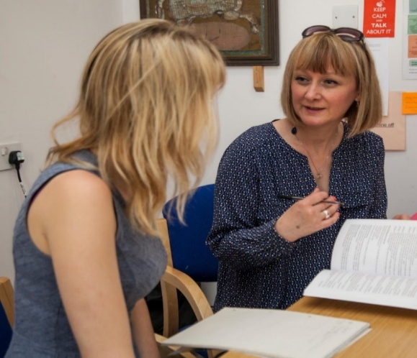

Key responsibilities continued
- To write and update support documents and disseminate information, as appropriate, within the bounds of confidentiality protocols. Signposting, where appropriate, to specialist provision outside of the ADRC’s academic-related remit.

- To provide advice and information on accessibility, equipment/software, and or disability support services available across the university and externally (e.g. through Disabled Students’ Allowances)

- To monitor support provided for individual students and provide evidence and opinion where revision or updating of support/adjustment is required, ensuring that the University fulfils its legal duties under the Equality Act (2010).

Advice and Guidance
- To contribute to the advice that the ADRC’s advisers, Head of Centre and Senior Disability Adviser provide the University, Departments and Institutions on the most effective ways to support disabled and neurodiverse students.

- To keep up-to-date with, and advise Departments, institutions and the University on, legislative, regulatory and policy developments. To use this knowledge to inform the advice provided and with a view to conflict prevention and resolution rather than litigation.
- To assist with small scale projects linked to best practice in services for disabled and neurodiverse students in Higher Education.

- To help inform and develop the service.

Coordinating Support Provision

- To enable disabled students to access on-going support, including non-medical help (NMH).

- Keeping abreast of technological developments and disseminating that information, advising Departments and Institutions on inclusive teaching and learning, giving advice regarding examination provisions with a focus on disabled or neurodiverse students; giving advice regarding adjustments to assessment and examination provisions.

Funding and Finance
- To enable applicants and students to claim Disabled Students’ Allowances (DSAs), and other sources of funding for academic-related disability support, such as the Reasonable Adjustment’s Fund (RAF), International Disabled Students’ fund (IDSF), and charitable/welfare grants/bursary funds, where appropriate. To negotiate with funding bodies, (e.g. Student Finance England, Research Councils). Support disabled students in completing the appropriate forms and documentation to maximise their access to funding.

- To make recommendations for the provision of funding from the sources of funds for disabled students managed and administered by the ADRC.

Event Management
- To assist with the co-ordination and organisation of events (for example Transition events, and open days) during both planning and delivery stages.
Key responsibilities continued
Monitoring and Evaluation
- To assist with the co-ordination and organisation of events (for example Transition events, and open days) during both planning and delivery stages.

Policy Development
- To contribute to the development of relevant policies, practices and procedures relating to the support of non-matriculated disabled or neurodiverse students at the University of Cambridge.

Data Management and Analysis

- To maintain accurate data and case-management records on the numbers, categories and status of disabled students, and the support that has been provided, and to provide analysis of significant trends to the Senior Disability Adviser and the Head of the ADRC.

Production of Materials

- To contribute to the production of written materials and information, including for web pages, including guidance for students and the staff who support them.

Design and delivery of Training and Development

- To assist with staff development activities that cover a range of disabilities. To participate in, and deliver at, external events and conferences. To assist with the coordination of external providers. To provide specialist training to staff at Professional and Continuing Education (PACE).
General
- To liaise with outside agencies and national professional bodies (such as NADP) in their work developing best practice in the field and represent the University by attending conferences and workshops as appropriate.

- To maintain own professional development – especially in the field of Disability Equality.

- To attend training sessions with an interest in developing specialist knowledge and skills in relevant areas of the role.

- To contribute to team development activities and monitoring and evaluation exercises (e.g. Annual Quality Review Meetings, team events).

The above outlines the duties required at the current time to indicate the level of responsibility. It is not intended to be a comprehensive or exhaustive list and may be varied by University management to include other reasonable requests which are up to the same skill level, and of the same type, already undertaken and which do not change the general character of the job or the overall level of responsibility.

Person Specification

Criteria | Essential | Desirable
Education
Educated to first-degree level or with equivalent experience.
Qualification in assessing and supporting individuals with specific learning difficulties
Post-graduate qualification in supporting adults with mental-health conditions and/or disability/disability equality/disability support in higher education.
Current PAToSS accreditation, or equivalent (practising certificate)
NADP membership at Accredited Member level.
Experience
Experience of providing disability-related support in an education context for students with a range of disabilities including Mental Health issues (preferably in a Higher Education context).
Experience in, and up-to-date comprehensive knowledge of, current legislation and debates in relation to disability in general, and its implications for students in Higher Education with a focus on a range of disabilities.
Experience in using diagnostic evidence to inform support for disabled students and neurodiverse students in a Higher Education environment.
Experience in supporting students with mental health conditions in Higher Education
Experience of working with sensitive personal data and case management processes.
Experience in supporting students with Autism Spectrum Conditions in Higher Education.
Knowledge and understanding of the principles of Universal Design for Learning and inclusive teaching and learning practices.
Experience of working within a busy environment with the ability to work independently or with colleagues to ensure effective completion of tasks

Person Specification continued

Criteria | Essential | Desirable
Knowledge and Skills
Experienced user of Microsoft Office, case management systems (CRMs) and a range of assistive software/productivity tools.
Excellent written & verbal communication skills, including giving presentations
Effective team-worker
Ability to work effectively with a range of individuals at different levels of the organisation both within and outside the University, demonstrating a commitment to equality of opportunity.
Effective and current IT skills and the ability to rigorously maintain electronic records
Additional Requirements
Proven ability to be proactive and take responsibility for decisions.
An ability to effectively organise own time and work
Effective negotiation / mediation / advocacy skills.
A commitment to effective student-focused, service delivery.
Ability to work flexibly and co-operatively within a team.
Ability to work to deadlines under pressure.
Ability to multitask whilst maintaining a professional service to students, colleagues and other external stakeholders.
Proven ability to work within a confidential environment.
A demonstrable understanding of Social Model/Affirmative Model approaches to disability support.
Ability to respond and deal appropriately with complex and sensitive / emotional situations and remain calm in difficult or sensitive situations
A divergent thinking & creative problem-solving approach.
Cultural adaptability and sensitivity in working with disabled students and international students and supporting students at a distance.
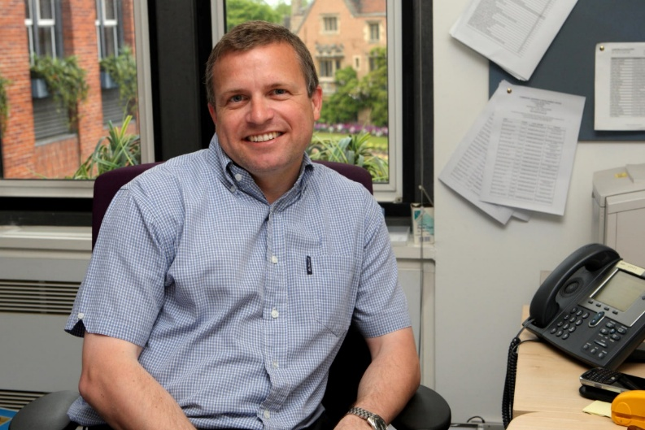
- Develop & implement support programmes for disabled students to ensure equal opportunity, access, & attainment allowing disabled students to achieve to the best of their abilities.

- Provide advice, guidance and
training for University and College staff in meeting the institution's duties to disabled students within the context of disability equality legislation.

- Develop and communicate policy, processes and guidance in relation to disabled students, accessibility, inclusive teaching and learning and universal design for learning.

The Accessibility and Disability Resource Centre (ADRC) is part of the Academic Division and reports to the Head of Student Support within Education Services.
About the ADRC
The Accessibility and Disability Resource Centre provides advice, information and support to prospective disabled applicants, undergraduates, graduates of the University of Cambridge and to the staff who support them.
It also provides support and advice to Colleges and Departments/Faculties on the Equality Act (2010) in relation to disability equality matters; facilities and support for disabled students related to teaching, learning and assessment as well as physical and digital accessibility. The ADRC also provides a training and consultancy service and coordinates approximately 20,000 hours of Non-Medical Assistance each academic year.

The objectives of the ADRC are to:
- Provide advice & guidance for prospective & current disabled students to enable them to access a wide range of services, and to identify and remove barriers to equitable learning opportunities.

The Accessibility and Disability Resource Centre




Education Services
Based at the purpose-built Student Services Centre (SSC) which opened in April 2019, Education Services brings together the teams that provide key services to students.
Education Services sits within the wider Academic Division of the University’s Professional Services and is made up of the following teams:

Access & Admissions
Including Cambridge Admissions Office, Postgraduate Admissions Office and Student Funding.

Student Support
Including the Accessibility and Disability Resource Centre, Student Wellbeing, the Mental Health Advice Service and the University Counselling Service.

Student Administration
Including Examinations and mitigation, International Student Office, Postgraduate Administration, Student Records, Office for Student Conduct, Complaints & Appeals and Space modelling & Allocation. Including Examinations and Mitigation, International Student Office, Postgraduate Administration, Student Records, Office for Student Conduct, Complaints & Appeals and Space modelling & Allocation.
Education and Student Outcomes
Including Education Quality and Policy Office, Careers Service, Postgraduate Research, Pathways to Inclusive Learning and the Cambridge Centre for Teaching and Learning.

These departments are supported by the SSC Support Team which delivers a shared service.

- Financial Administration
- Human Resources support, including recruitment administration
- Reception and Facilities Management
- Health and Safety.

Terms of Appointment
Tenure and probation Temporary cover: This post is fixed term for 12 months Appointments will be subject to satisfactory completion of a six-month probationary period.

Hours of Work and Working Pattern
The hours of work for the position are 37 hours per week, working Monday – Friday.

Pension
You will automatically be enrolled to become a member of USS (Universities Superannuation Scheme) – a hybrid pension scheme. For further information please visit: www.pensions.admin.cam.ac.uk

Annual leave
Full time employees are entitled to annual paid leave of 41 days inclusive of public holidays. For part-time employees, annual leave will be calculated pro rata based on days worked.

General information
Pre-employment checks

Right to work in the UK
We have a legal responsibility to ensure that you have the right to work in the UK before you can start working for us.
If you do not have the right to work in the UK already, any offer of employment we make to you will be conditional upon you gaining it.

Health declaration Once an offer of employment has been made the successful candidate will be required to complete a work health declaration form.

Qualifications
The person specification for this position lists qualifications that are essential and/or desirable. Please note that if you are offered the post you will be asked to provide your relevant original certificates of these qualifications.

References
Offers of appointment will be subject to the receipt of satisfactory references.

Screening Checks:
This role requires a standard Disclosure and Barring Service (DBS) Check. Any offer of employment we make to you will be conditional upon the satisfactory completion of this check; whether an outcome is satisfactory will be determined by the University.

Information if you have a disability
The University welcomes applications from individuals with disabilities. We are committed to ensuring fair treatment throughout the recruitment process. We will make adjustments to enable applicants to compete to the best of their ability wherever it is reasonable to do so and, if successful, to assist them during their employment.

We encourage you to declare any disability that you may have, and any reasonable adjustments that you may require, in the section provided for this purpose in the application form. This will enable us to accommodate your needs throughout the process as required. However, applicants and employees may declare a disability at any time.
If you prefer to discuss any special arrangements connected with a disability, please contact the ES HR Team at @SSCJobs@admin.cam.ac.uk.

The University of Cambridge is consistently ranked one of the best universities in the world, achieving academic excellence through its Faculties, Departments and other Institutions, together with the 31 Colleges.
The University is renowned for its record of discovery and innovation. It is one of the great institutions, with a regional, national and global reach, attracting the very best and brightest minds. Our staff and students shape the world around us for the better: we attract and partner with like-minded people.
Whether contributing to the development of new anti-cancer drugs, adding to the understanding of how black holes are formed, revolutionising the study of ancient settlements, convening academic expertise to offer solutions to the climate crisis, or analysing public attitudes towards democracy around the world, the University’s research is remarkable in its breadth, quality and impact. The University also sits at the heart of Europe’s largest technology cluster and has catalysed more than 1,500 high-tech companies. And yet what inspires our 24,000 students and 13,000 staff is not what has already been achieved, but what is possible in the future.
The education and experience of our students, based on a partnership between the University’s academic Departments and Faculties and the 31 Colleges, is second to none. Every student is a member of one of the Colleges, each a community of students, academics and staff drawn from across the University’s comprehensive range of subject areas.
The University is a self-governing community, with a system for decision-making that provides a high degree of accountability and transparency to its members. Each Department and Faculty is part of one of six academic Schools, but each of them, and each individual academic, has a great deal of autonomy. The Colleges are independent and self-governing, working in a symbiotic relationship with the University.
The University has a number of Institutions that are independent of any Faculty or Department and are not part of the academic Schools. These include the Institute of Continuing Education (which provides high-quality education to adults throughout their lives), the Fitzwilliam Museum, Kettle’s Yard (an historic house and gallery that holds important collections of modern art) and the University Library. In addition to their diverse contributions to University and public life, these non-School Institutions are also important centres of teaching and research.
Cambridge University Press & Assessment provides academic publishing, examinations and learning materials worldwide, supporting the dissemination of research, academic development at school and in higher education, and international student mobility. Legally, the Press & Assessment is a department of the University. It provides very important funds to invest in the academic purposes of the University.
The University has made truly remarkable contributions to the sum of human understanding, with breakthrough ideas and discoveries that have changed the way we understand ourselves, our planet, and the universe around us. Yet the global and national contexts in which it operates are fast-changing and increasingly filled with uncertainty. In a world that is becoming - politically, economically, socially, and technologically – ever more interconnected but even less equal, the University’s mission – “to contribute to society through the pursuit of education, learning and research at the highest international levels of excellence” – has never been more relevant.

The University

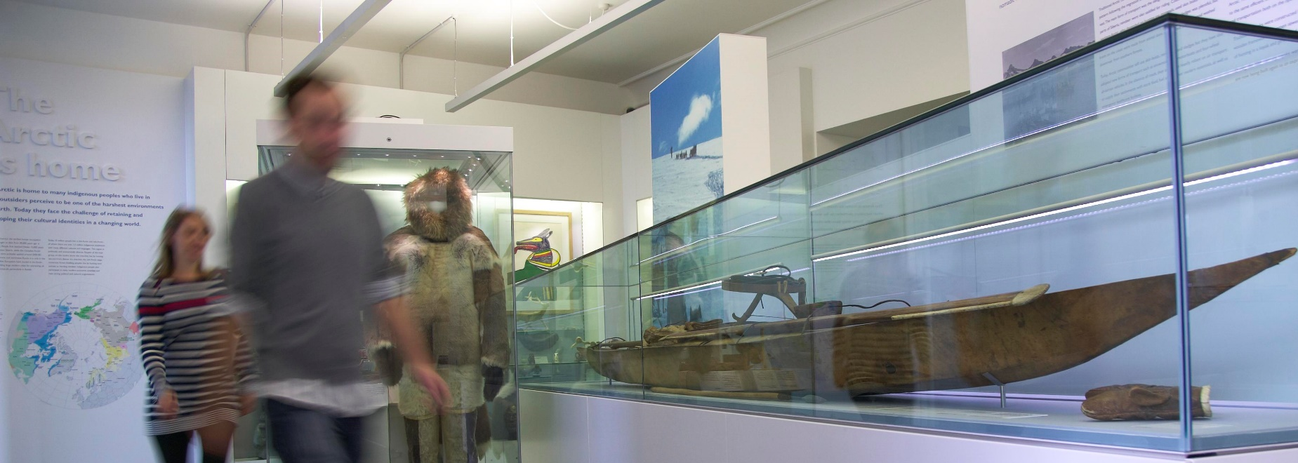
“Through its outstanding education, research and innovation, the University of Cambridge has made – and continues to make – a lasting contribution to human knowledge and is flourishing. By working at the University of Cambridge, you will be joining a vibrant community of students, scholars and professional services staff committed to supporting and enhancing the University’s mission to contribute to society.”
Professor Deborah Prentice,
Vice Chancellor 2023
The University is one of the world's leading academic centres. It comprises 150 faculties and departments, together with a central administration and other institutions. Our institutions, museums and collections are a world-class resource for researchers, students and members of the public representing one of the country’s highest concentrations of internationally important collections.
The University has an annual income of £2 billion. Research income, won competitively from the UK Research Councils, the European Union (EU), major charities and industry, exceeds £500 million per annum and continues to grow.
The Colleges and the University remain committed to admitting the best students regardless of their background and to investing considerable resources both in widening access and financial support. The 31 Colleges are self-governing, separate legal entities which appoint their own staff. Many academic staff are invited to join a College as a Teaching Fellow, which provides a further social and intellectual dimension. The Colleges admit undergraduate students, provide student accommodation and pastoral support and deliver small group teaching for undergraduates.
The University awards degrees and its faculties and departments provide lectures and seminars for students and determine the syllabi for teaching.
Our instinct for seeking out excellence and setting up enduring and mutually beneficial collaborations has led us to establish strategic partnerships across the globe. Whether it is the successful Cambridge-Africa Programme involving universities in Ghana, Uganda and elsewhere on the African continent; or the close association with the government of India to pursue new research in crop science; or the creation, with Germany’s Max Planck Institutes, of a Cambridge-based centre for the study of ethics, human economy and social change – international partnerships are now an inextricable part of the University’s make-up.

About Us

Working at the University
Working at Cambridge you will join a diverse, talented and innovative community, with more than 24,000 students and over 13,000 staff from all walks of life and corners of the world.
The University continually explores strategies to attract and retain the best people. It is committed to supporting its staff to achieve their best. We are a fair, diverse and inclusive society and we believe our staff are our greatest asset. There is strong commitment to developing institutional leadership and supporting and encouraging staff development at all levels.
The University offers a variety of roles including academic, research, professional, managerial and support roles. We also offer extensive benefits and excellent learning opportunities within a stimulating working environment.
The University’s estate is undergoing the most significant transformation in its history. Cambridge has been able to create a science and technology campus to the west of the city centre, and is expanding further to the north west of Cambridge including investing in affordable homes for University key workers and community facilities. Even with their continued development, the University remains within walking or cycling distance across the campus. The University is a major partner on the Cambridge Biomedical Campus and continues to redevelop its historic city centre sites demonstrating a clear determination to ensure that we can offer the best facilities and opportunities for our staff and students.



Equality, Diversity and Inclusion
The University has built its excellence on the diversity of its staff and student community. We aim to be a leader in fostering equality and inclusion, and in promoting respect and a sense of belonging for all. We encourage applications from all sections of society. All appointments are made on the basis of merit. We have an Equal Opportunities Policy, along with a range of diversity groups, including the Women’s Staff Network, Race Equality Network and LGBT+ Staff Network. More details are available here: http://www.equality.admin.cam.ac.uk/
The University has a bronze Race Equality Charter award, with a framework for improving the representation, progression and success of minority ethnic staff and students within higher education. Furthermore, the University’s silver Athena swan award recognises and celebrates good practice in recruiting, retaining and promoting gender equality.

Living in Cambridge
Cambridge is rich in cultural diversity. From beautiful University and College buildings, museums and art galleries, quaint gardens and punts on the River Cam, to a vibrant restaurant and café scene, our employees are surrounded by the wonderful features of this unique city.
You can find a wide-range of high street shops and 3 shopping centres, with independent alternatives at the historic market and nestled within the passageways in the city centre. You will find a cinema, bowling alley, a nightclub and various live performances at the Cambridge Leisure Park, with further entertainment options at the Corn Exchange, Arts Theatre and the ADC Theatre. Further information can be found on the Visit Cambridge website.
If you prefer the faster pace of life, London is a 45-minute train journey away. For those travelling from overseas, Stansted Airport is just 45 minutes away and Heathrow Airport under 2 hours away. The University is a short distance from a host of other attractions such as Ely Cathedral, Newmarket Races and various wildlife parks and stately homes. Cambridge is also within easy reach of the beautiful Broads and coastlines of Norfolk and Suffolk.
Relocation Support
The University recognises the importance of helping individuals to move and settle into a new area. We provide support and guidance to those relocating internationally or domestically to take up a post at the University of Cambridge, liaising with other University offices and selected partners to ensure comprehensive relocation support is available. This includes: accommodation, childcare, schools, banking, immigration and transport. If you would like further information, please visit https://www.accommodation.cam.ac.uk/RelocationService/. The Shared Equity Scheme and the Reimbursement of Relocation Expenses Scheme provide financial assistance to qualifying new members of staff with the costs of relocating to Cambridge.

Accommodation Service
The University Accommodation Service helps staff, students and visiting scholars who are affiliated to the University in their search for suitable accommodation in Cambridge. The dedicated accommodation team can provide access to a wide range of University-owned furnished and unfurnished properties, and has a database of private sector accommodation available for short and long-term lets. For further information and to register with this free service please visit: https://www.accommodation.cam.ac.uk/

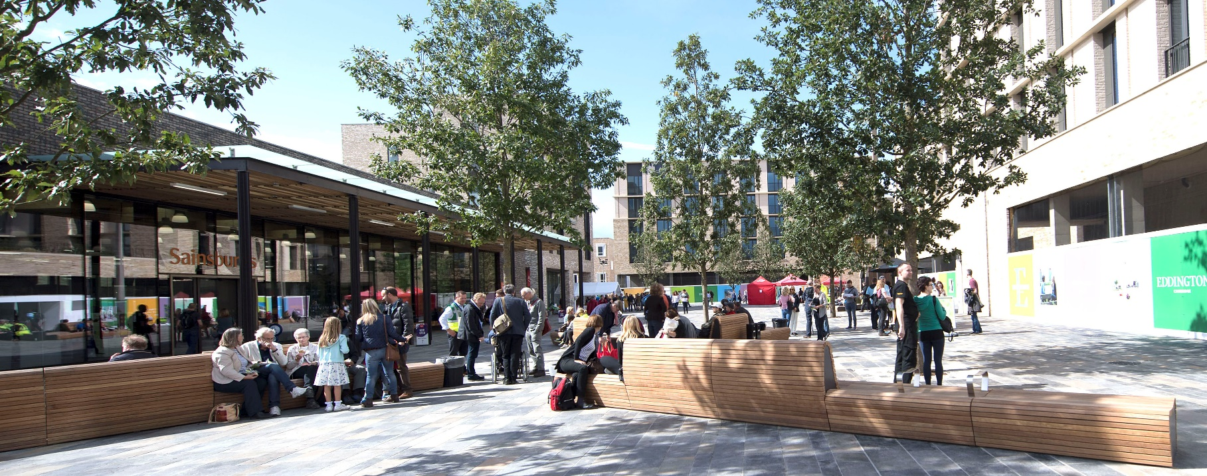



What Cambridge can offer
We offer a comprehensive reward package to attract, motivate and retain high performing staff at all levels and in all areas of work.
The University offers a wide range of competitive benefits, from family leave entitlement, to shopping and travel discount schemes. Our generous annual leave package contributes to the positive wellbeing of our University employees. Sabbatical leave enables academics to focus on research and scholarship, whilst still maintaining their full salary. The University also has a career break scheme for academic and academic-related staff, with additional flexible working policies for all other staff.
Pay and benefits
The University salary structure includes automatic service-related pay progression in many of its grades and an annual cost of living increase. In addition to this, employees are rewarded for outstanding contribution through a number of regular pay progression schemes. The University offers attractive pensions schemes for employees, with an additional benefit of a salary exchange arrangement providing tax and national insurance savings.
CAMbens employee benefits
The University offers employees a wide range of competitive benefits, known as CAMbens. CAMbens offers something for everyone across a range of categories, including:
- Financial Benefits, including shopping discounts (both local and national) and a Payroll Giving scheme;
- Relocation and Accommodation Benefits, including relocation assistance and interest-free Rental Deposit Loans;
- Travel Benefits, including Cycle to Work, discounts on train season tickets and interest-free Travel to Work loans;
- Family Friendly and Lifestyle Benefits, including support with childcare and family friendly policies;
- Health and Wellbeing Benefits, including a University Staff Counselling Service, discounts at the University Sports Centre, and other local gyms, and healthcare schemes.



What Cambridge can offer
Family-friendly policies
The University recognises the importance of
supporting its staff. We have a range of family-friendly policies to aid employees’ work-life balance including a generous maternity, adoption and shared parental leave entitlement of 26 weeks’ full pay, and paid emergency leave for parents and carers.
Other family-friendly support includes:
Our highly regarded workplace nurseries, a childcare salary exchange scheme and a high-quality holiday Playscheme are available to help support University employees with caring responsibilities (subject to demand and qualifying criteria). Further childcare information can be found here: https://www.childcare.admin.cam.ac.uk/
The Newcomers and Visiting Scholars Group (https://www.nvs.admin.cam.ac.uk/) is an organisation within the University that welcomes the partners and families of visiting scholars and new members of the University. Run by volunteers, the group offers opportunities to visit interesting Cambridge venues, learn about the community, take part in social events and gain local knowledge while developing a strong support network of both residents and other newcomers.
Your wellbeing
The University’s Sport Centre, Counselling Services and Occupational Health are just some of the support services available to University employees to promote their physical and mental wellbeing. The University delivers The Festival of Wellbeing annually, which is a programme of stimulating talks and activities, which aim to promote wellbeing and good mental and physical health. The University also hosts the Cambridge Festival, which is a great opportunity to get your first taste of public engagement, through volunteering, supporting hands-on activities or proposing a talk.

Development opportunities
We support new employees to settle in through various activities as well as supporting their professional and career development on an ongoing basis. Our Personal and Professional Development (PPD) team provide development opportunities for all University employees, including face-to-face sessions, online learning modules and webinars. All employees also have unlimited access to LinkedIn Learning to support their development. Both new and existing employees can undertake funded Apprenticeships, which lead to a range of vocational and professional qualifications. We offer reduced staff fees for University of Cambridge graduate courses and the opportunity to attend lectures and seminars held by University departments and institutions. A range of University training providers also offer specialist learning and development in their own areas e.g. teaching and learning, digital literacy, finance, health and wellbeing, safety.

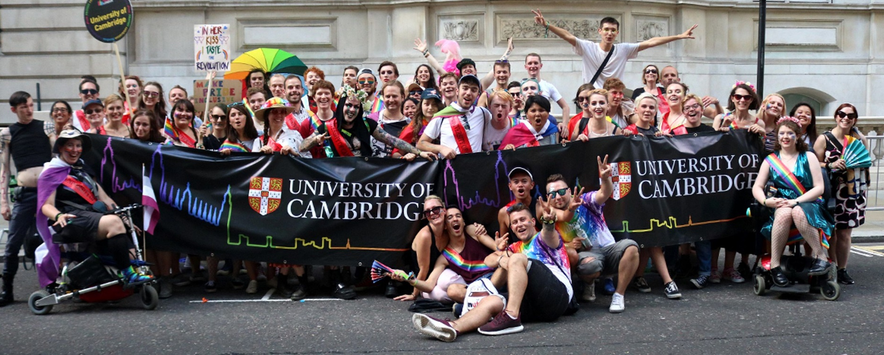
Informal enquiries are welcomed and should be directed to:
Hannah Barton, Senior Disability Adviser – hb611@cam.ac.uk

If you have any queries regarding the application process, please contact the
ES HR team - SSCjobs@admin.cam.ac.uk

The closing date for applications is: 22/11/2026
The interview date for the role is:03/12/2026

How to apply

Applications should be submitted online via the University of Cambridge jobs page www.jobs.cam.ac.uk by clicking “Apply online” in the job advert. You will need an email address to register for our online system.
Conversations about flexible working are encouraged at the University of Cambridge. Please feel free to discuss flexibility prior to applying (using the contact information below) or at interview if your application is successful.

