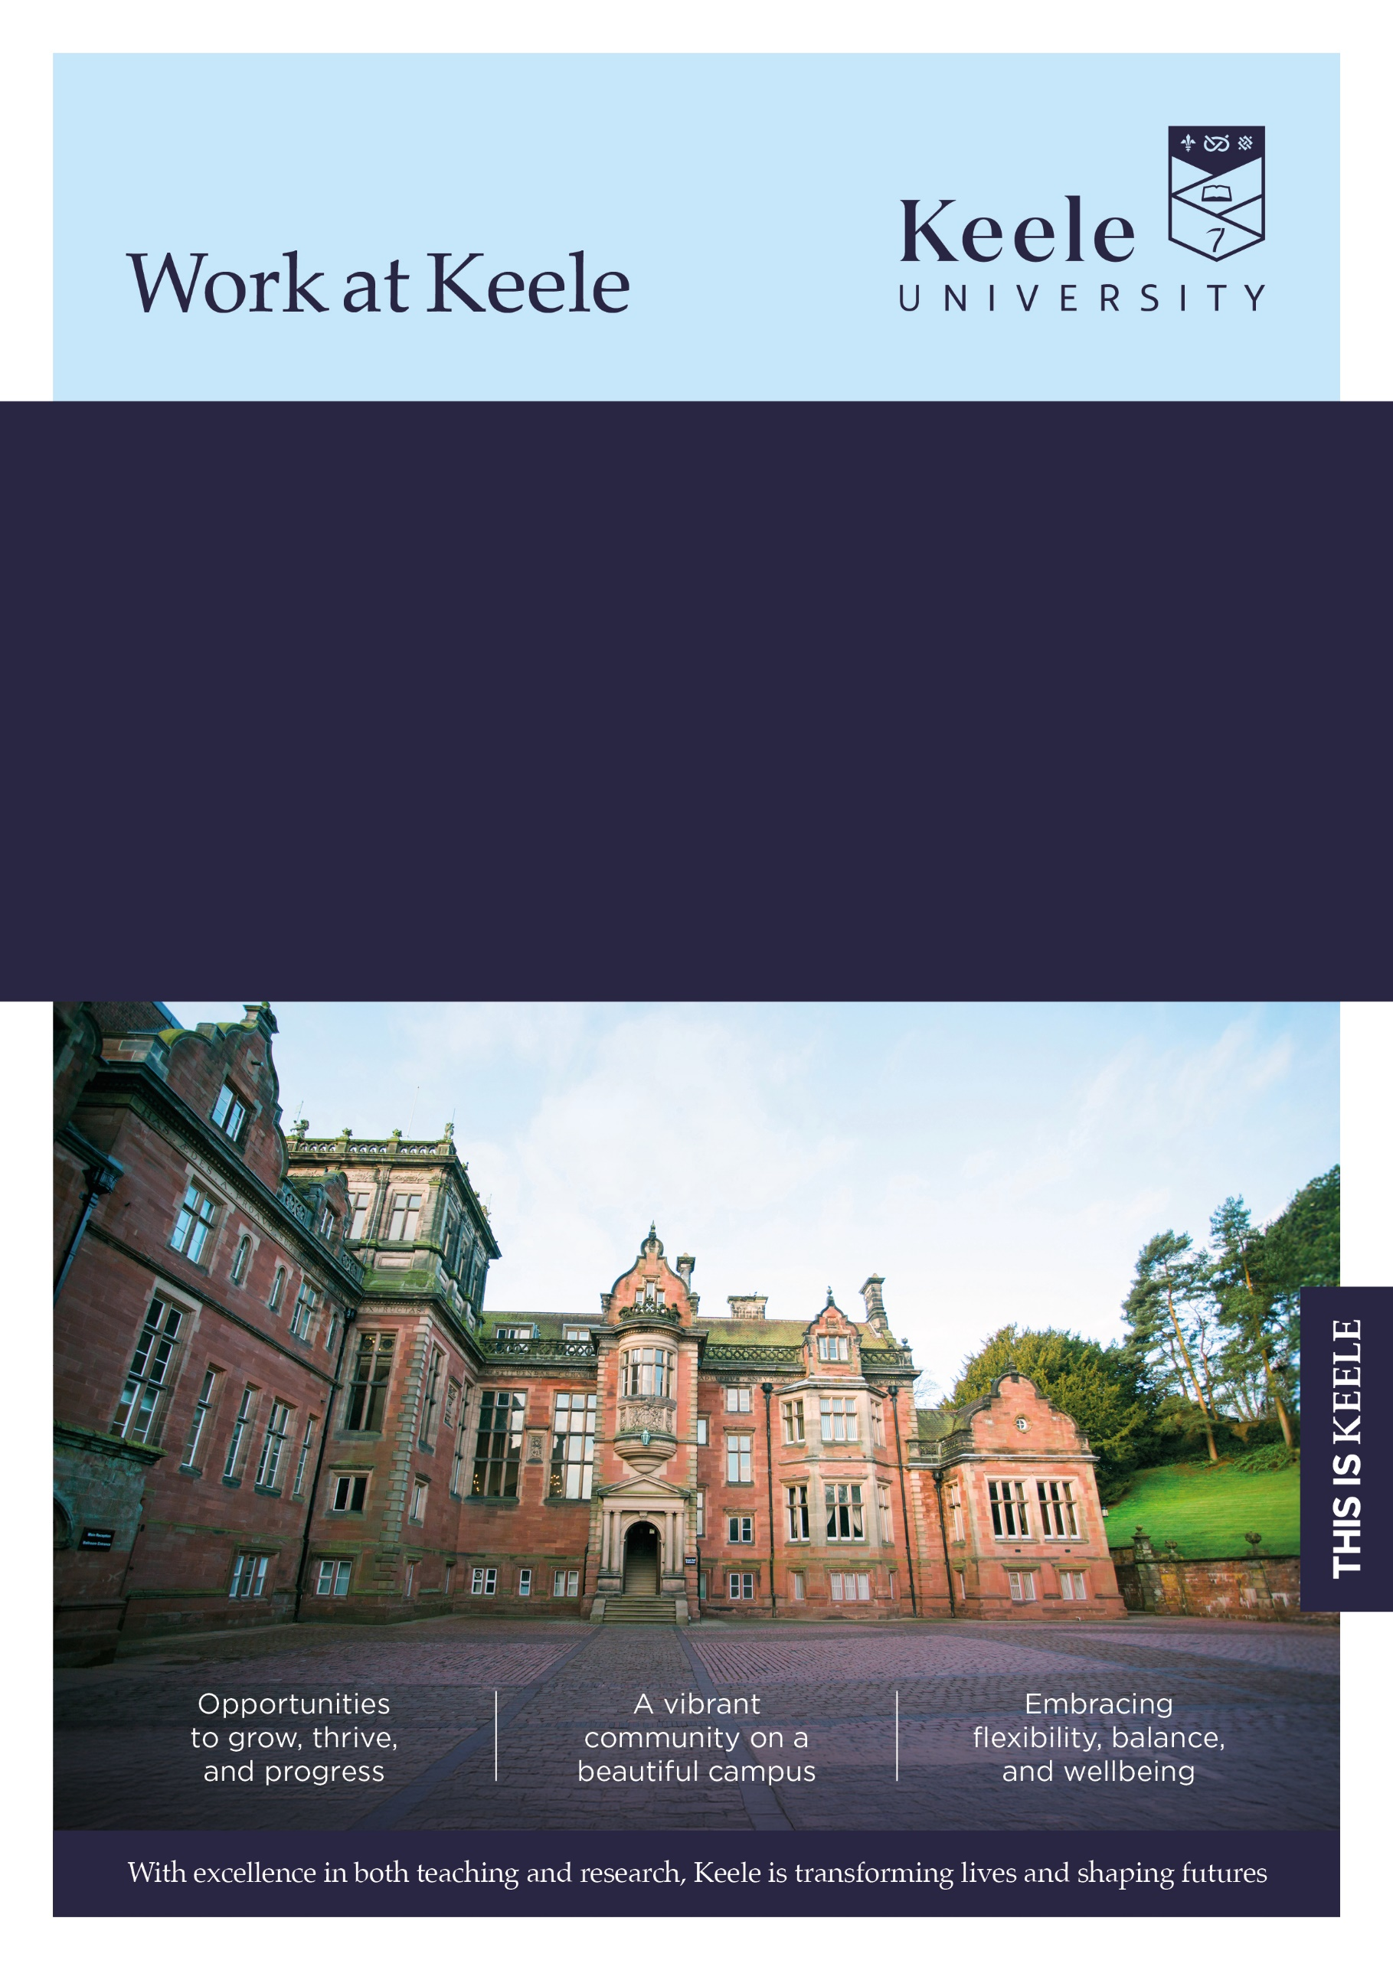
Faculty/Directorate: Faculty of Natural Sciences
Dept/School: School of Life Sciences
Location: Campus
Grade: 7
Salary Range: £39,560 - £48,337
Full Time: 1 FTE
Term: Fixed Term until November 2030
Responsible to: Lecturer in Plant Health
Job Ref: KU00005461

Molecular Entomologist
Thank you for considering a role at Keele University.

Inside this document, you'll discover key details about the job and our diverse and vibrant institution. We invite you to explore the impressive benefits that come with joining our community - just click here to learn more about our values and what makes Keele a fantastic place to work.

The Role

An exciting opportunity is available within the School of Life Sciences for a Postdoctoral Research Associate to investigate insect-vectored bacterial plant pathogens and their interactions with host plants. Planthoppers vector these bacterial diseases causing significant losses to a wide range of important crops including carrots, potatoes, sugar beet and grapevines in continental Europe.
The postdoctoral researcher will play a critical role in unravelling the insect vector’s ecology and transmission biology. Effective communication, organisational, and time management skills are essential.

The postdoctoral researcher will work closely with Dr Trisna Tungadi and E-Prep II consortium partners, contributing to a highly interdisciplinary and collaborative programme of research that is funded by UKRI and led by Keele University. Applicants should hold a PhD or have equivalent postdoctoral-level work experience in molecular entomology, plant pathology, or related discipline.

The ideal candidate possess molecular skills, data analysis and scientific writing skills. Experience in some, but not necessarily all, of the following areas is desirable: rearing insect colonies, designing and conducting insect bioassay experiments, analysing insect probing behaviour using Electrical Penetration Graph (EPG) technology molecular biology techniques including DNA and RNA extractions from insects and plant materials for downstream analytical applications such as PCR, RT-PCR, qRT-PCR, data analysis skills, such as R, RStudio, or Python. Previous experience working with planthopper and bioinformatics are advantageous but not essential. The role will involve travel within the UK and Europe for field sampling, project meetings, visits and stays with partner institutions.

Main duties and responsibilities

- Plan and carry out day-to-day research activities independently using a variety of laboratory and field techniques within the framework of the project, contributing to knowledge that supports Keele’s and the broader academic research community.
- Develop and implement research objectives for the project.
- Develop and optimise new research methods related to the project.
- Identify new areas of research and potential funding sources.
- Conduct individual and collaborative research with consortium partners using new and existing techniques and methods as appropriate.
- Prepare, set up and conduct experiments to analyse and interpret data. drawing conclusions. and recording the outcomes.
- Conduct literature reviews.
- Analyse and interpret results/data and generate original ideas based on outcomes.
- Write up results of research findings and produce work for publication in appropriate journals.
- Conduct travel to the UK and Europe, working with partners and other stakeholders.
- Coordinate, attend and contribute to relevant research meetings, annual events and conferences.
- Present information on research progress and outcomes to the E-prep II consortium, academic, lay audiences and funding bodies.

Team Work

- Participate as a member of the research team, including contributing to decisions affecting the work of the team and dealing with problems which may affect the achievement of research objectives and deadlines.

Communication

- Attend and contribute to project team meetings.
- Communicate effectively across a wide range of audiences.
- Liaise, establish and maintain positive links with other consortia members, research partners, external agencies and providers.

Supervision/Staffing
- Assist with supervision of student projects at undergraduate and postgraduate level as required.
- Provide technical assistance to members of the research team and consortia partners as required.

This job description is not intended as an exhaustive list of duties or a restrictive definition of the post but rather should be read as a guide to the main priorities and typical areas of activity of the post-holder. These activities are subject to amendment over time as priorities and requirements evolve and as such it may be amended at any time by the line manager following discussion with the post holder.

In addition, University staff are expected to:
We believe that diversity in its many forms is a strength that underpins the exchange of ideas, innovation and debate. We are committed to providing an environment in which all members of our community can reach their full potential and are treated with dignity and respect.

Our policy and procedure framework has been developed to ensure that we meet our statutory obligations whilst also setting out the obligations of colleagues to contribute to providing an inclusive environment for all, irrespective of an individual’s background, views or beliefs.

All University staff are expected to:

Take reasonable care of the Health and Safety of yourself and that of any other person who may be affected by your acts or omissions at work.

Adhere to regulations and procedures relating to data protection and information security.

Co-operate with the University in ensuring as far as is necessary, that Statutory Requirements, Codes of Practice, University Policies and Procedures at both University and Departmental level are complied with.

Ensure robust procedures and processes are followed for services and products that are procured and undertaken in line with prevailing legislation, statutory obligations and policies.

Adhere to the University’s environmental policy and procedures and seek to implement mechanisms which will enhance environmental sustainability within your area of responsibility.

Undertake continuing Personal/Professional Development and to engage with appropriate development activities to ensure that your skills and knowledge enable you to meet current and future role requirements.

Contribute to the delivery of the University’s Vision and Values as appropriate to your role. Further information regarding the University’s Values and Behaviours Framework can be found on the Staff Intranet which has been put in place to underpin how we work together in delivering an environment which values both difference and inclusion.



The Person
Selection Criteria | Essential (E) or  Desirable (D) | Evidenced by:  Application (A)  Interview (I)  Test (T)  Presentation (P)
Qualifications / Training
PhD in relevant subject | E | A
Experience
Experience of working in a research environment | E | A,I
Experience of rearing insect colonies, designing and conducting insect bioassay experiments, analysing insect probing behaviour using Electrical Penetration Graph (EPG) technology | D | A, I
Experience of molecular biology techniques including DNA and RNA extractions from insects and plant materials for downstream analytical applications such as PCR, RT-PCR, qRT-PCR | D | A,I
Experience of working and communicating effectively with people from a broad range of backgrounds | E | A,I
Experience of writing research reports and producing publications | E | A,I
Experience of collecting and analysing complex research data | E | A,I
Experience of identifying new areas of research and sourcing potential funding | D | A,I
Experience of transferring knowledge to support future course content | D | A,I
Experience of writing grant applications | D | A,I
Skills / Aptitudes / Competences
Specialist knowledge of research methods and techniques in the research area | E | A,I
Ability to produce reports to strict deadlines and manage the research project | E | A,I
Excellent attention to detail | E | A,I
Excellent IT skills | E | A,I
Ability to build relationships and internal networks for the exchange of information and future collaboration | E | A,I
Excellent interpersonal and communication skills with the ability to communicate complex information both orally and in writing | E | A,I
Other
Ability to collaborate with academic colleagues and external stakeholders on areas of shared research | E | A,I
Committed to the application of the principles of research governance & ethics | E | A,I
Ability to travel to meet the requirements of the role when necessary: travel to conferences, field sampling, and visits to partner institutions | E | A, I

Further Information

Closing date for applications: 22 November 2026

Interviews will be held on: 7 or 11 December 2026

How to apply
For full post details and to apply, please visit: www.keele.ac.uk/jobs.

Keele University employees wishing to apply for this vacancy should login to Employee Self Service and click on the 'View current vacancies' link.

Eligibility to work

This post may meet the relevant criteria to allow the University to issue a Certificate of Sponsorship to individuals who wish to come to work in the UK through the Skilled Worker Route of the UK Immigration System. For information on the sponsorship system, please visit the UK Visas and Immigration website at https://www.gov.uk/government/organisations/uk-visas-and-immigration. You are advised to assess your circumstances against the criteria set out in the UKVI policy guidance, available at https://www.gov.uk/browse/visas-immigration. UK ENIC provides advice and guidance on international qualifications at UK ENIC Visas and Nationality

References
You will be asked to supply details by two individuals (three if you are applying for an academic or research post), that can provide relevant and credible insights into your employment details and suitability for the role. This will include a reference from your current line manager (or most recent line manager if currently unemployed), and your next most recent employer (where applicable). In providing these details you are giving the University permission to request personal information about you from your referees, which may include confirmation of your previous salary, disciplinary and work history.

For graduates or candidates with limited work experience, references may be provided by individuals who can speak to your achievements and skills in other areas such as academia, volunteering or extracurricular activities.

With your consent, the University may request additional references if it is felt these are necessary to provide a more comprehensive understanding of your suitability for the role.

Further information regarding references can be found here: www.keele.ac.uk/jobs/vacanciesfaqs

Disability Confident
Keele University is committed to taking positive steps to employ, keep and develop the abilities of disabled staff and has been awarded the disability symbol. We undertake to offer all applicants with a disability and who meet the minimum essential criteria an interview. If you wish to be considered under this scheme, please indicate this by selecting ‘Yes’ in the Guaranteed Interview Scheme Section of your application. You can also provide specific information of any requirements / adjustments you may require to assist you during the recruitment process within this section. For advice or guidance please contact the Recruitment Team email: vacancies@keele.ac.uk.

The information you provide on your application will be forwarded to the recruiting area so that they may consider whether they can facilitate your requested adjustments. Please note that if you do not indicate that you wish to be considered under the Disability Confident scheme in your application, you will not be considered under this Scheme.

Alternative formats
If you have any other requirements that will help you access the application or interview process, or require documents in alternative formats, please contact vacancies@keele.ac.uk.

About Keele

We're Keele and we're different. Founded 75 years ago to meet the demands of a new kind of society, economy and world, our principles resonate now more than ever.

We are a campus university with over 15,000 students, nestled in 600 acres of Staffordshire countryside and just an hour from Manchester and Birmingham. It's a big campus but a small and cosmopolitan community, with space to think and plenty to do.

Our research seeks to improve lives and address the most pressing challenges across our region, country, and world. Our academics are actively studying matters of global importance: from food security, climate change and smart energy, to neglected tropical diseases, global health and sustainable futures.

As well as world-leading research (Research Excellence Framework, 2021), Keele also sets the gold standard for teaching, with some of the most satisfied students in the country – in 2022, students ranked us “Britain’s best university” in the Student Crowd University Awards, and in 2023 we were awarded the highest rating of “Gold” overall in the Teaching Excellence Framework.

For more information about the benefits of working at Keele University, visit www.keele.ac.uk/jobs.



