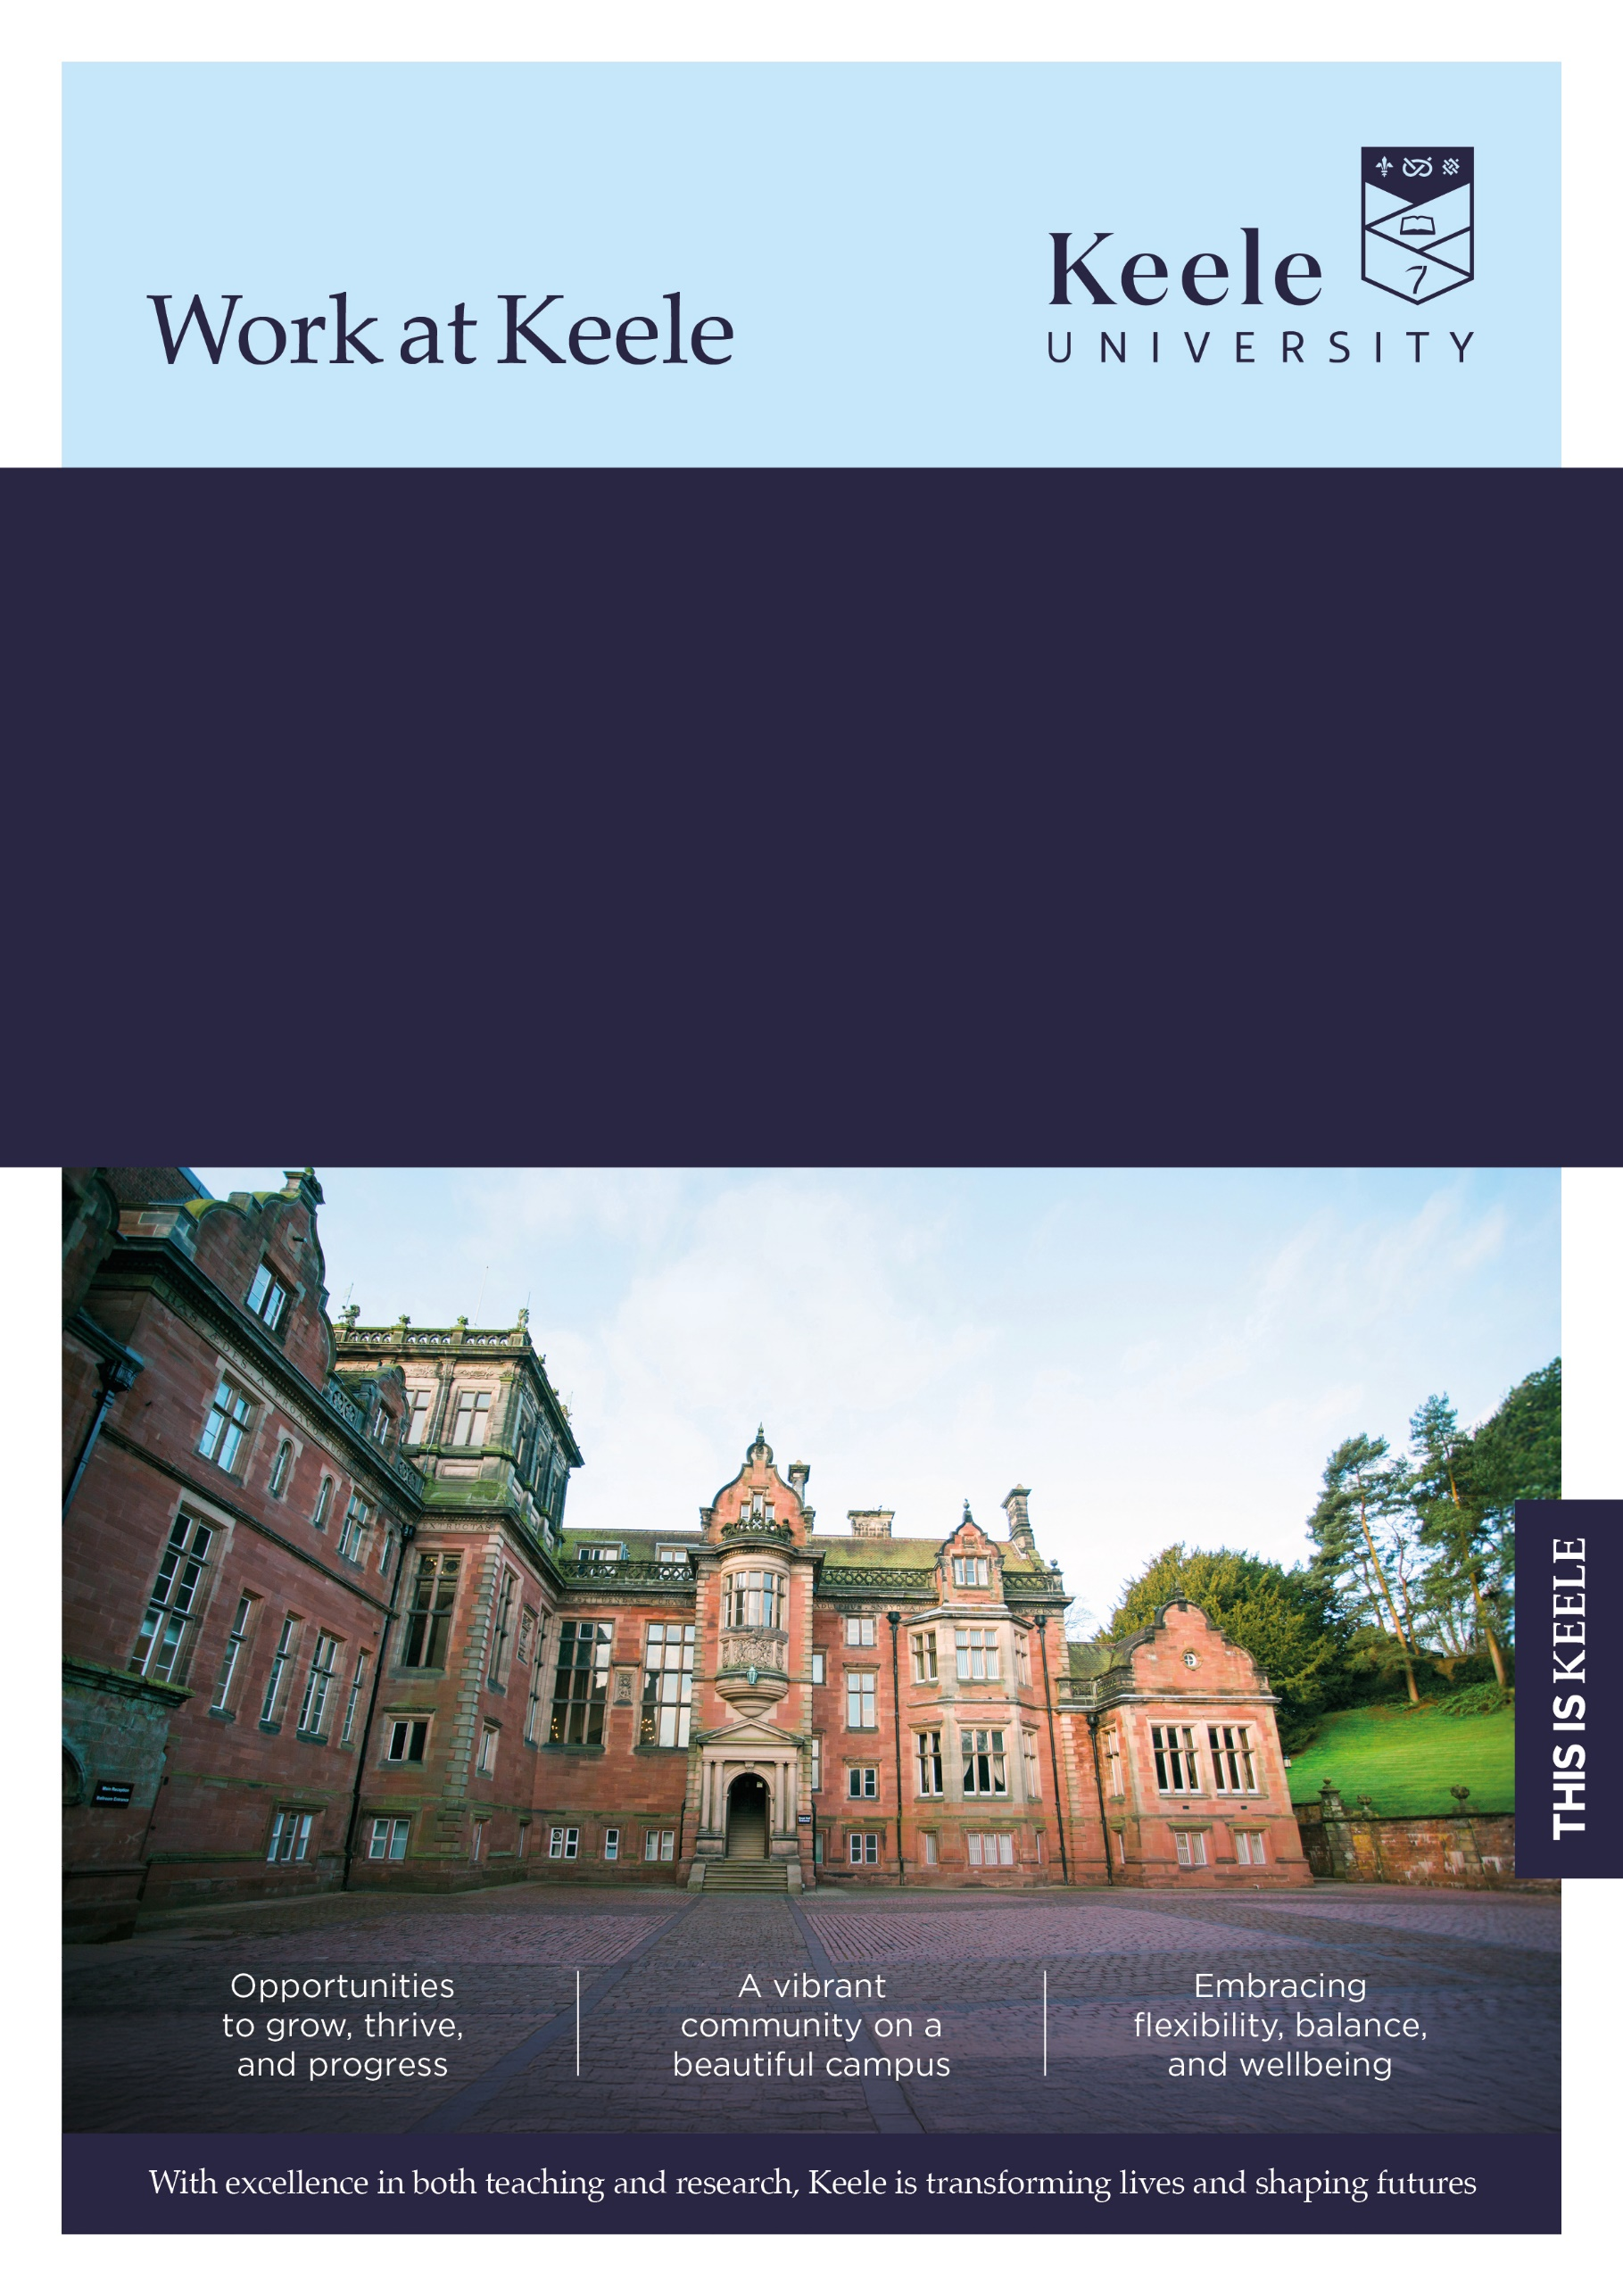
Faculty/Directorate: Faculty of Natural Sciences
Dept/School: School of Life Sciences
Location: Campus / Hybrid / Remote
Grade: 7
Salary Range: £39,560 – £48,337 pro rata
Part Time (hours and FTE): 14.5 hours per week / 0.4 FTE
Term: Fixed term until November 2030
Responsible to: Professor of Entomology
Job Ref: KU00005483
Project Manager
Thank you for considering a role at Keele University.

Inside this document, you'll discover key details about the job and our diverse and vibrant institution. We invite you to explore the impressive benefits that come with joining our community - click here to learn more about our values and what makes Keele a fantastic place to work.

The Role

An important and interesting opportunity has arisen to join the School of Life Sciences as Project Manager for the UKRI-funded E-Prep II project. This interdisciplinary project brings together biologists, ecologists, economists, social scientists, statisticians and mathematicians from eight research organisations. You will also work closely with project partners, including agricultural experts, farmers and growers in the UK and internationally.
As Project Manager, you will play a key role in coordinating the delivery of project objectives and working directly with the PI, Professor James Bell. You will monitor progress, track milestones, organise team meetings and events, work with the steering group and provide administrative support, such as help creating data management plans, to ensure the project runs effectively.
Effective collaboration is central to the success of E-Prep II. You will help maintain strong working relationships across the project team and with external partners, supporting a shared vision and strategy.
While knowledge of the research area is not mandated, an interest in science would be advantageous, particularly applicants with a biological background. Occasional travel to project meetings and events will be required.

Main duties and responsibilities

- Independently resolve sensitive or complex enquiries from a broad range of stakeholders.
- Research, collate, organise, and prepare materials for reports and presentations, assessing management information and conducting analysis to present findings and recommendations that support decision-making.
- In consultation with colleagues, develop and implement procedures and policy to align with current standards, regulations and best practices.
- Monitor and maintain records and reports to fulfil internal and external requirements. (e.g. legislative or regulatory)
- Plan and prioritise personal work activities over a period of months to support team objectives and meet service needs adapting to non-standard work adjusting priorities as needed.
- Support resource planning by assessing needs to ensure alignment with team objectives. Oversee the management of finances throughout the process
- Build and sustain effective working relationships with Professional Services teams to facilitate coordinated service delivery.
- Engage with internal and external bodies to acquire and share knowledge to support and promote best practice in service implementation.
- Manage the local implementation of departmental and University-wide process changes.

This job description is not intended as an exhaustive list of duties or a restrictive definition of the post but rather should be read as a guide to the main priorities and typical areas of activity of the post-holder. These activities are subject to amendment over time as priorities and requirements evolve and as such it may be amended at any time by the line manager following discussion with the post holder.

In addition, University staff are expected to:

We believe that diversity in its many forms is a strength that underpins the exchange of ideas, innovation and debate. We are committed to providing an environment in which all members of our community can reach their full potential and are treated with dignity and respect.

Our policy and procedure framework has been developed to ensure that we meet our statutory obligations whilst also setting out the obligations of colleagues to contribute to providing an inclusive environment for all, irrespective of an individual’s background, views or beliefs.

All University staff are expected to:

Take reasonable care of the Health and Safety of yourself and that of any other person who may be affected by your acts or omissions at work.

Adhere to regulations and procedures relating to data protection and information security.

Co-operate with the University in ensuring as far as is necessary, that Statutory Requirements, Codes of Practice, University Policies and Procedures at both University and Departmental level are complied with.

Ensure robust procedures and processes are followed for services and products that are procured and undertaken in line with prevailing legislation, statutory obligations and policies.

Adhere to the University’s environmental policy and procedures and seek to implement mechanisms which will enhance environmental sustainability within your area of responsibility.

Undertake continuing Personal/Professional Development and to engage with appropriate development activities to ensure that your skills and knowledge enable you to meet current and future role requirements.

Contribute to the delivery of the University’s Vision and Values as appropriate to your role. Further information regarding the University’s Values and Behaviours Framework can be found on the Staff Intranet which has been put in place to underpin how we work together in delivering an environment which values both difference and inclusion.



The Person
Selection Criteria | Essential (E) or  Desirable (D) | Evidenced by:  Application (A)  Interview (I)  Test (T)  Presentation (P)
Qualifications / Training
Degree or professional qualification in a relevant subject or demonstrable equivalent work experience | E | A
Further degree e.g. MSc | D | A
Relevant Professional registration or equivalent | D | A
Experience
Significant experience of working in a similar role. | D | A,I
Experience of managing and utilising specialist systems. | E | A,I
Experience of providing specialist advice and guidance to a range of customers and colleagues | E | A,I
Experience of developing, following and understanding of the importance of Standard Operating Procedures and/ or policy. | D | A,I
Experience of the planning and organisation of resources. | E | A,I
Understanding of regulations/legislation/ codes of practice relevant to the role | D | A/I
Experience of leading and managing a team (where relevant) | E | A,I
Experience of working effectively with internal and external stakeholders and at all levels | E | A, I
Experience in analysis of results and drafting reports and presentations. | E | A, I
Experience of working in HE | D | A,I
Experience of budget management. (where relevant) | D
Knowledge of University policies, procedures or working practices | D | A,I
Skills / Aptitudes / Competences
Comprehensive knowledge of work practices, policies and procedures relevant to the role | E | A,I
Ability to develop and implement improvements to systems and processes | E | A,I
High level of competence in IT and extensive familiarity with relevant Microsoft Office Software | E | A,I,T
Able to analyse data and present findings | E | A,I,T
Excellent interpersonal and communication skills, including written and verbal communication | E | A,I,T
Ability to build internal and external relationships | E | A,I
Ability to work autonomously and collaboratively using initiative to prioritise task effectively | E | A,I
Ability to provide advice and respond to enquiries in a tactful and professional manner. | E | A,I,T
Financial/Budget Management skills | D | A,I
Other
Understanding and awareness of confidentiality and its importance. | E | A,I
Understanding and awareness of data security | E | A,I
Committed to continuous improvement and professional development, undertaking training as required. | E | A,I
Ability to work flexibly according to the demands of the role / to support the needs of the service and which could include occasional evenings and weekends when required (notice provided). | E | A,I

Further Information

Closing date for applications: 25th November 2026

Interviews will be held on: 11th December 2026

How to apply
For full post details and to apply, please visit: www.keele.ac.uk/jobs.

Keele University employees wishing to apply for this vacancy should login to Employee Self Service and click on the 'View current vacancies' link.

Eligibility to work
This post is unlikely to meet the relevant criteria to allow the University to issue a Certificate of Sponsorship. Applications from candidates who require a Certificate of Sponsorship to work in the UK will be considered against the requirements stated in the recruitment documentation. Recruitment decisions will be made in accordance with the UK Visas and Immigration guidance.

References
You will be asked to supply details by two individuals (three if you are applying for an academic or research post), that can provide relevant and credible insights into your employment details and suitability for the role. This will include a reference from your current line manager (or most recent line manager if currently unemployed), and your next most recent employer (where applicable). In providing these details you are giving the University permission to request personal information about you from your referees, which may include confirmation of your previous salary, disciplinary and work history.

For graduates or candidates with limited work experience, references may be provided by individuals who can speak to your achievements and skills in other areas such as academia, volunteering or extracurricular activities.

With your consent, the University may request additional references if it is felt these are necessary to provide a more comprehensive understanding of your suitability for the role.

Further information regarding references can be found here: www.keele.ac.uk/jobs/vacanciesfaqs

Disability Confident
Keele University is committed to taking positive steps to employ, keep and develop the abilities of disabled staff and has been awarded the disability symbol. We undertake to offer all applicants with a disability and who meet the minimum essential criteria an interview. If you wish to be considered under this scheme, please indicate this by selecting ‘Yes’ in the Guaranteed Interview Scheme Section of your application. You can also provide specific information of any requirements / adjustments you may require to assist you during the recruitment process within this section. For advice or guidance please contact the Recruitment Team email: vacancies@keele.ac.uk.

The information you provide on your application will be forwarded to the recruiting area so that they may consider whether they can facilitate your requested adjustments. Please note that if you do not indicate that you wish to be considered under the Disability Confident scheme in your application, you will not be considered under this Scheme.

Alternative formats
If you have any other requirements that will help you access the application or interview process, or require documents in alternative formats, please contact vacancies@keele.ac.uk.

About Keele

We're Keele and we're different. Founded 75 years ago to meet the demands of a new kind of society, economy and world, our principles resonate now more than ever.

We are a campus university with over 15,000 students, nestled in 600 acres of Staffordshire countryside and just an hour from Manchester and Birmingham. It's a big campus but a small and cosmopolitan community, with space to think and plenty to do.

Our research seeks to improve lives and address the most pressing challenges across our region, country, and world. Our academics are actively studying matters of global importance: from food security, climate change and smart energy, to neglected tropical diseases, global health and sustainable futures.

As well as world-leading research (Research Excellence Framework, 2021), Keele also sets the gold standard for teaching, with some of the most satisfied students in the country – in 2022, students ranked us “Britain’s best university” in the Student Crowd University Awards, and in 2023 we were awarded the highest rating of “Gold” overall in the Teaching Excellence Framework.

For more information about the benefits of working at Keele University, visit www.keele.ac.uk/jobs.



